**Cycle-1**

**1) Print your name to the screen with every letter being a different heading size**

<html>

<head>

<title>online class</title>

</head>

<body style="background-color:DodgerBlue;">

<center>

<form >

<h1 >Time to Study</h1><b/>

<h2 >Time to Study</h2><b/>

<h3 >Time to Study</h3><b/>

<h4 >Time to Study</h4><b/>

<h5 >Time to Study</h5><b/>

<h6 >Time to Study</h6><b/>

</body>

</html>

**OUTPUT**

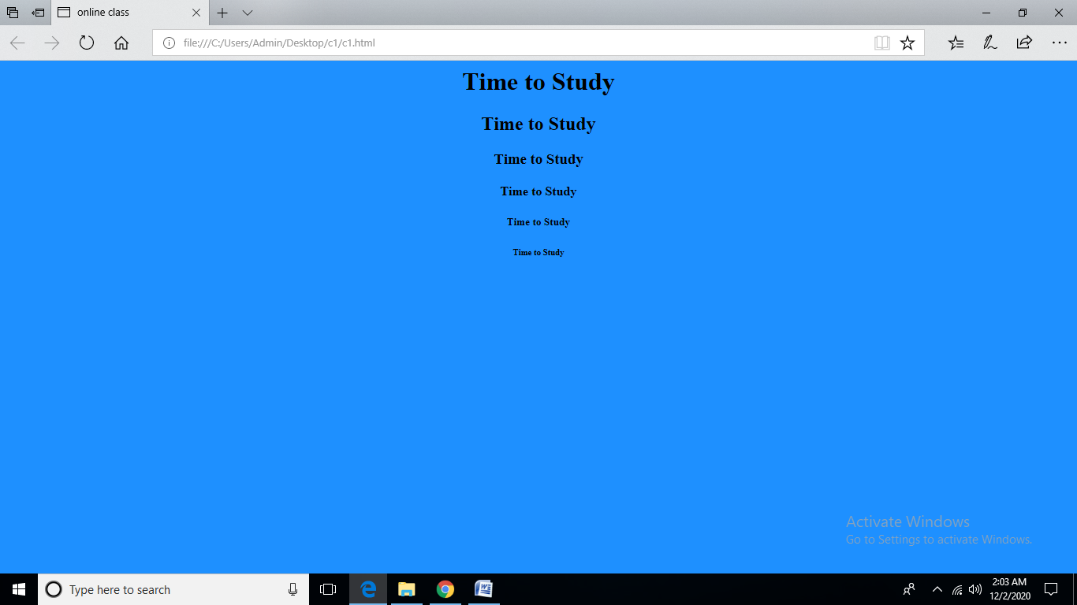

**2) Display the following text:**

**H2O**

**12th April 2016**

**HTML stands for ~~High Text Markup Language~~**

**He said <I am fine>**

<html>

<head>

</head>

<body >

<center>

<h6 >H<sup>2</sup>O</h6><br>

<h6 >12 <sup>th </sup>April 2016</h6><br>

<h6 >HTML stands for <strike>High Text Markup Language</strike></h6><br>

<h6>He said<<b>I am Fine</b>></h6>

</body>

</html>

**OUTPUT**

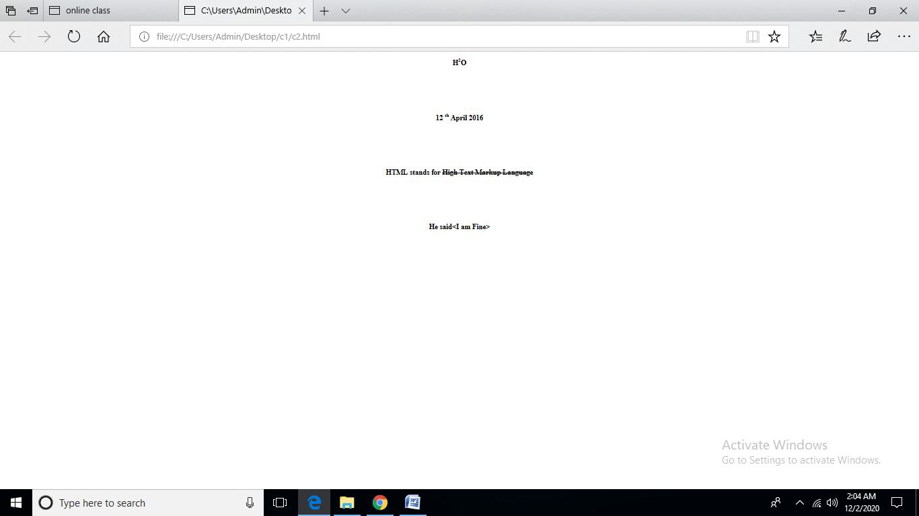

**3) Print a paragraph with 4 - 5 sentences. Each sentence should be a different font.**

<html>

<head>

</head>

<body >

<center>

<font size="5" face="Courier New">

<p> the font tag allows us to change the style ,size and color</p><br></font>

<font size="4" face="Courier New">

<p> the font tag allows us to change the style ,size and color</p><br></font>

<font size="3" face="Courier New">

<p> the font tag allows us to change the style ,size and color</p><br></font>

<font size="2" face="Courier New">

<p> the font tag allows us to change the style ,size and color</p><br></font>

<font size="1" face="Courier New">

<p> the font tag allows us to change the style ,size and color</p><br></font>

</body>

</html>

**OUTPUT**

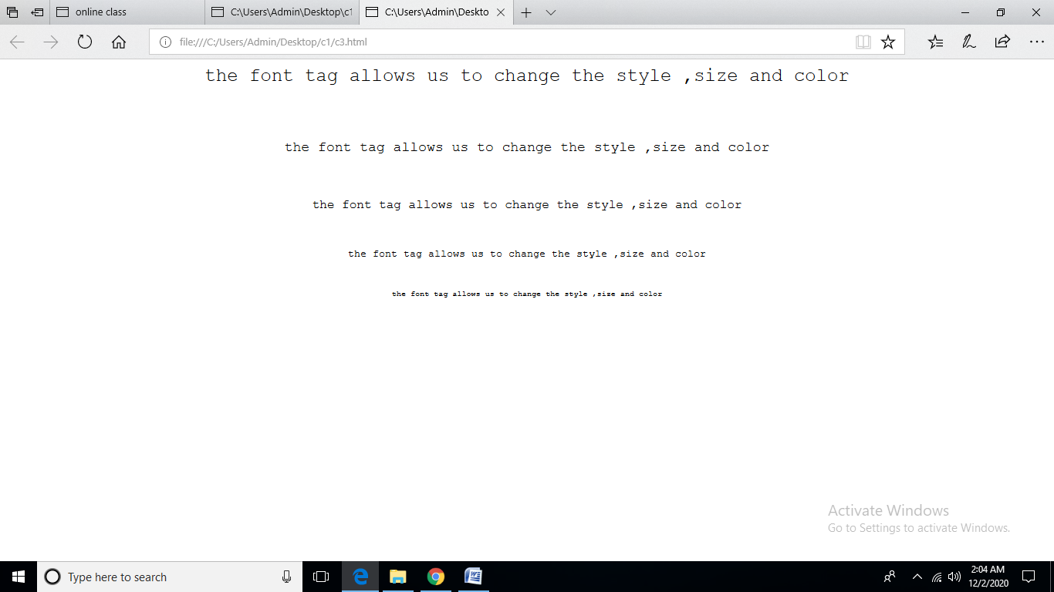

**4) Print a paragraph that is a description of a book, include the title of the book as well as its author. Names and titles should be underlined, adjectives should be italicized and bolded**

<html>

<head>

<title>bca</title>

</head>

<body >

<center>

<font size="5" face="Courier New">

<h1> <b><i><u>WEB PROGRAMING</b></i></u></h1><BR>

<p>AUTHOR</P><br>

<p>binu m.b</p><br>

<p> HTML is the standard markup language for Web pages.

With HTML you can create your own Website.

HTML stands for Hyper Text Markup Language

HTML consists of a series of elements

HTML elements tell the browser how to display the content

HTML elements label pieces of content such as "this is a heading", "this is a paragraph", "this is a link", etc…r</p><br></font>

</p><br></font>

</body>

</html>

**OUTPUT**

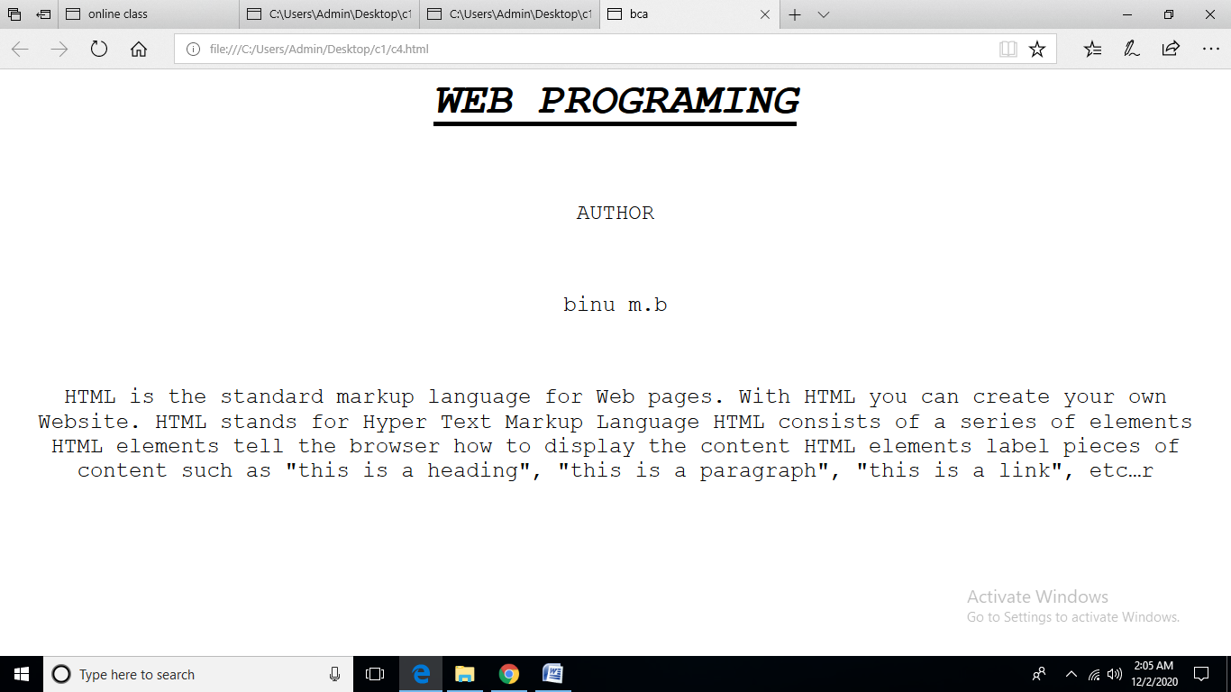

**5) Print two lists with any information you want. One list should be an ordered list, the other list should be an unordered list**.

<html>

<head>

</head>

<body >

<font size="5" face="Courier New">

<h1>List</h1><BR>

<ol type="1">

<li>car</li>

<li>bus</li>

<li>van</li>

</ol></br>

<ul>

<li>anu</li>

<li>anisha</li>

<li>albins</li>

</ul>

</font>

</body>

</html>

**OUTPUT**

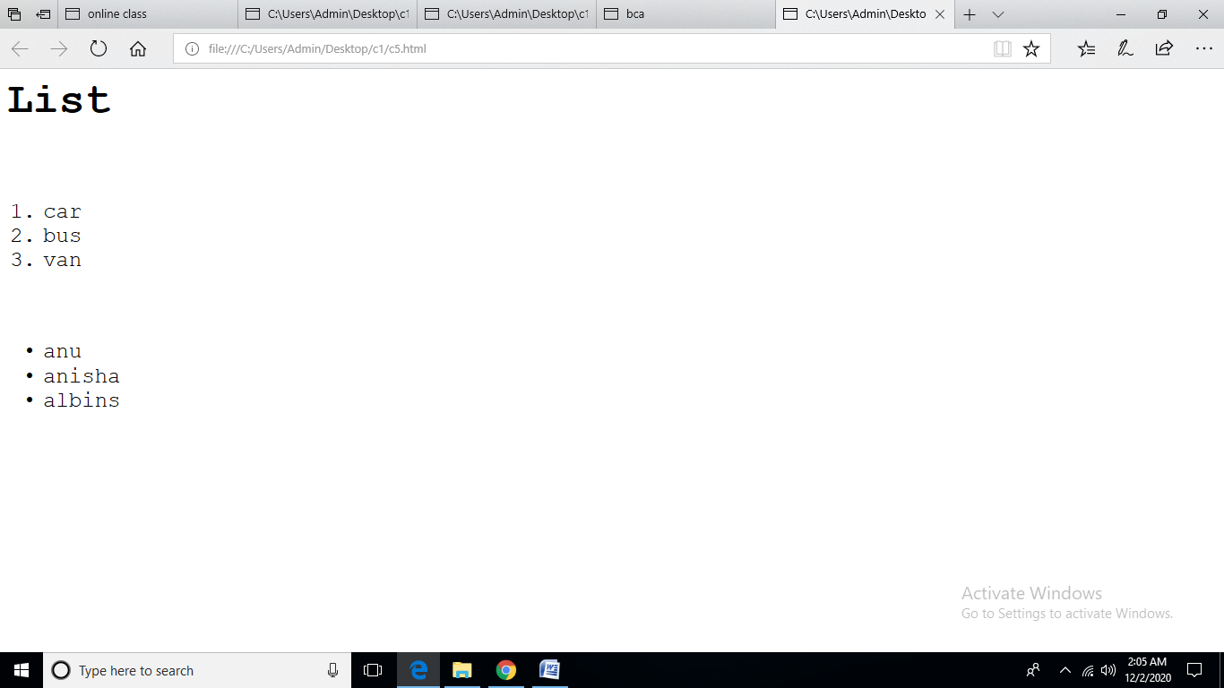

**6) Prints 10 names with a line break between each name. The list should be alphabetized, and to do this place a subscripted number next to each name based on where it will go in the alphabetized list. (Example: Alan1). Print first, the unalphabetized list with a subscript number next to each name, then the alphabetized list. Both lists should have an <h1> level heading**

<html>

<head>

</head>

<body >

<h1>Unalphabetized list</h1></br>

<ul>

<li >

Bill<sub>3</sub></li >

<li >Roger<sub>5</sub></li >

<li >Sandra<sub>6</sub></li >

<li >Stacy<sub>7</sub></li ><li>William<sub>10</sub></li ><li >Thomas<sub>8</sub></li >

<li >Wendy<sub>9</sub></li ><li >Jane<sub>4</sub></li ><li >Andy<sub>1</sub></li >

<li >Anna<sub>2</p></li >

</ul>

<h1>Alphabetized list</h1></br>

<ol type="a">

<li><P>Andy

</br></li>

<li>Anna</p><hr/></li

</center>

</body>

</html>

**OUTPUT**

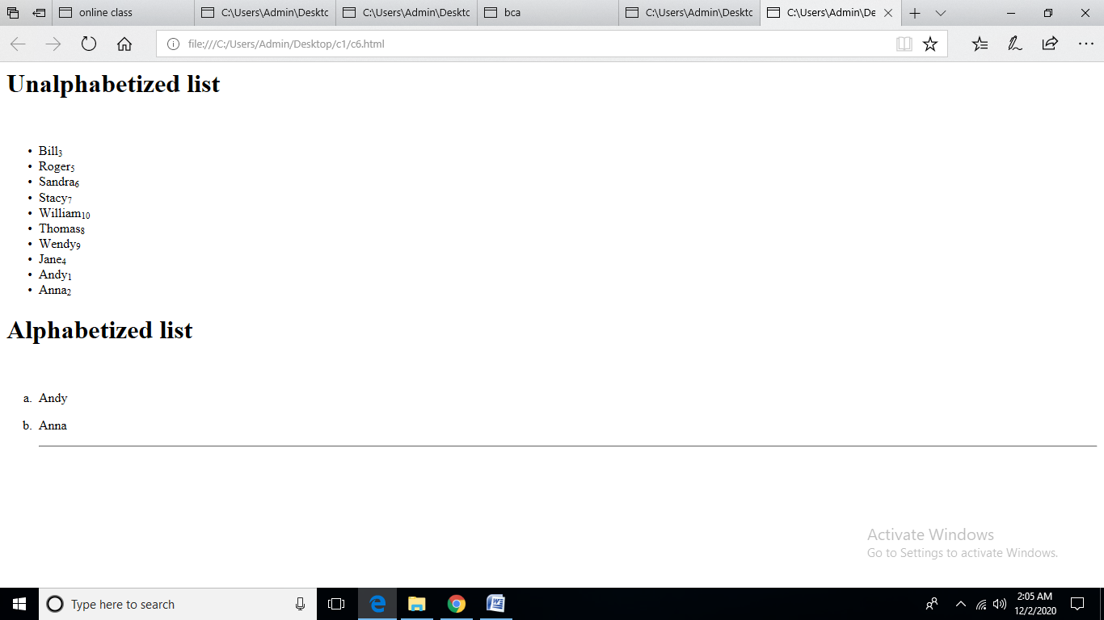

**7) Print the squares of the numbers 1 - 20. Each number should be on a separate line, next to it the number 2 superscripted, an equal sign and the result**

<html>

<head>

</head>

<body >

<center>

<p>1<sup>2</sup>=1</br>2<sup>2</sup>=4</br>3<sup>2</sup>=9</br>4<sup>2</sup>=16</br>5<sup>2</sup>=25</br>6<sup>2</sup>=36</br>7<sup>2</sup>=49</br>8<sup>2</sup>=64</br>9<sup>2</sup>=81</br>10<sup>2</sup>=100

</center>

</body>

</html>

**OUTPUT**

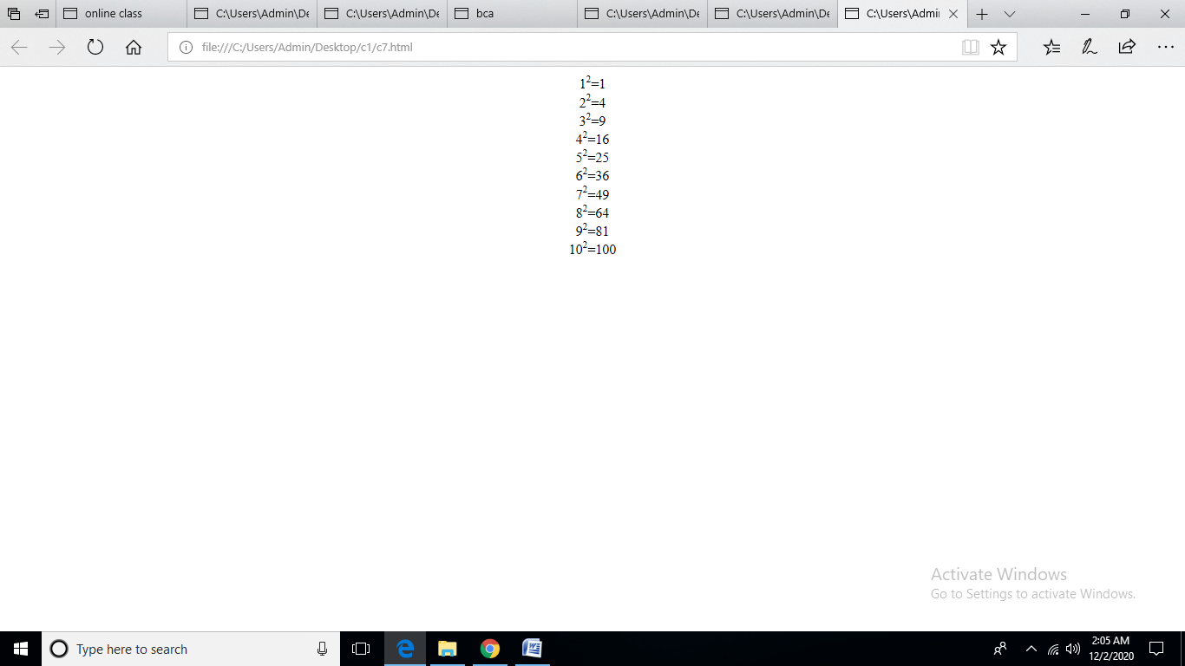

**8) Print a definition list with 5 items**

<html>

<head>

</head>

<body >

<center>

<font size="5" face="Courier New">

<h1>List</h1><BR>

<dl>

<dt>Keyboard</dt>

<dd>an input device</dd>

<dt>Mouse</dt>

<dd>an input device</dd>

<dt>Printer</dt>

<dd>an output device</dd>

</dl>

</font>

</center>

</body>

</html>

**OUTPUT**

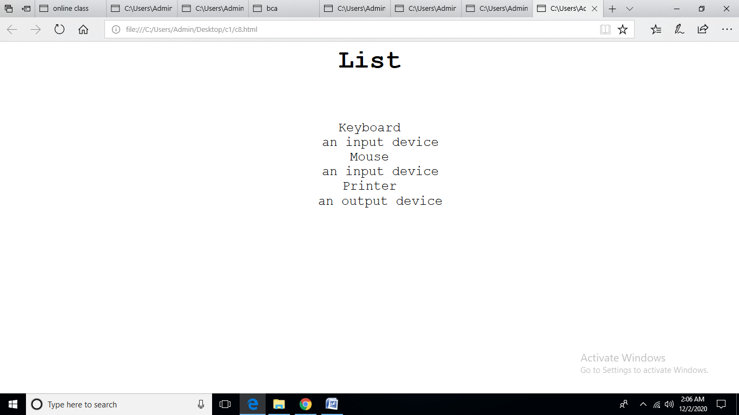

**9) Display an image that has a border of size 2, a width of 200, and a height of 200.**

<html>

<head>

</head>

<body >

<center>

<h1>Image</h1><BR>

<img src="C:\Users\Admin\Documents\home.jpg" border="2" height="200" width="200">

</center>

</body>

</html>

**OUTPUT**

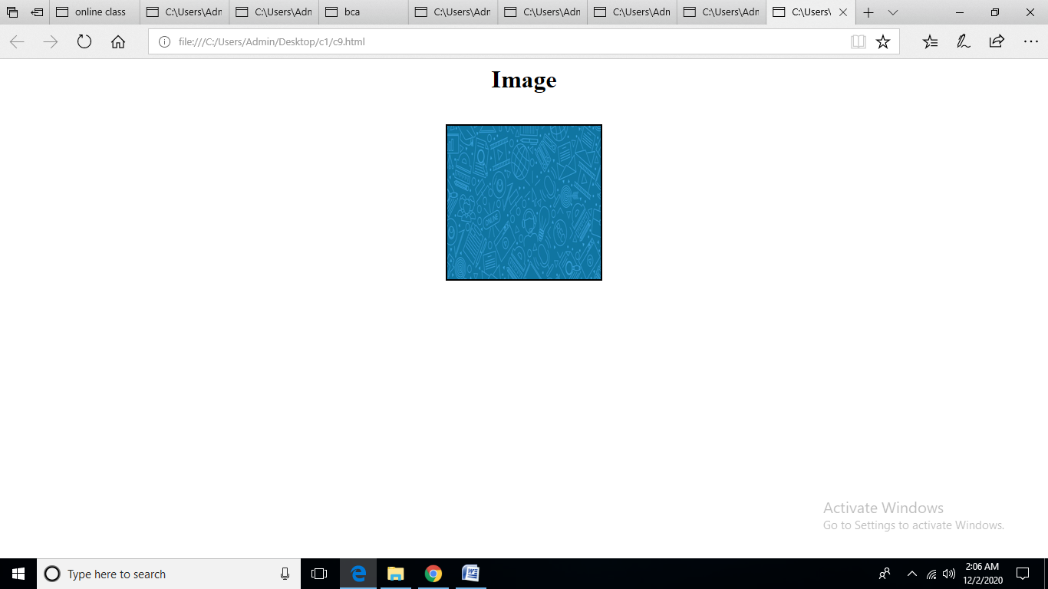

**10) Print ten acronyms and abbreviations of your choosing, each separated by two lines. Specify the data that the abbreviations and acronyms represent**

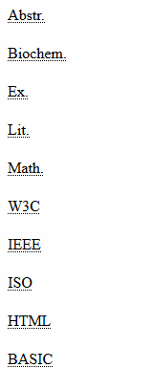

<html>

<head>

</head>

<body >

<center>

<abbr title="abstract">Abstr.</abbr>

</br>

</br>

<abbr title="biochemistry">Biochem.</abbr>

</br></br>

<abbr title="Example">Ex.</abbr>

</br></br>

<abbr title="Literature">lit.</abbr>

</br></br>

<abbr title="mathematics">math.</abbr>

</br>

</br>

</center>

</body>

</html>

**OUTPUT**

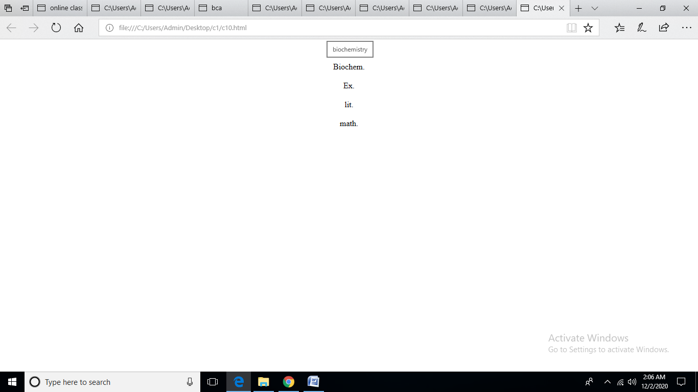

**11) Print two addresses in the same format used on the front of envelopes (senders address in top left corner, receivers address in the center**

<html>

<head>

<style>

p{

text-align:right;

font-family:algerian;

}

</style>

</head>

<body >

<font size="5" face="algerian">

Dilbert H</br>

1234 Anim Street</br>

<p>Someone A person</br>

5555 Street AvenueM<p>

</font>

</body>

</html>

**OUTPUT**

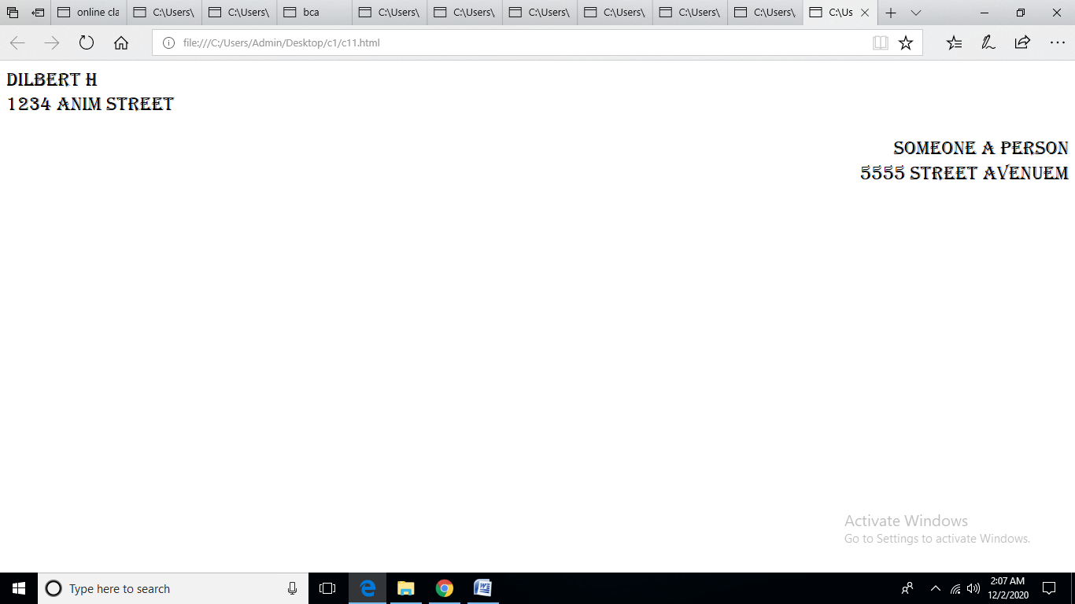

**12) Create an HTML page with the following contents:**

<html>

<head>

</head>

<body >

<center>

<font size="5" face="algerian">

<h1>HTML Practice Exercise</h1>

<p style="color:red"><u>James Madison University</u></p><hr/></br>

</center

>

<h5>i love HTML becasue:</h5></br>

<ol>

<li>I learned it quickly

</li>

<li>i can make web pages using code</li>

<li>it is fun</li>

</ol>

</hr>

</br>

<h5>My professor<sup>'</sup>s -mail address is <a href="mail box" >clarketb@jmu.edu.</a></h5></br>

<b>Have A great day!</b>

</font>

</body>

</html>

**OUTPUT**

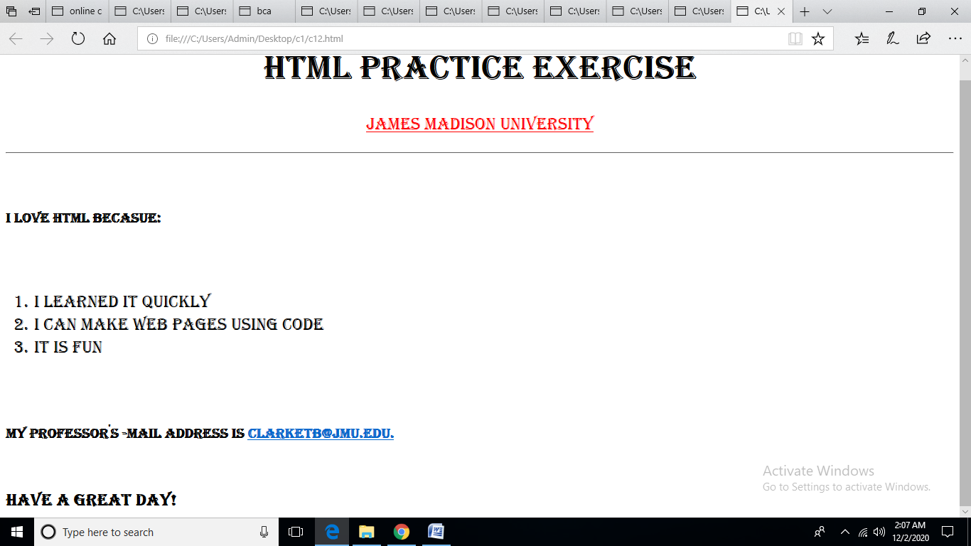

**13) Create the following table**

<!DOCTYPE html>

<html>

<body>

<table border="5" cellspacing="0" align="center">

<tr>

<td colspan="6" align="center"

height="50">Time Table</td>

</tr>

<tr>

<td rowspan="6" align="center" height="50">

Hours

</td>

<td align="center" height="50">

<b>Monday</b>

<td align="center" height="50">

<b>Tuesday</b>

<td align="center" height="50">

<b>wednesday</b>

<td align="center" height="50">

<b>thursday</b>

<td align="center" height="50">

<b>friday</b>

</td> </tr>

<td align="center" height="50">sci</td>

<td align="center" height="50">maths</td>

<td align="center" height="50">sci</td>

<td align="center" height="50">maths</td>

<td align="center" height="50">art</td>

</tr>

<tr>

<td align="center" height="50">social</td>

<td align="center" height="50">history</td>

<td align="center" height="50">english</td>

<td align="center" height="50">scial</td>

<td align="center" height="50">art</td>

</tr>

<tr>

<td colspan="5" align="center"

height="50">lunch

</td> </tr>

<tr>

<td align="center" height="50">sci</td>

<td align="center" height="50">maths</td>

<td align="center" height="50">sci</td>

<td align="center" height="50">maths</td>

<td rowspan="2" align="center" height="50">

Project

</td>

</tr>

<tr> <td align="center" height="50">social</td>

<td align="center" height="50">history</td>

<td align="center" height="50">english</td>

<td align="center" height="50">scial</td>

</tr>

</table>

</body>

</html>

**OUTPUT**

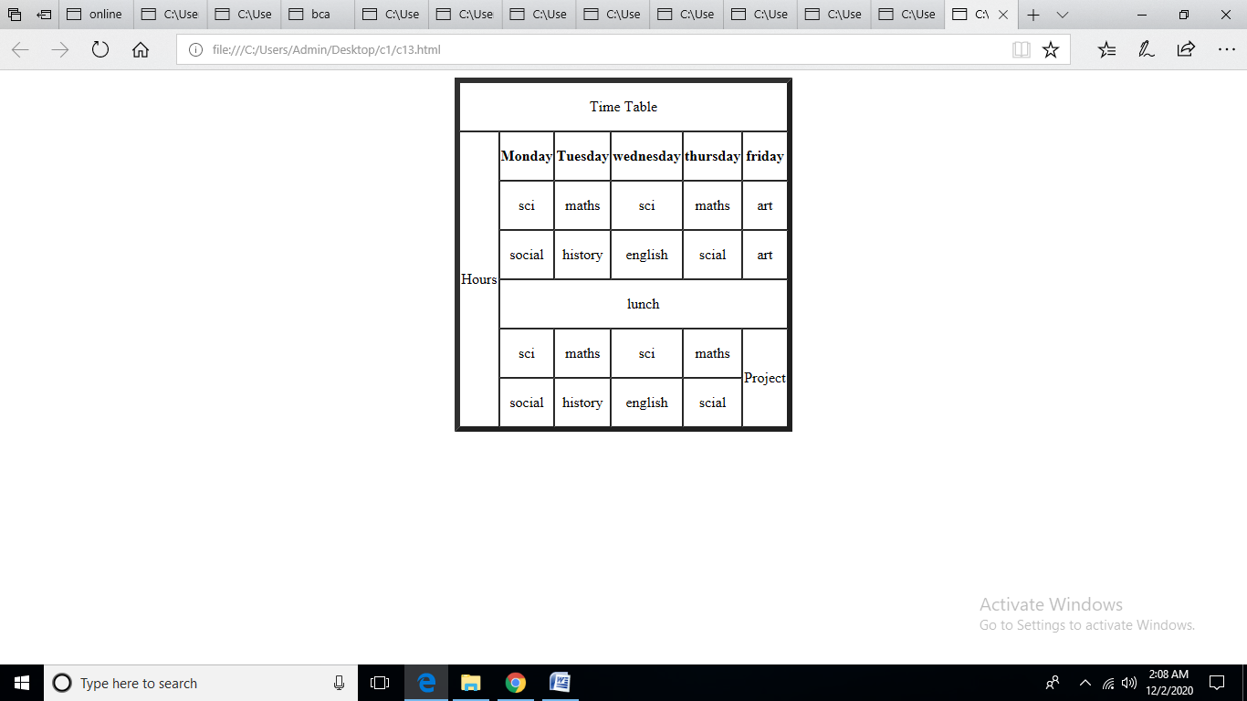

**14) Create a HTML Page which looks like the one given below**

<html>

<head>

</head>

<body >

<font size="5" face="algerian">

<h1>Pochi the Cat</h1>

</br>

<h2> Introduction</h2>

</br>

<p>

Pochi was adopted ffrom an animal shelter and now resides in seattle.WA where she runs a small but successul web page design business exclusively for cat clients.

<img src="C:\Users\Admin\Desktop\study.jpg" align="right" width ="150" height="140" />

</br>

<h2>Profile</h2>

<ul>

<li>faorite ood</li>

<li>hobbies</li>

<li>hiden talent</li>

</ul>

<h2>Links</h2>

<ul>

<li><a href="mail box" ><u>SACS</U></a></li>

<li><a href="mail box" ><u>HSUS</U></a></li>

</ul>

</font>

</body>

</html>

**OUTPUT**

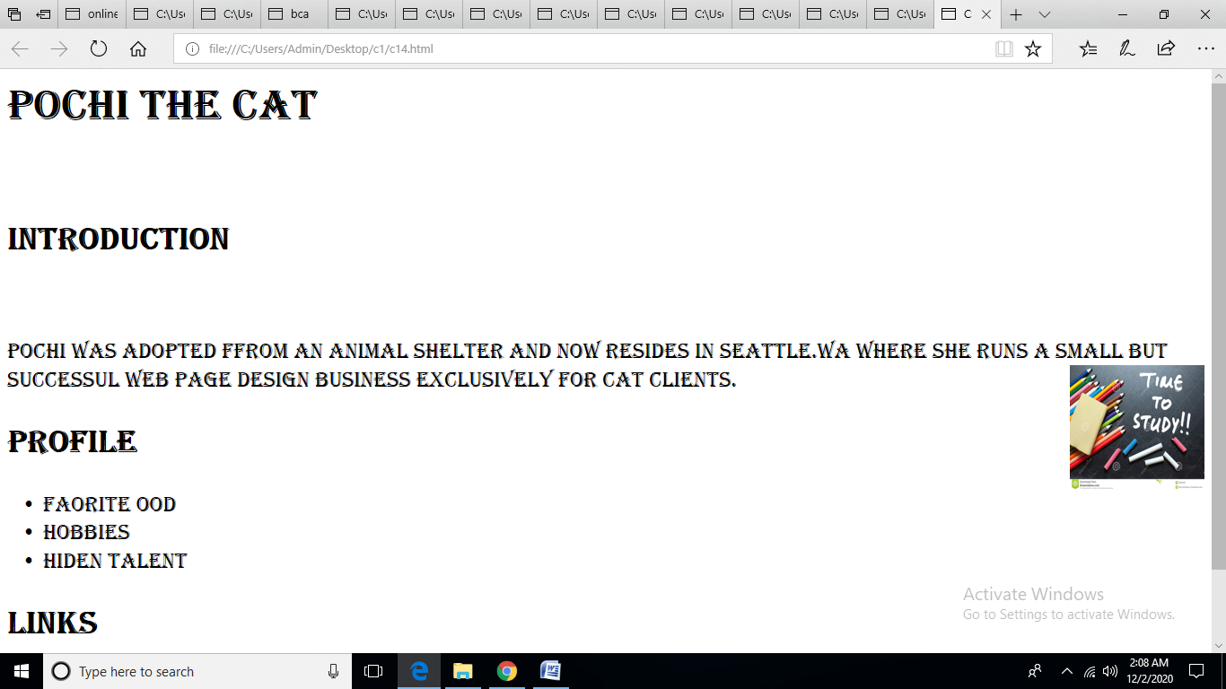

**CYCLE-2**

**1 ) Create an html page to display the following nested list**

<html>

<head>

</head>

<body >

<font size="5" face="algerian">

<h2>An ordered nested list:</h2>

<ol type="1">

<li>Coffee</li>

<li>Tea</li>

<ol type="a">

<li>Black Tea</li>

<li>Green Tea</li>

<ol type="i">

<li>China</li>

<li>Africa</li>

</ol>

</ol>

<li>Milk</li>

</ol>

</html>

**OUTPUT**

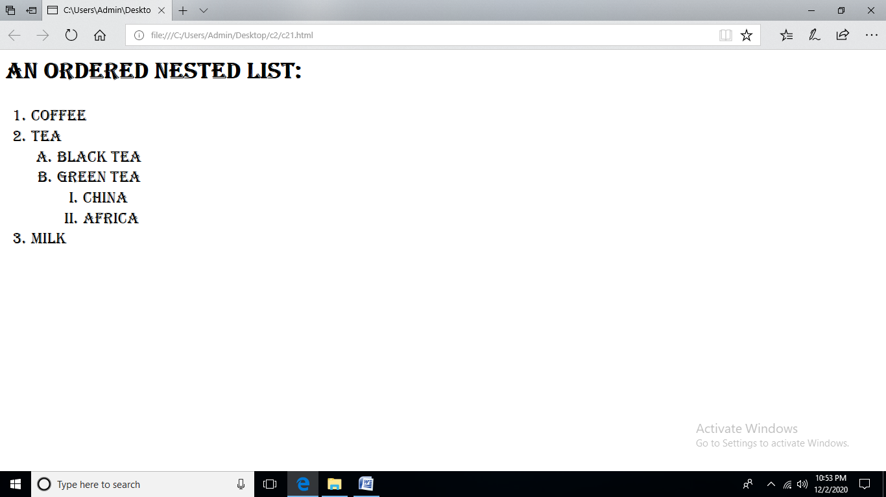

**2)Create links to three different pages on three different websites that should all open in a new window.**

<html>

<head>

<title>online class</title>

</head>

<body style="background-color:DodgerBlue;">

<center>

<form >

<h1 >Time to Study</h1><b/>

&nbsp;&nbsp;&nbsp;

<a href="C:\Users\Admin\Documents\notification.html">Notifficaion</a>&nbsp;&nbsp;

<a href="C:\Users\Admin\Documents\syl.html">Syllabus</a>&nbsp;&nbsp;

<a href="C:\Users\Admin\Documents\doubts.html">Doubts</a>&nbsp;&nbsp;

<a href="C:\Users\Admin\Documents\online.html">Online Class</a>&nbsp;&nbsp;

<a href="C:\Users\Admin\Documents\book.html">Book refence</a>

</center>

</form>

</body>

</html>

-notification

<html>

<head>

<title>online class</title>

</head>

<body style="background-color:Tomato;" >

<center>

<form >

<h1 >You have a notification</h1><b/>

<input type="text" name="msg" width="800" height="600" />

<br/>

<br/>

<br/>

<br/>

<br/>

<br/>

<a href="C:\Users\Admin\Documents\homepage1.html">Home</a>

</center>

</form>

</body>

</html>

-online class

<html>

<body>

<body style="background-color:Tomato;" >

<center>

<h1>Online class</h1>

<br/>

<br/>

<br/>

<video width="320" height="240" controls>

<source src="movie.mp4" type="video/mp4">

<source src="movie.ogg" type="video/ogg">

Your browser does not support the video tag.

</video>

<br/>

<br/>

<br/>

<br/>

<br/>

<br/>

<a href="C:\Users\Admin\Documents\homepage1.html">Home</a>

</body>

</html>

</center>

Syllabus

<html>

<head>

<title>online class</title>

</head>

<body>

<center>

<body style="background-color:Tomato;" >

<h1 >Syllabus</h1><b/>

<body style="background-color:Tomato;" >

<br/>

<br/>

<br/>

<br/>

<a href="https://ktu.edu.in/eu/acd/academicRegulationMCA.htm">Syllabus</a>

<br/>

<br/>

<br/>

<br/>

<br/>

<br/>

<a href="C:\Users\Admin\Documents\homepage1.html">Home</a>

</center>

</form>

</body>

</html>

Doubts

<html>

<head>

<title>online class</title>

</head>

<body>

<center>

<body style="background-color:Tomato;" >

<br/>

<br/>

<br/>

<br/>

<H1>Please enter the doubt</h1>

<form >

<table width="700" height="400" border="0">

<tr><td>Please enter the Doubts</td><td>

<input type="text" name="FName" /></td>

<td>Which subject</td>

<td><select name="coutry" id="coutry">

<option value="0">------------select------------</option>

<option >WEB</option>

<option>FDS</option>

<option>SE</option>

<option>MATHS</option>

</select></td

<td>&nbsp;</td>

<td><input type="submit" value="Save" /></td></tr>

</table>

<br/>

<br/>

<a href="C:\Users\Admin\Documents\homepage1.html">Home</a>

</center>

</form>

</body>

</html>

Book

<html>

<head>

<title>online class</title>

</head>

<body>

<center>

<body style="background-color:Tomato;" >

<h1 >Book Rreference </h1><b/>

<br/><br/>

<br/>

<br/>

<a href="https://www.w3schools.com/">Rreference</a>

<br/>

<br/>

<br/>

<br/>

<br/>

<br/>

<a href="C:\Users\Admin\Documents\homepage1.html">Home</a>

</center>

</form>

</body>

**OUTPUT**

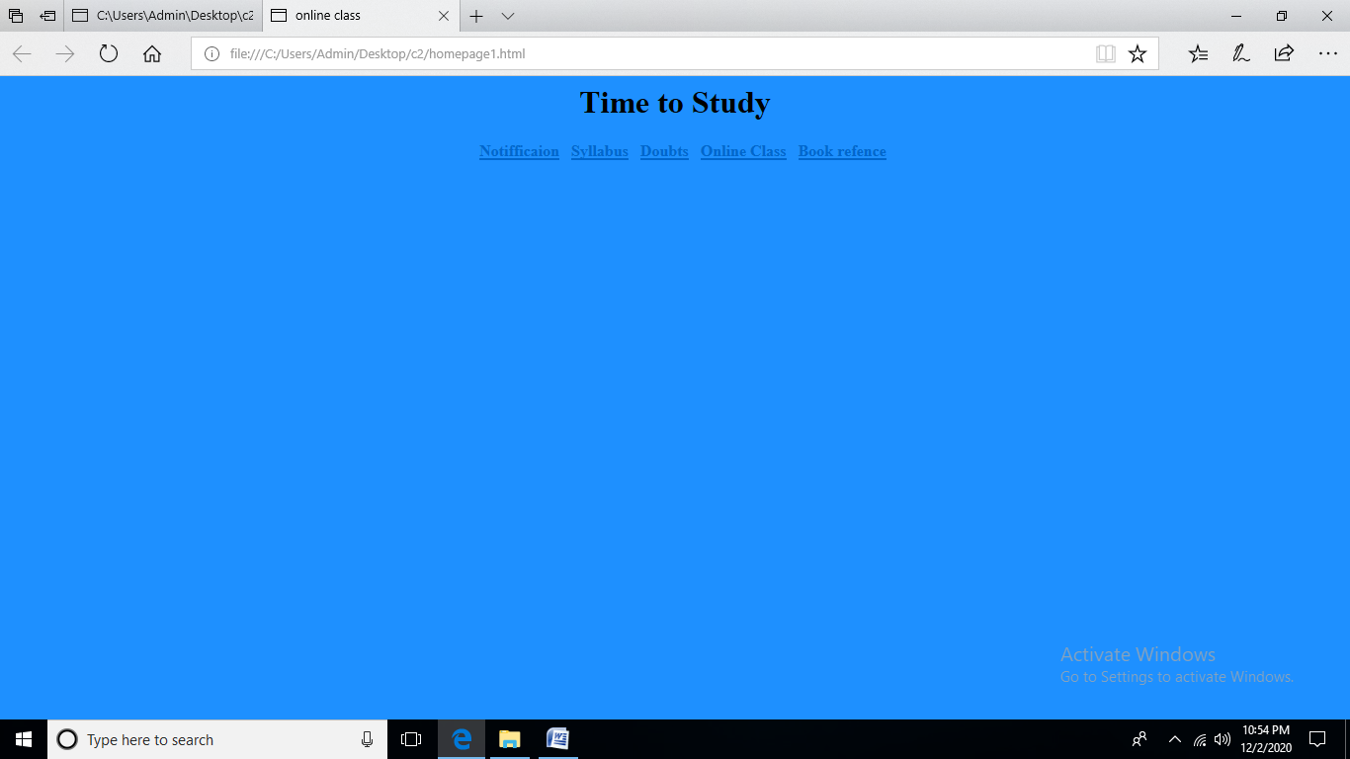

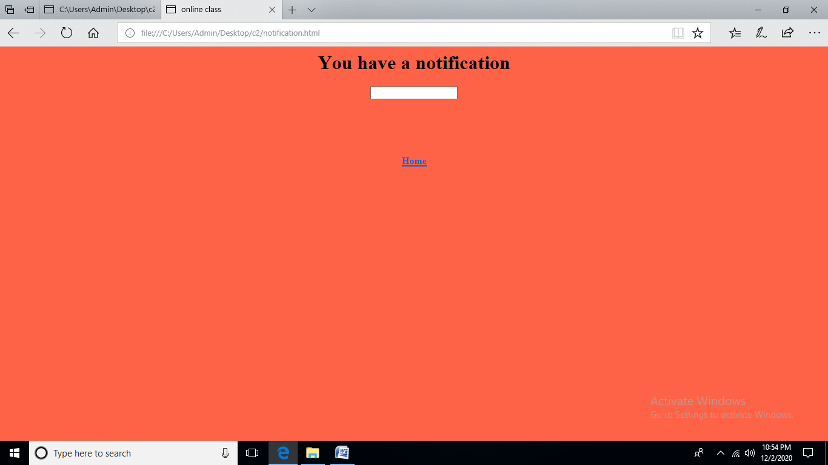

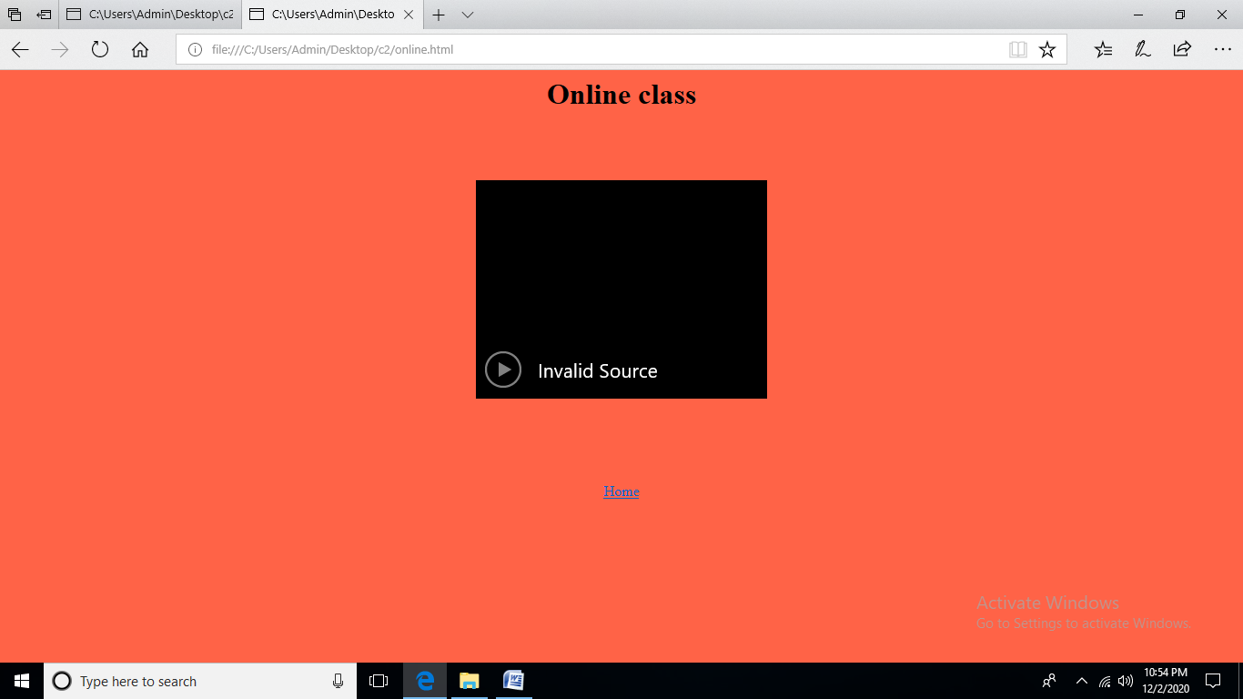

**3)Create links to three different pages on three different websites that should all open in a new window.**

<html>

<head>

</head>

<body >

<font size="5" face="algerian">

<a href="#bottom"> click here to move bottom of page</a>

<p>Kollam is</br> located in </br>the</br> the South </br>west coast</br> of Kerala. </br>It is an old</br> sea port of the</br> Arabian </br>sea coast. Kollam </br>occupies an </br>area of 2,491 sq.</br>

km. According </br>to the</br>census </br>of 2001, the total </br>population of </br>the</br> district is 25,84,118 with</br> the</br> population</br>

density of 1037</br> people per </br>square </br>kilometer.

<a name="bottom">the bottom of page</a>

</font>

</body>

</html>

**OUTPUT**

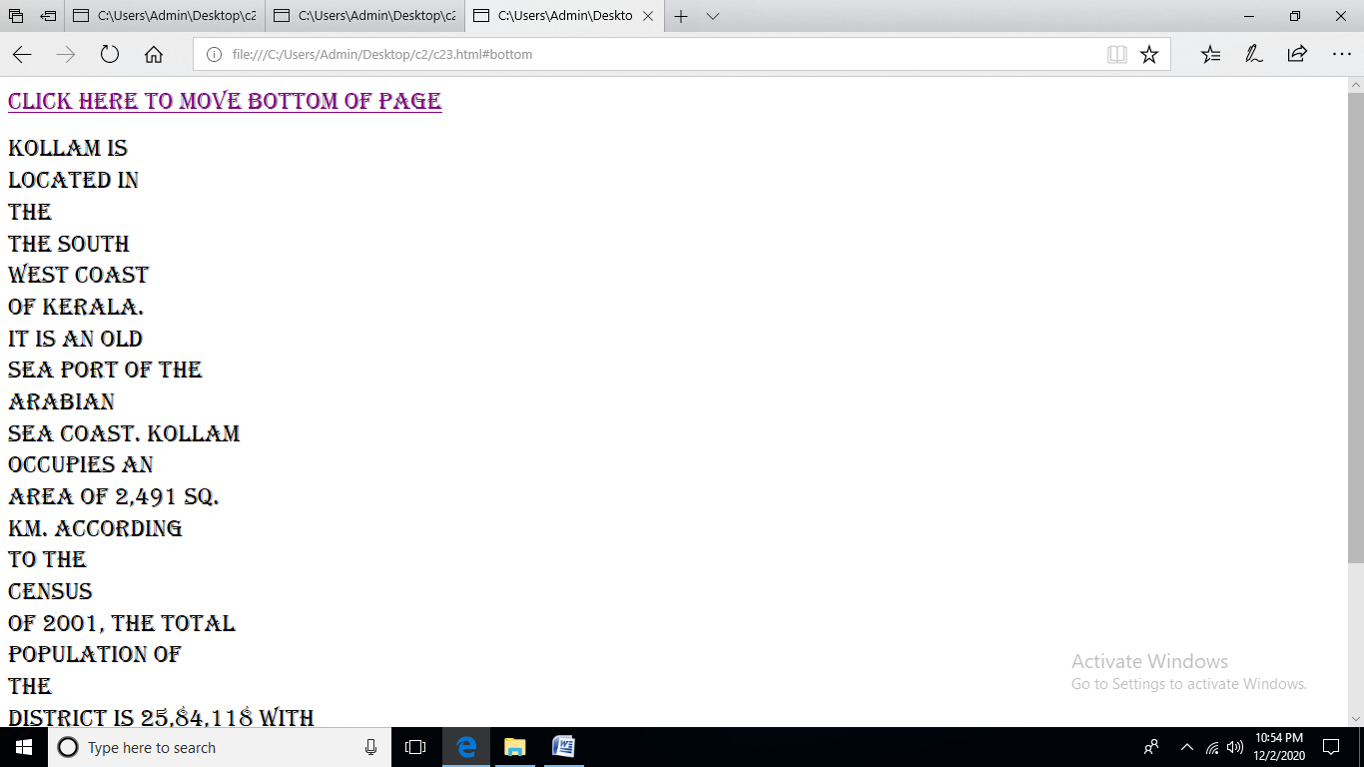

**4)Display three different images. Skip two lines between each image. Each image should have a heading.**

<html>

<head>

</head>

<body >

<font size="5" face="algerian">

<h1>heading 1</h1></br>

<img src="C:\Users\Admin\Desktop\study.jpg" width ="150" height="140" /></br>

<hr/>

<hr/>

<h1>heading 2</h1>

</br>

<img src="C:\Users\Admin\Desktop\study.jpg" width ="150" height="140" /></br>

<hr/>

<hr/>

<h1>heading 3</h1>

</br>

<img src="C:\Users\Admin\Desktop\study.jpg" width ="150" height="140" /></br>

<hr/>

<hr/>

</font>

</body>

</html>

**OUTPUT**

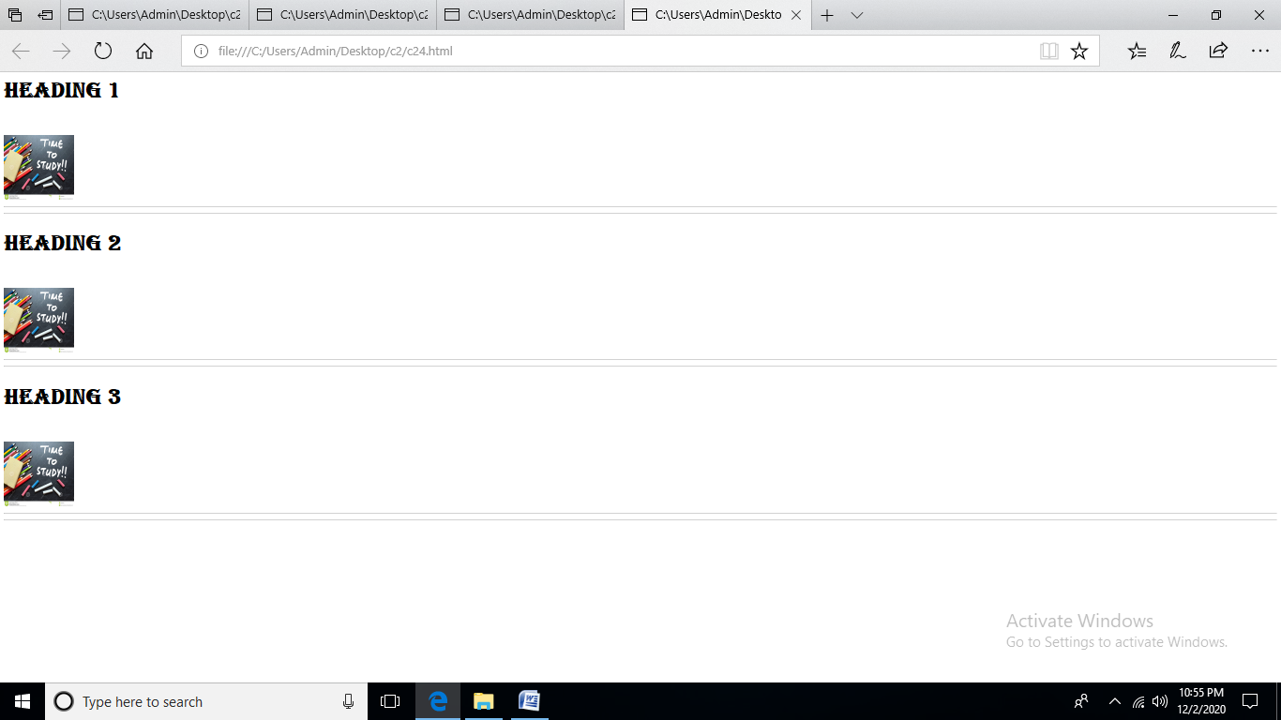

**5)Display an image that when clicked will link to a search engine of your choice in a different window**

<html>

<head>

</head>

<body >

<center>

<a href ="https://www.google.com/"><img src="C:\Users\Admin\Desktop\c2\g.png" alt="google" height="150" width="150"/>

</a>

</body>

</html>

**OUTPUT**

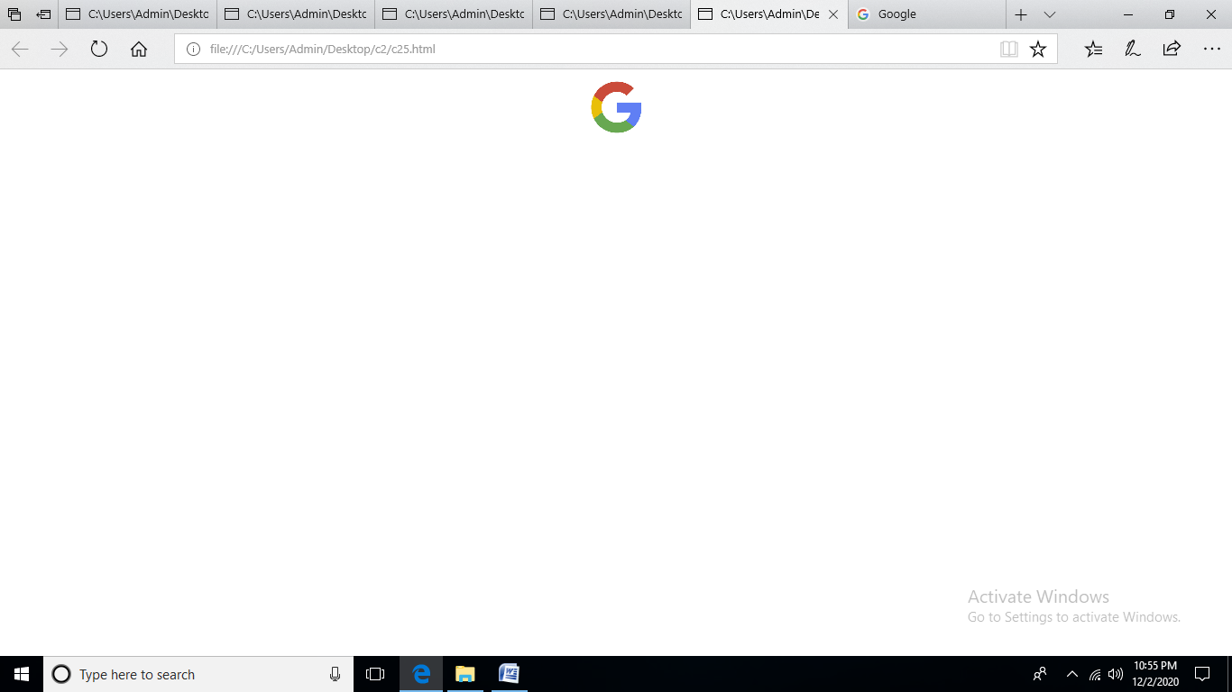

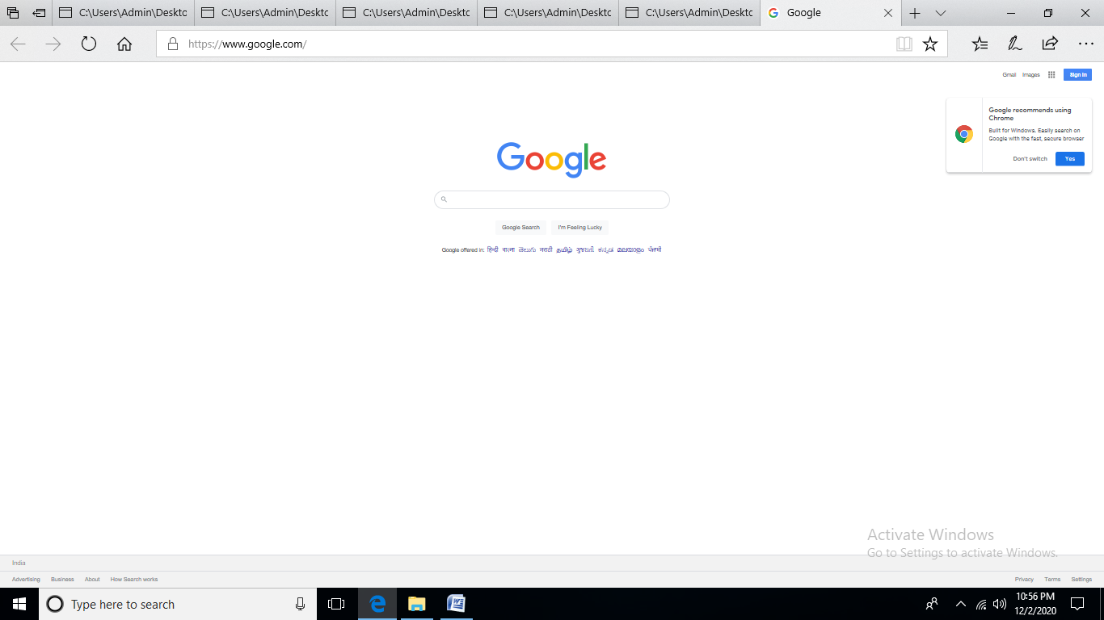

**6)Create the following Html Page using appropriate form controls**

<html>

<head>

<style>

p{

background-color:yellow;

}

</style>

</head>

<body bgcolor="#c0c0c0">

<center>

<p>The World of Fruit</p></br>

<h5> Fruit Survey</h5>

</center

<form>

<table border="0" align="center" cellpadding="6">

<tr>

<td>Name</td>

<td><input type="text" name="name1"/>

</td></tr></br>

<tr>

<td>Address</td>

<td><input type="text" name="name2"/>

</td></tr></br>

<tr>

<td>Email</td>

<td><input type="text" name="name3"/>

</td></tr></br>

<tr>

<td>how many pieces of fruit do you eat per day?</td>

<td><input type="radio" name="name1">0

<input type="radio" name="name1">1

<input type="radio" name="name1">2

<input type="radio" name="name1">More than 2

</td></tr></br>

<tr><td>My Favourite fruit</td>

<td><textarea rows="5" cols="50">Apple

Banana

Plum</textarea>

</td></tr></br>

<tr>

<td>Would you like a brochute</td>

<td><input type="checkbox" name="name1">

</td></tr>

<tr>

<td></td>

<td>

<input type="submit" name="name2"/></td></tr></br>

</table>

</body>

</html>

**OUTPUT**

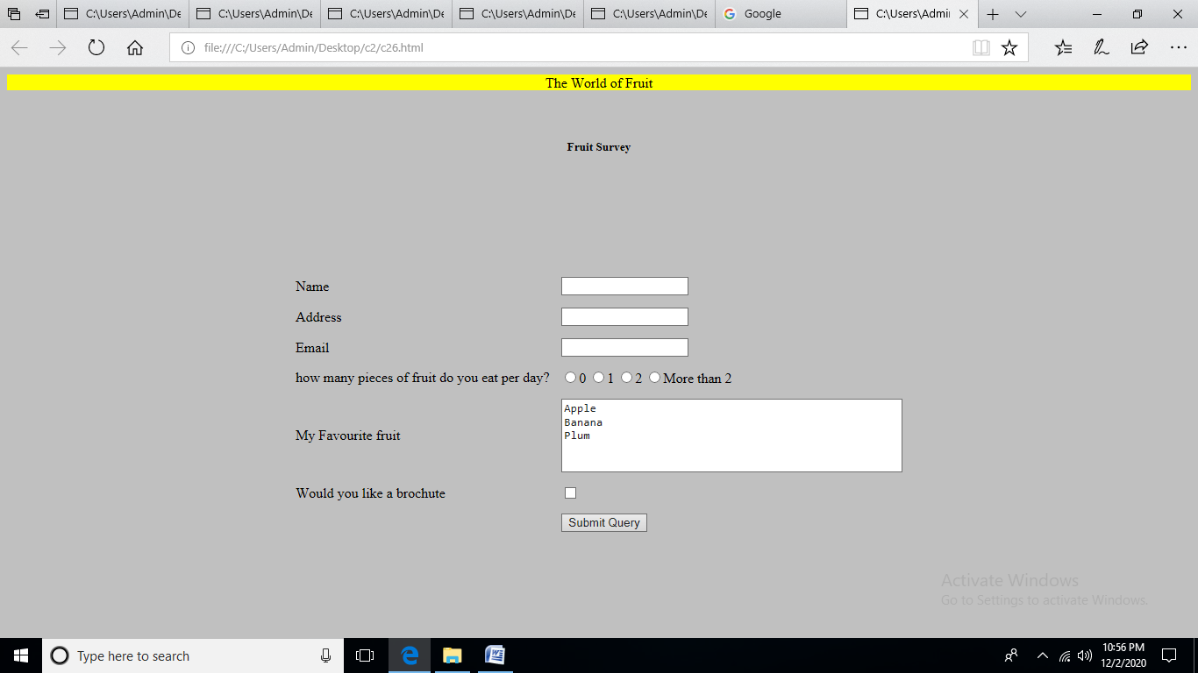

**7)Create an image map for ‘Kerala Map’. Map at least 3 districts so that when you click on that particular district the details regarding that district(eg: population, Area, Tourist Spots(with images), Monuments, Interesting Facts ) should be displayed on a new page.**

<html>

<head>

</head>

<body>

<center>

<font size="5" face="algerian">

<h1> Kerala</h1></br>

<map name="kerala">

<area shape="rect" coords="324,451,395,501" href="C:\Users\Admin\Desktop\c2\kottayam.html"/>

<area shape="rect" coords="324,451,395,501" href="C:\Users\Admin\Desktop\c2\tvm.html"/>

<area shape="rect" coords="324,451,395,501" href="C:\Users\Admin\Desktop\c2\kollam.html"/>

<img src="C:\Users\Admin\Desktop\c2\kerala.jpg" alt="kerala usemap="#kerala"/>

<p></p>

</font>

</map>

</body>

</html>

**OUTPUT**

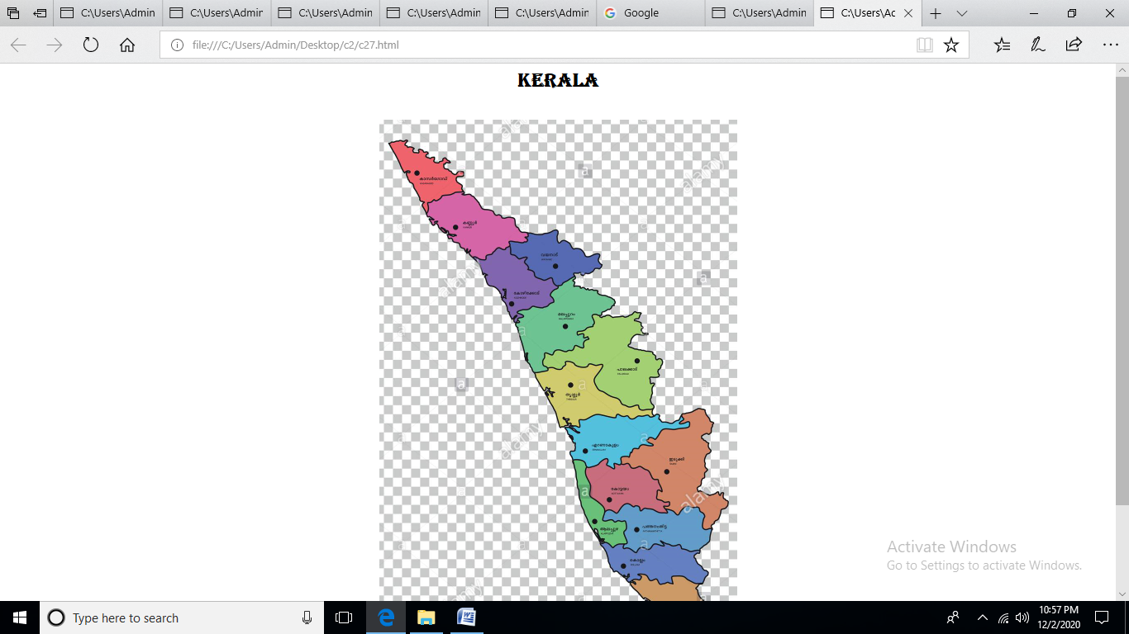

**8)Construct this puzzle looking thing**

<!DOCTYPE html>

<html>

<body>

<table border="5" cellspacing="0" align="center">

<tr>

<td colspan="3" align="center"

height="50">Top</td>

</tr>

<tr>

<td rowspan="2"align="center" height="50">

Way left

</td>

<td align="center" height="50">

middle up</td>

<td rowspan="2"align="center" height="50">

Way right

</td> </tr>

<tr>

<td align="center" height="50">

middle down

</td> </tr>

<tr>

<td colspan="3" align="center"

height="50"></td>

</tr>

</table>

</body>

</html>

**OUTPUT**

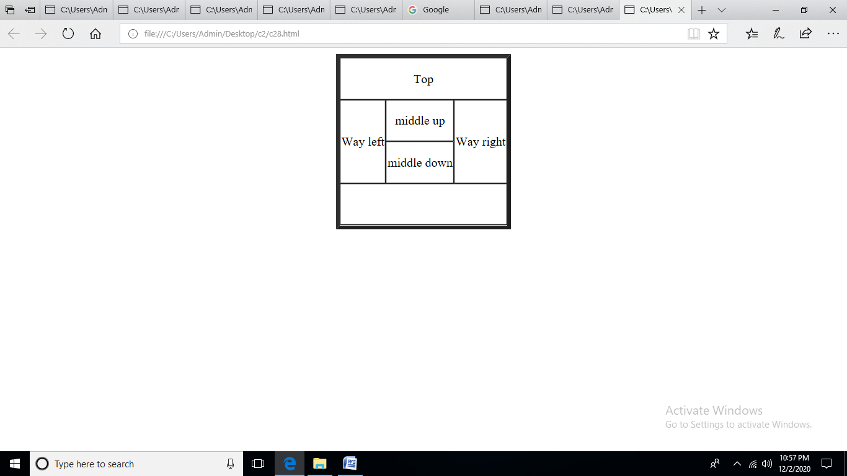

**9)Make up three image links for 3 web browsers and put them in a borderless table. Construct the table so that there is just a little space between the images.**

<html>

<head>

</head>

<body >

<center>

<table border="0">

<tr>

<td>

<a href ="https://www.google.com/" target="ia"><img src="C:\Users\Admin\Desktop\c2\g.png" alt="firefox" height="150" width="150"/>

</a></td></tr>

<tr>

<td>

<a href ="https://www.mozilla.org/en-US/firefox/new/" target="ia"><img src="C:\Users\Admin\Desktop\c2\fi.jpg" alt="firefox" height="150" width="150"/>

</a></td></tr>

<tr>

<td>

<a href ="https://in.yahoo.com/?p=us" target="ia"><img src="C:\Users\Admin\Desktop\c2\y.jpg" alt="firefox" height="150" width="150"/>

</a></td></tr>

</table

</body>

</html>

**OUTPUT**

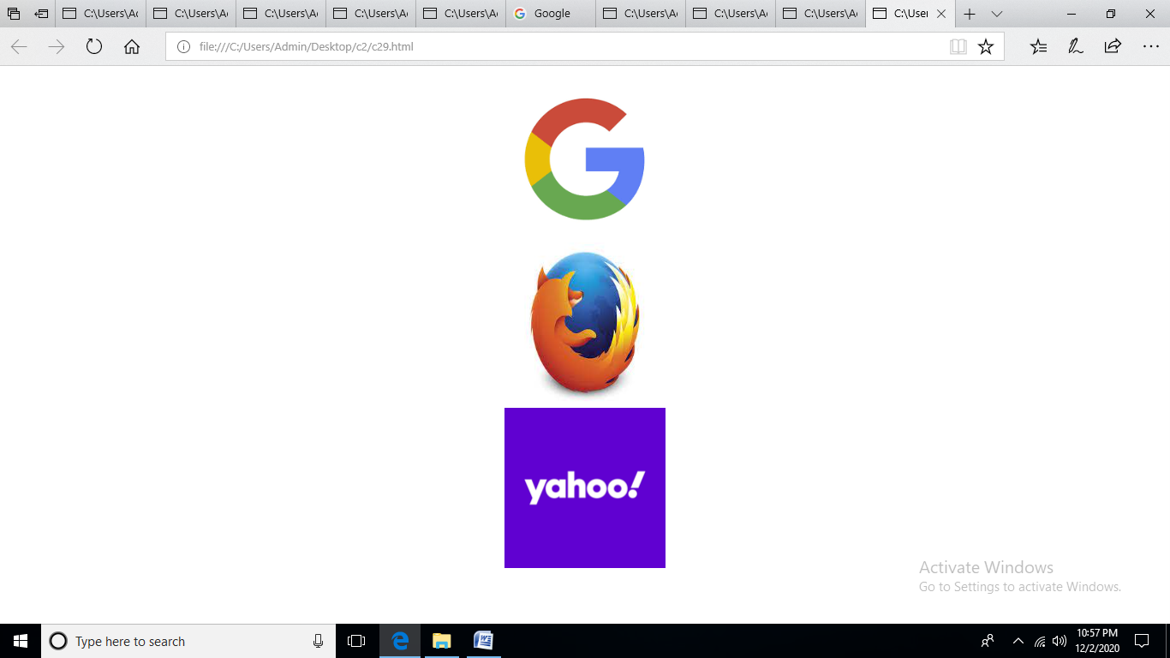

**10) Create the following html page using frames**

<html>

<head>

</head>

<body bgcolor="#c0c0c0" >

<font size="4" face="algerian" >

<h5> Kerala</h5>

<iframe src="C:\Users\Admin\Desktop\ c2\kottayam.html" height="50px" width="100%" name ="ia" ></iframe>

<iframe src="C:\Users\Admin\Desktop\c2\tvm.html" height="100px" width="100%" name ="ib" ></iframe>

<iframe src="C:\Users\Admin\Desktop\ c2\kollam.html" height="400px" width="40%" name ="ic" ></iframe>

<iframe src="C:\Users\Admin\Desktop\ c2\kollam.html" height="400px" width="40%" name ="ic" ></iframe>

</font>

</body>

</html>

**OUTPUT**

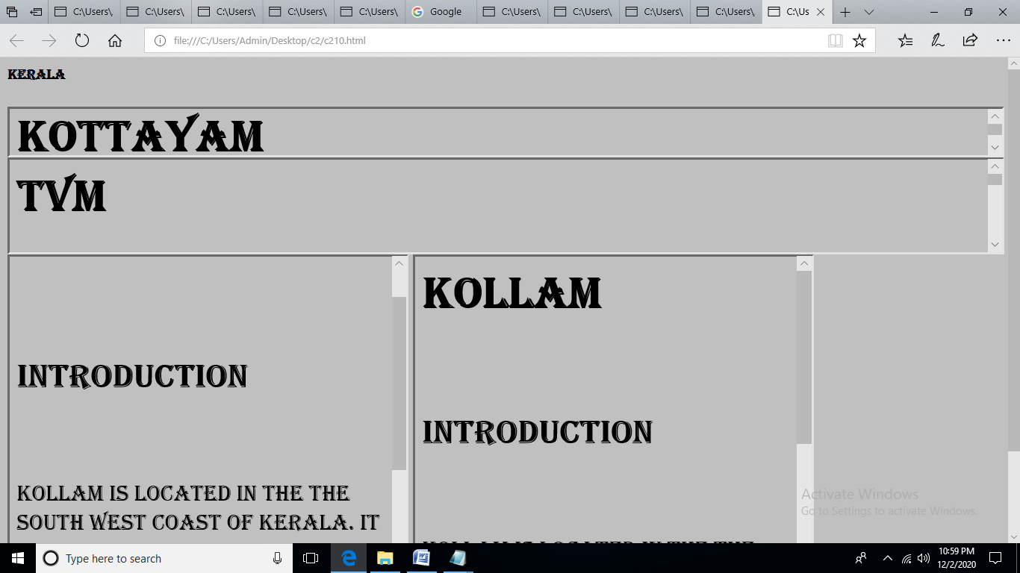

**11))Create an HTML page using frames which is similar to the following one. In the left frame provide hyperlinks to 3 important monuments in world. On clicking that hyperlink an image of the monument should be displayed in right frame with suitable description**

<html>

<head>

<title>list</title>

</head>

<frameset cols="25%,*">

<frame src="C:\Users\Admin\Desktop\c2\link.html"/>

<frame src="C:\Users\Admin\Desktop\c2\n.html" name="z"/>

</frameset>

<body>

</body>

</html>

Link

<html>

<head>

<title>index</title>

</head>

<body style="background-color:DodgerBlue;">

<form >

<center>

<h1>LIST</h1>

</center>

</br>

</br>

<ul>

<li>

<a href="C:\Users\Admin\Desktop\c2\f.html" target="z" >Fruits</a></br></li>

<li>

<a href="C:\Users\Admin\Desktop\c2\a.html" target="z">Animals</a></br></li>

<li><a href="C:\Users\Admin\Desktop\c2\b.html" target="z">Birds</a></br></li>

</ul>

</form>

</body>

</html>

N

<html>

<head>

<style>

h1{

background-color:green;

}

body {background-color: hsla(89, 43%, 51%, 0.3);}

</style>

</head>

<body>

<center>

<h1><u>Nature</u></h1>

<div id="menu" align="middle">

<p>Nature, in the broadest sense, is the natural, physical, <img src="C:\Users\Admin\Desktop\c2\n.jpg" align="right" width="140" height="150"/> or material world or universe. "Nature" can refer to the phenomena of the physical world, and also to life in general. The study of nature is a large, if not the only, part of science. Although humans are part of nature, human activity is often understood as a separate category from other natural phenomena

</p>

</body>

</html>

**OUTPUT**

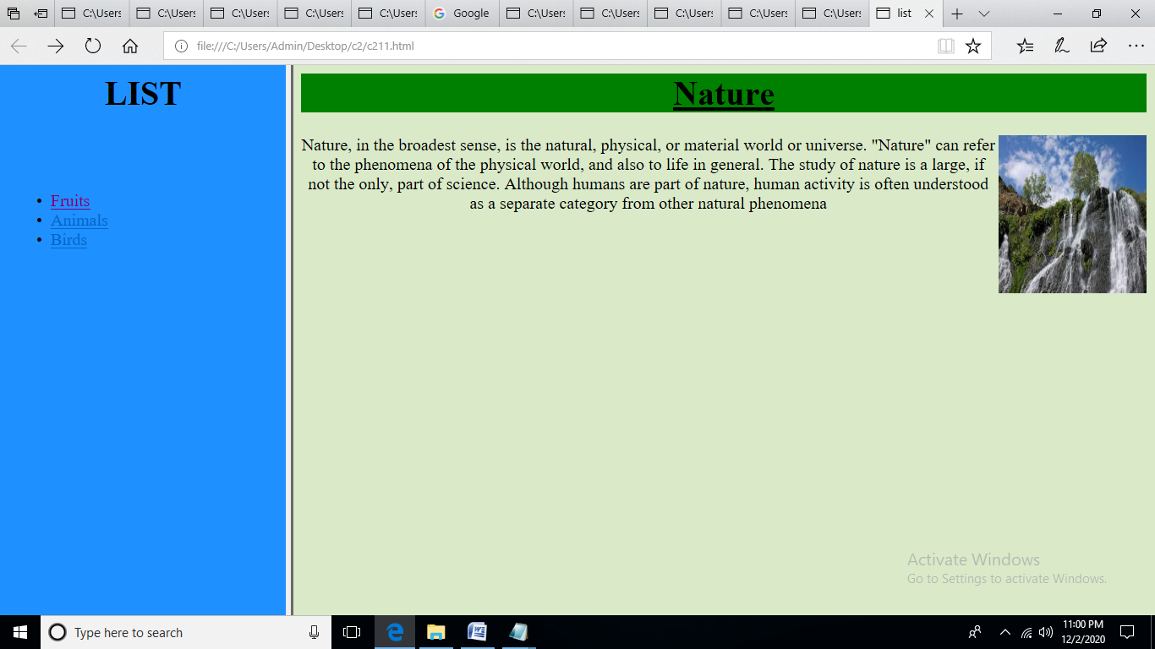

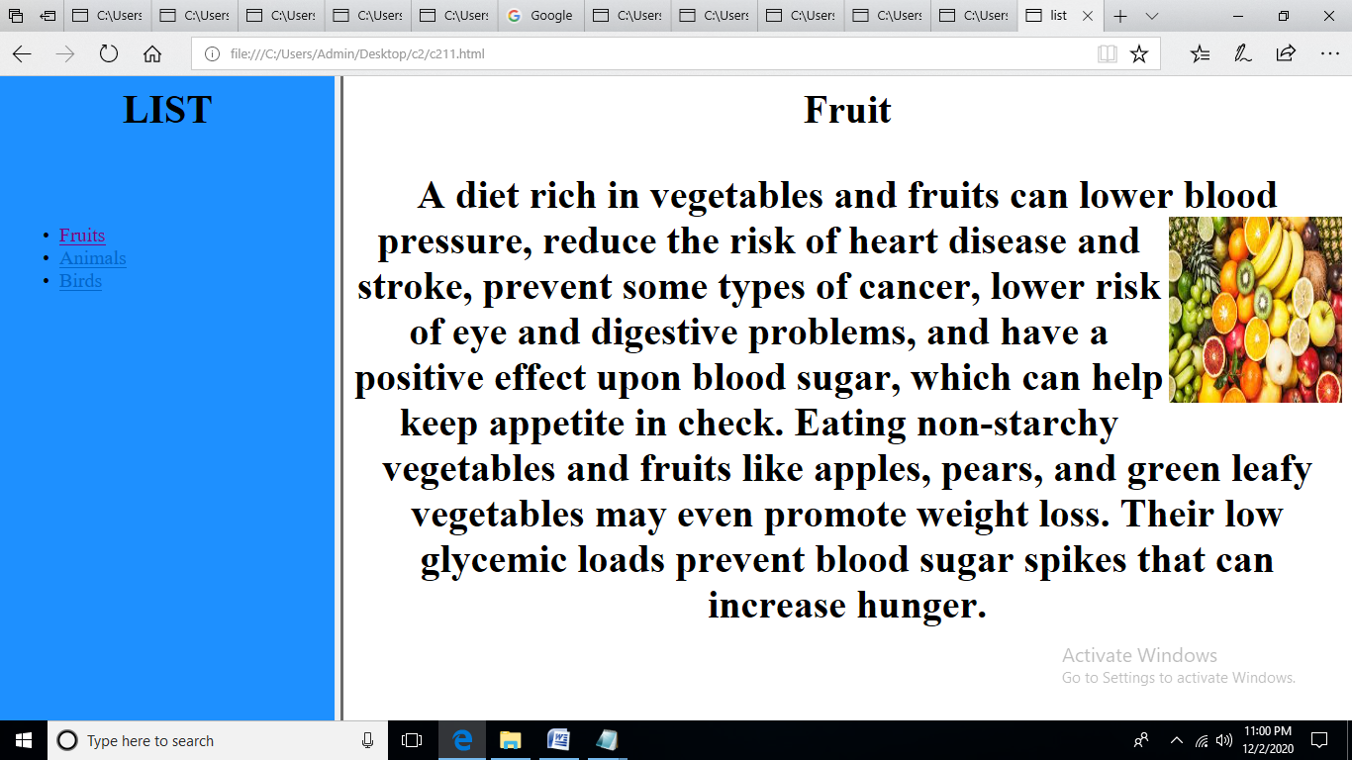

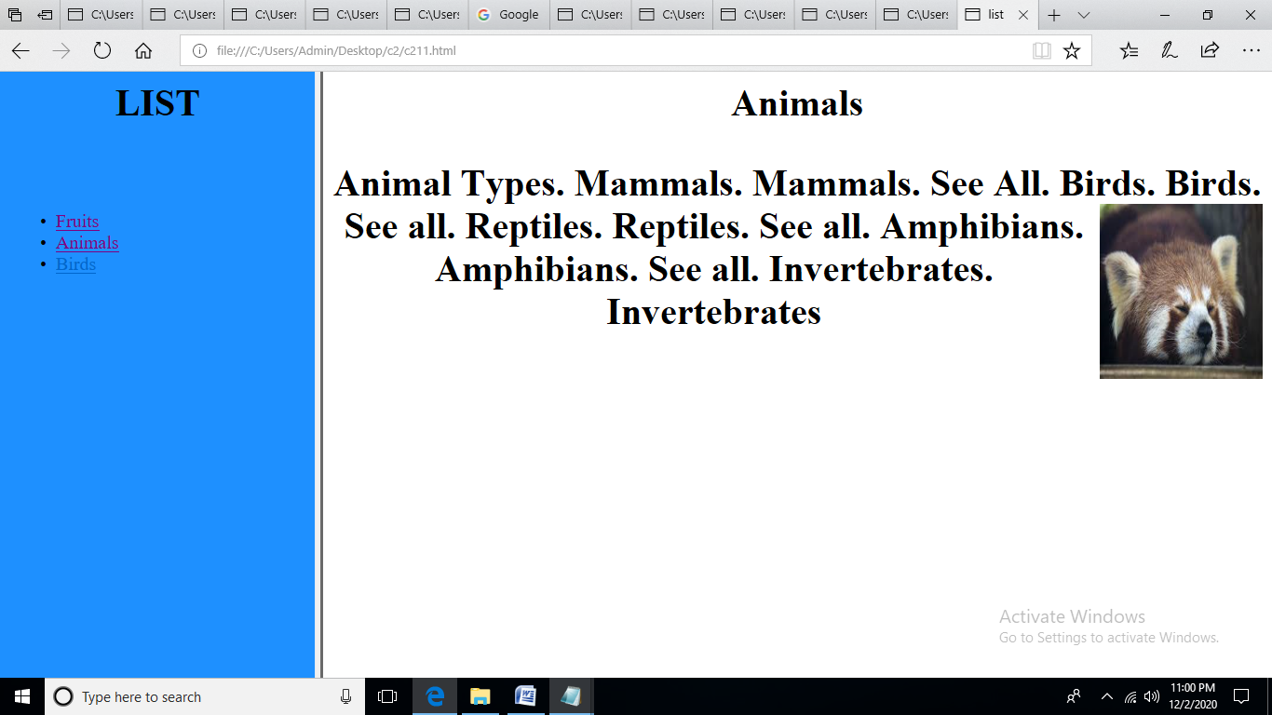

**CYCLE-3**

1. **Change the color of all <p> elements to "red".**

<html xmlns="http://www.w3.org/1999/xhtml">

<head>

<meta http-equiv="Content-Type" content="text/html; charset=utf-8" />

<title>Untitled Document</title>

<style>

p{color:red;}

</style>

</head>

<body><center>

<h1>CSS</h1></center>

<p> css stands for cascading style sheet .</p>

<h5> selector{ declaration block }</h5>

<p>selector indicates the html element</p>

</body>

</html>

**OUTPUT**

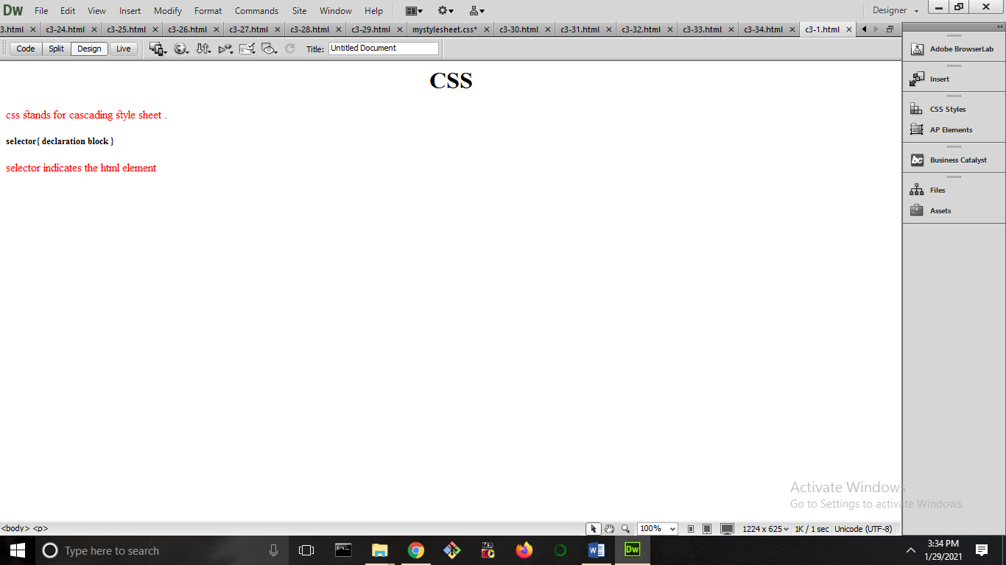

1. **Create all <p> elements will be center-aligned, with a red text color.**

<html xmlns="http://www.w3.org/1999/xhtml">

<head>

<meta http-equiv="Content-Type" content="text/html; charset=utf-8" />

<title>Untitled Document</title>

<style>

p{color:red;text-align:center;}

</style>

</head>

<body>

<h1>CSS</h1>

<p> css stands for cascading style sheet .</p>

<h5> selector{ declaration block }</h5>

<p>selector indicates the html element</p>

</body>

</html>

**OUTPUT**

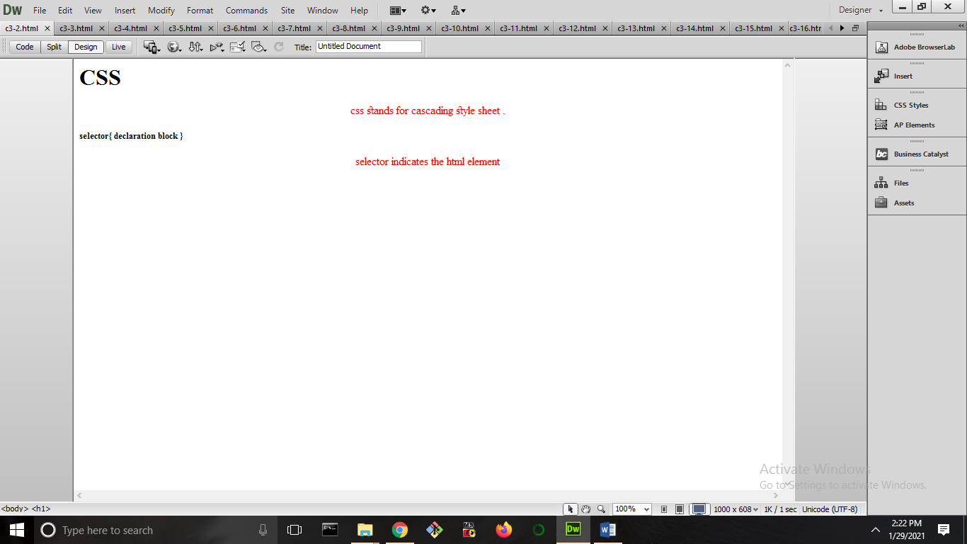

1. **Create CSS comment starts with /* and ends with */.**

<html>

<head>

<style>

/* Create CSS comment starts with and ends with */

p{color:red;text-align:center;}

</style>

</head>

<body>

<h1>CSS</h1>

<p> css stands for cascading style sheet .</p>

<h5> selector{ declaration block }</h5>

<p>selector indicates the html element</p>

</body>

</html>

**OUTPUT**

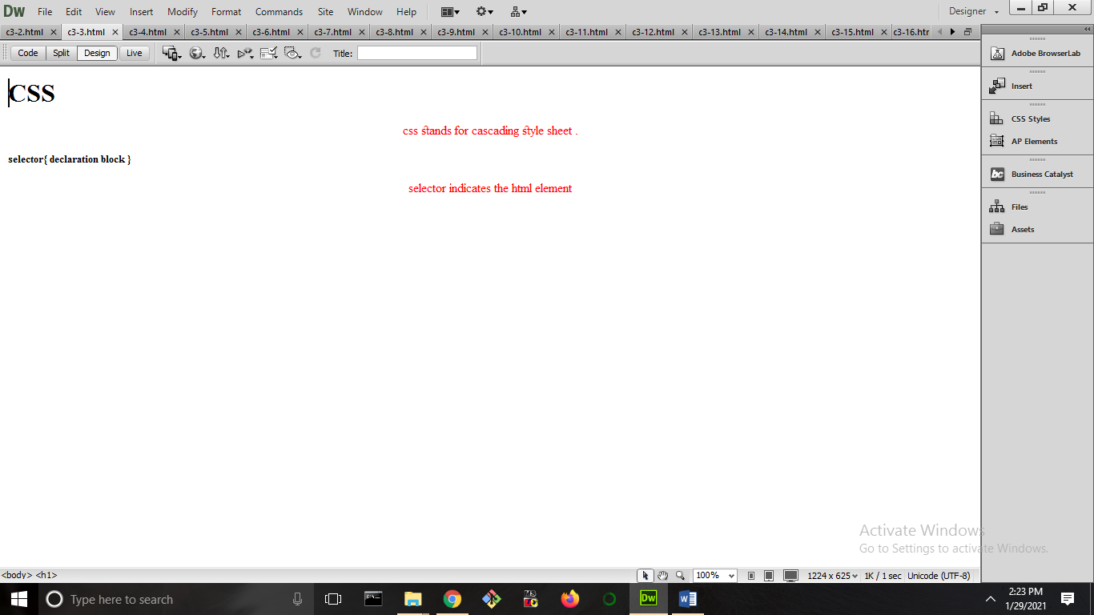

1. **Set the background color for the page to "linen" and the background color for <h1> to "lightblue".**

<html xmlns="http://www.w3.org/1999/xhtml">

<head>

<meta http-equiv="Content-Type" content="text/html; charset=utf-8" />

<title>Untitled Document</title>

<style>

body{background-color:#6FF;}

h1{background-color:#09F;}

</style>

</head>

<body><center>

<h1>CSS</h1></center>

<p> css stands for cascading style sheet .</p>

<h1> selector{ declaration block }</h1>

<p>selector indicates the html element</p>

<h1>css</h1>

</body>

</html>

**OUTPUT**

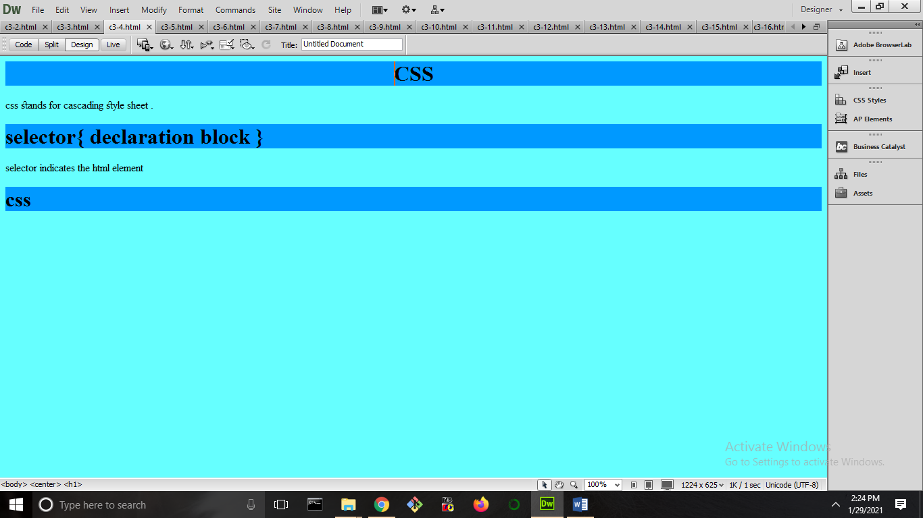

1. **Set the font family for the page to "Courier New", and the font family for <h1> to "Verdana".**

<html xmlns="http://www.w3.org/1999/xhtml">

<head>

<meta http-equiv="Content-Type" content="text/html; charset=utf-8" />

<title>Untitled Document</title>

<style>

body{font-family:Courier New;}

h1{font-family:Verdana;}

</style>

</head>

<body><center>

<h1>CSS</h1></center>

<p> css stands for cascading style sheet .</p>

<h1> selector{ declaration block }</h1>

<p>selector indicates the html element</p>

<h1>css</h1>

<h1>Set the font family for the page to "Courier New", and the font family for to "Verdana".</h1>

</body>

</html>

**OUTPUT**

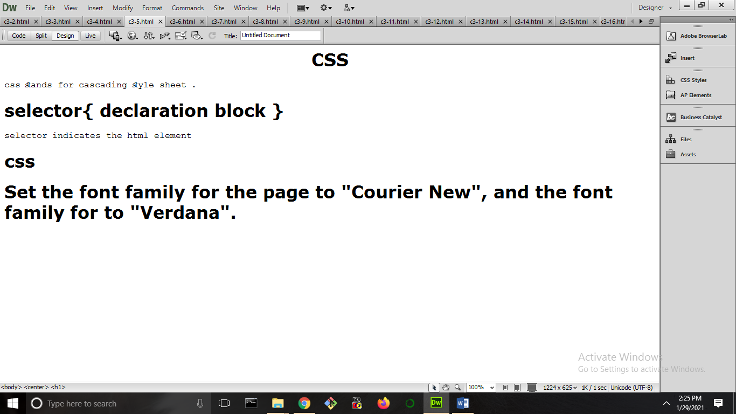

1. **Change the color of all <p> and <h1> elements, to "red". Group the selectors to minimize code.**

<html xmlns="http://www.w3.org/1999/xhtml">

<head>

<meta http-equiv="Content-Type" content="text/html; charset=utf-8" />

<title>Untitled Document</title>

<style>

h1,p{color:red;}

</style>

</head>

<body><center>

<h1>CSS</h1></center>

<p> css stands for cascading style sheet .</p>

<h1> selector{ declaration block }</h1>

<p>selector indicates the html element</p>

<h5> Change the color of all and elements, to "red". Group the selectors to minimize code.</h5>

<h1>css</h1>

<h4>Set the font family for the page to "Courier New", and the font family for to "Verdana".</h4>

</body>

</html>

**OUTPUT**

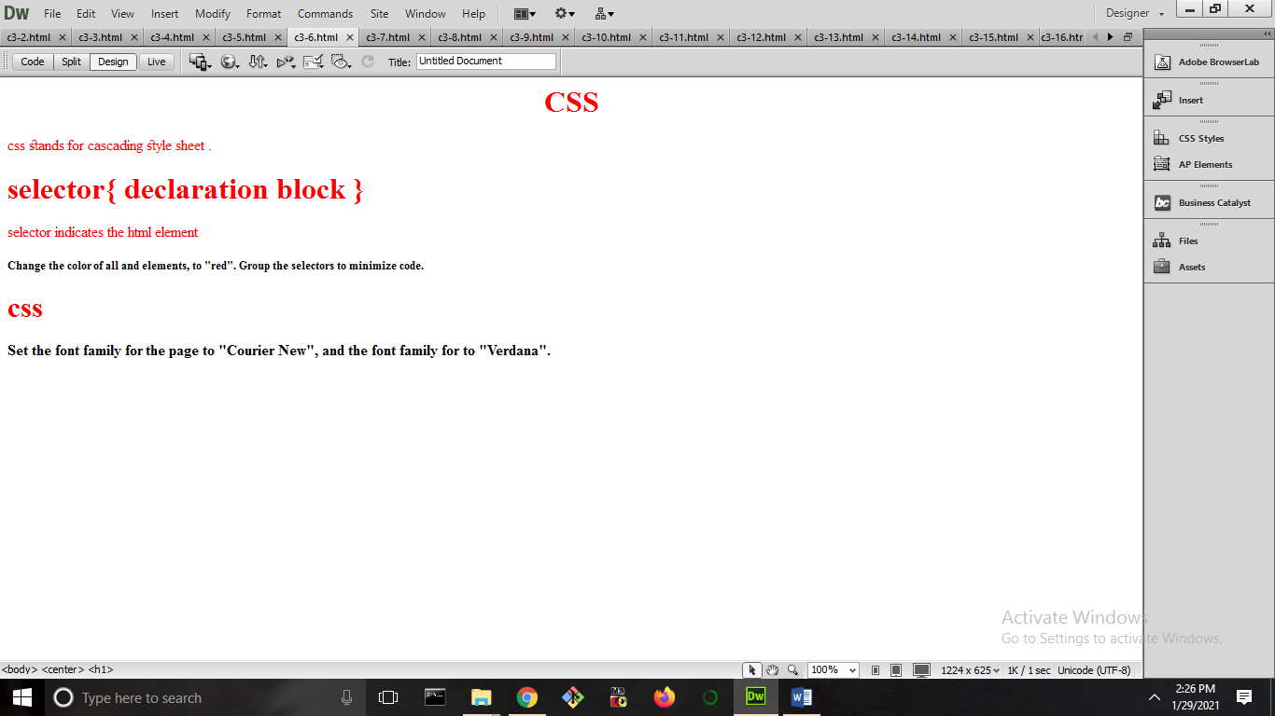

1. **Specify that the background image should be shown once, in the top right corner.**

<!DOCTYPE html PUBLIC "-//W3C//DTD XHTML 1.0 Transitional//EN" "http://www.w3.org/TR/xhtml1/DTD/xhtml1-transitional.dtd">

<html xmlns="http://www.w3.org/1999/xhtml">

<head>

<meta http-equiv="Content-Type" content="text/html; charset=utf-8" />

<title>Untitled Document</title>

<style>

body{background-image:url("https://cdn.pixabay.com/photo/2015/04/19/08/33/flower-729512__340.jpg");

background-repeat:no-repeat;

background-position:1500px;}

</style>

</head>

<body>

<p>A rose is a woody perennial flowering plant of the genus Rosa, in the family Rosaceae, or the flower it bears.</p>

<p> There are over three hundred species and tens of thousands of cultivars. </p>

<p>They form a group of plants that can be erect shrubs, climbing, or trailing, with stems that are often armed<br> with sharp prickles.</p>

</body>

</html>

**OUTPUT**

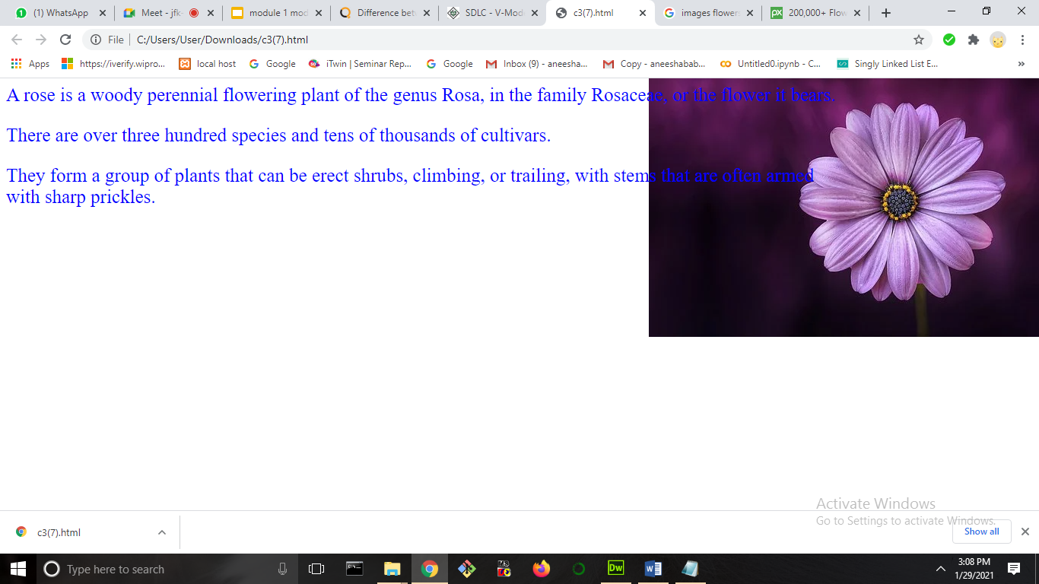

1. **With the font property: Set the <p> to "italic", "20px" and "Verdana".**

<html xmlns="http://www.w3.org/1999/xhtml">

<head>

<meta http-equiv="Content-Type" content="text/html; charset=utf-8" />

<title>Untitled Document</title>

<style>

p{font-style:italic;

font-family:Verdana;

font-size:20px;}

</style>

</head>

<body><center>

<h1>CSS</h1></center>

<p> css stands for cascading style sheet .</p>

<h5> selector{ declaration block }</h5>

<p>With the font property: Set the to "italic", "20px" and "Verdana".</p>

</body>

</html>

**OUTPUT**

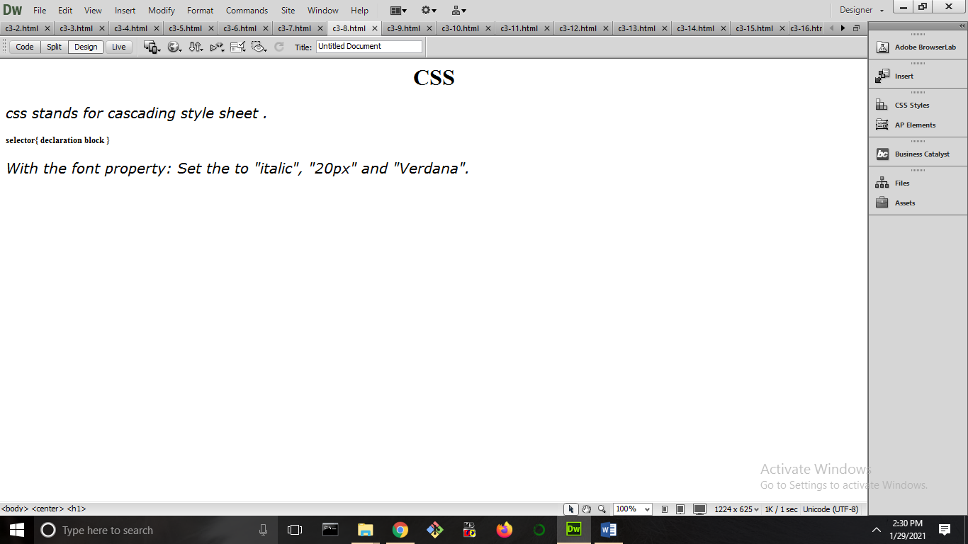

1. **Set " gif image" as the background image of the page**

<html xmlns="http://www.w3.org/1999/xhtml">

<head>

<meta http-equiv="Content-Type" content="text/html; charset=utf-8" />

<title>Untitled Document</title>

<style>

body{background-image:url(demo.gif);

background-repeat:no-repeat;

}

</style>

</head>

<body>

</body>

</html>

**OUTPUT**

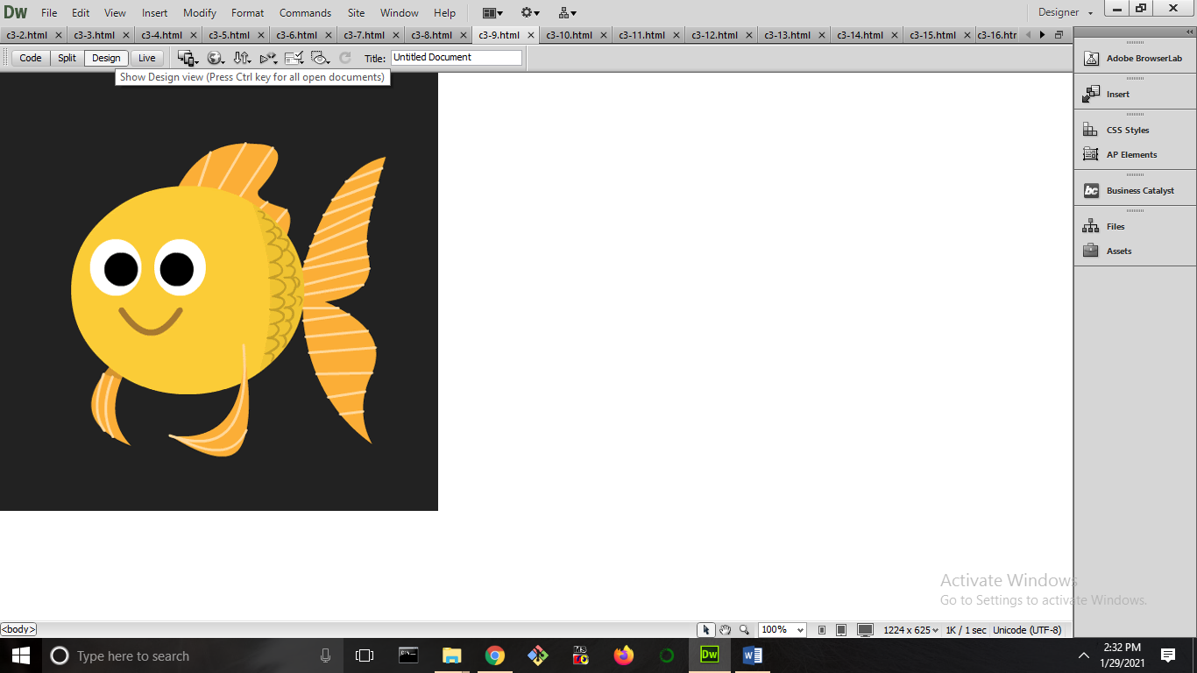

1. **Set " png image" as the background image of the page, and repeat it vertically only.**

<html xmlns="http://www.w3.org/1999/xhtml">

<head>

<meta http-equiv="Content-Type" content="text/html; charset=utf-8" />

<title>Untitled Document</title>

<style>

body{background-image:url(123.png);

background-repeat:repeat-y;

background-position:1000px;}

</style>

</head>

<body>

<h1>Set " png image" as the background image of the page, and repeat it vertically only.</h1>

</body>

</html>

**OUTPUT**

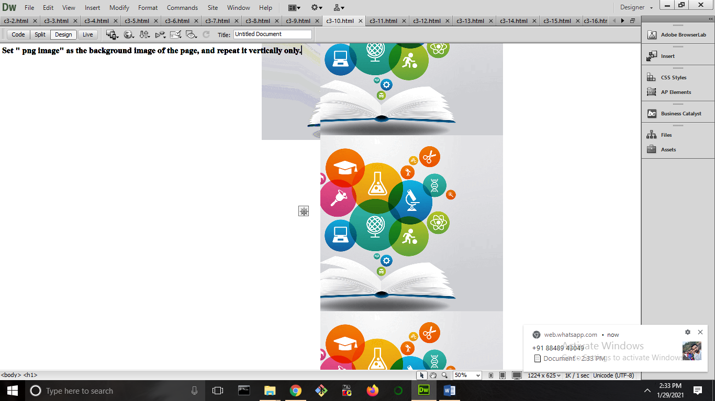

1. **Indent the first line of the <p> element with 20px.**

<html xmlns="http://www.w3.org/1999/xhtml">

<head>

<meta http-equiv="Content-Type" content="text/html; charset=utf-8" />

<title>Untitled Document</title>

<style>

#p1{font-size:20px;}

</style>

</head>

<body>

<p id="p1">the id selector</p><p>a id is always unique within the page so it is chosen to select a single</p>

</body>

</html>

**OUTPUT**

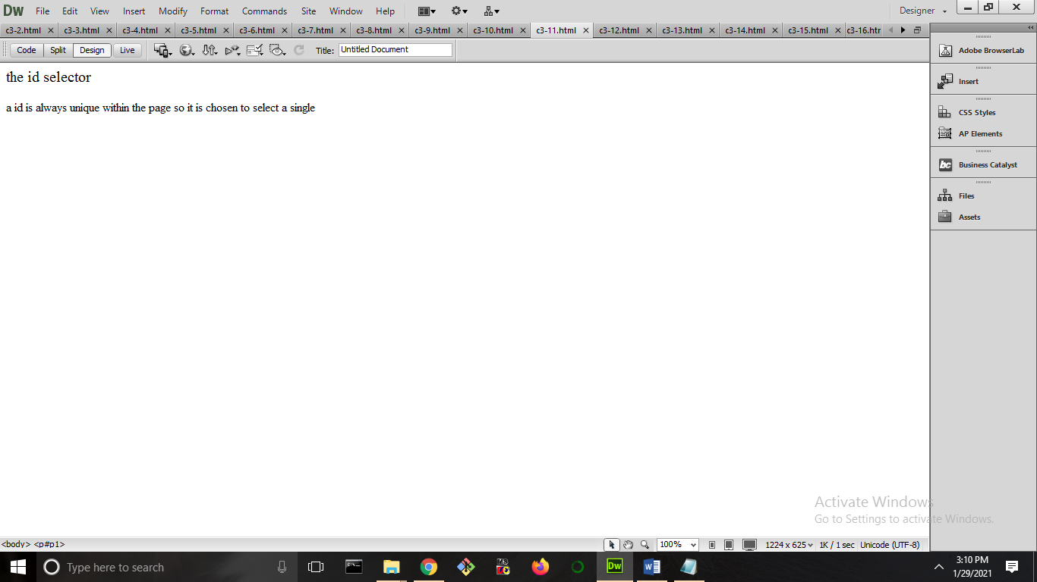

1. **Set the color for links to "green".**

<html xmlns="http://www.w3.org/1999/xhtml">

<head>

<meta http-equiv="Content-Type" content="text/html; charset=utf-8" />

<title>Untitled Document</title>

</head>

<body bgcolor="#FFFF99" link="#33CC00">

<p>the id selector</p>

<a href="##">ID SELECTOR</a><br />

<p>a id is always unique within the page so it is chosen to select a single</p><a href="##">MOVE</a>

</body>

</html>

**OUTPUT**

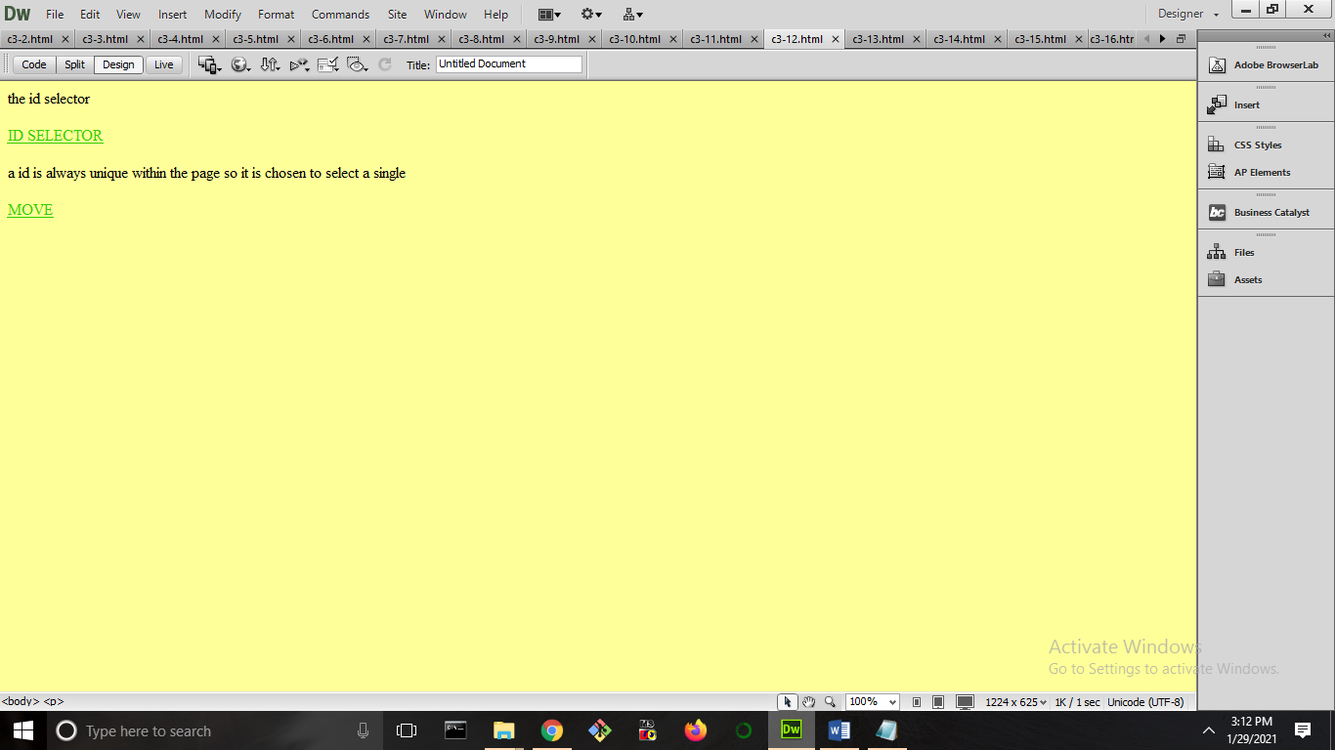

1. **Show <p> elements as "italic" text**.

<html xmlns="http://www.w3.org/1999/xhtml">

<head>

<meta http-equiv="Content-Type" content="text/html; charset=utf-8" />

<title>Untitled Document</title>

<style>

p{font-style:italic;}

</style>

</head>

<body><center>

<h1>CSS</h1></center>

<p> css stands for cascading style sheet .</p>

<h5> selector{ declaration block }</h5>

<p>With the font property: Set the to "italic"</p>

<h5>Paragraphs are usually represented in visual media as blocks of text separated from adjacent blocks by blank lines and/or first-line indentation, but HTML paragraphs can be any structural grouping of related content, such as images or form fields.Dec 18</h5>

</body>

</html>

**OUTPUT**

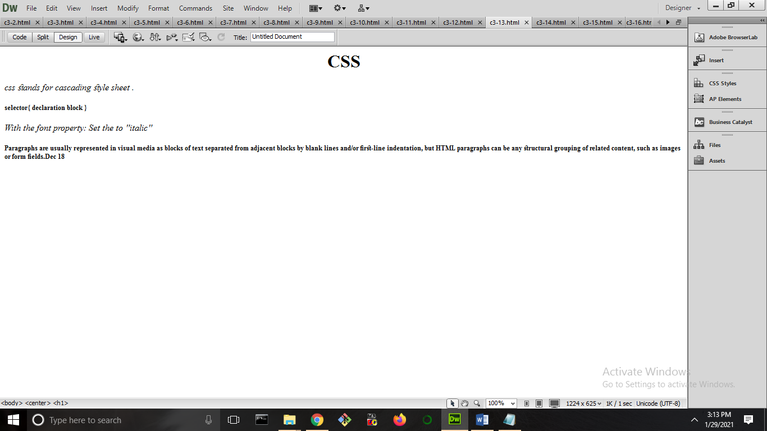

1. **Change the color of the element with id="para1", to "red".**

<html xmlns="http://www.w3.org/1999/xhtml">

<head>

<meta http-equiv="Content-Type" content="text/html; charset=utf-8" />

<title>Untitled Document</title>

<style>

#para1{color:#F03;text-align:center;}

</style>

</head>

<body>

<p> css stands for cascading style sheet .</p>

<p id="para1">With the font property: Set the color to "red"</p>

<p>Paragraphs are usually represented in visual media as blocks of text separated from adjacent blocks by blank lines and/or first-line indentation, but HTML paragraphs can be any structural grouping of related content, such as images or form fields.Dec 18</p>

</body>

</html>

**OUTPUT**

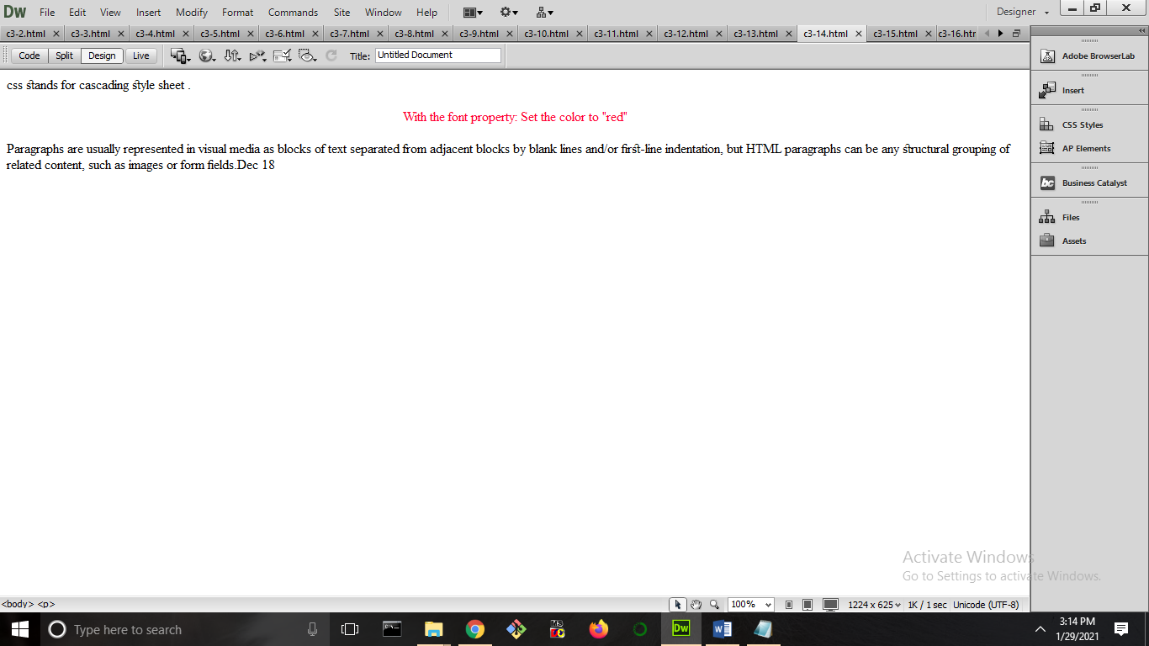

1. **Change the color of all elements with the class "colortext", to "red".**

<html xmlns="http://www.w3.org/1999/xhtml">

<head>

<meta http-equiv="Content-Type" content="text/html; charset=utf-8" />

<title>Untitled Document</title>

<style>

.center{color:#F30;text-align:center;}

</style>

</head>

<body>

<p class="center">With the font property: Set the color to "red"</br>

Paragraphs are usually represented in visual media as blocks of text separated from adjacent blocks by blank lines and/or first-line indentation, but HTML paragraphs can be any structural grouping of related content, such as images or form fields.Dec 18</p>

</body>

</html>

**OUTPUT**

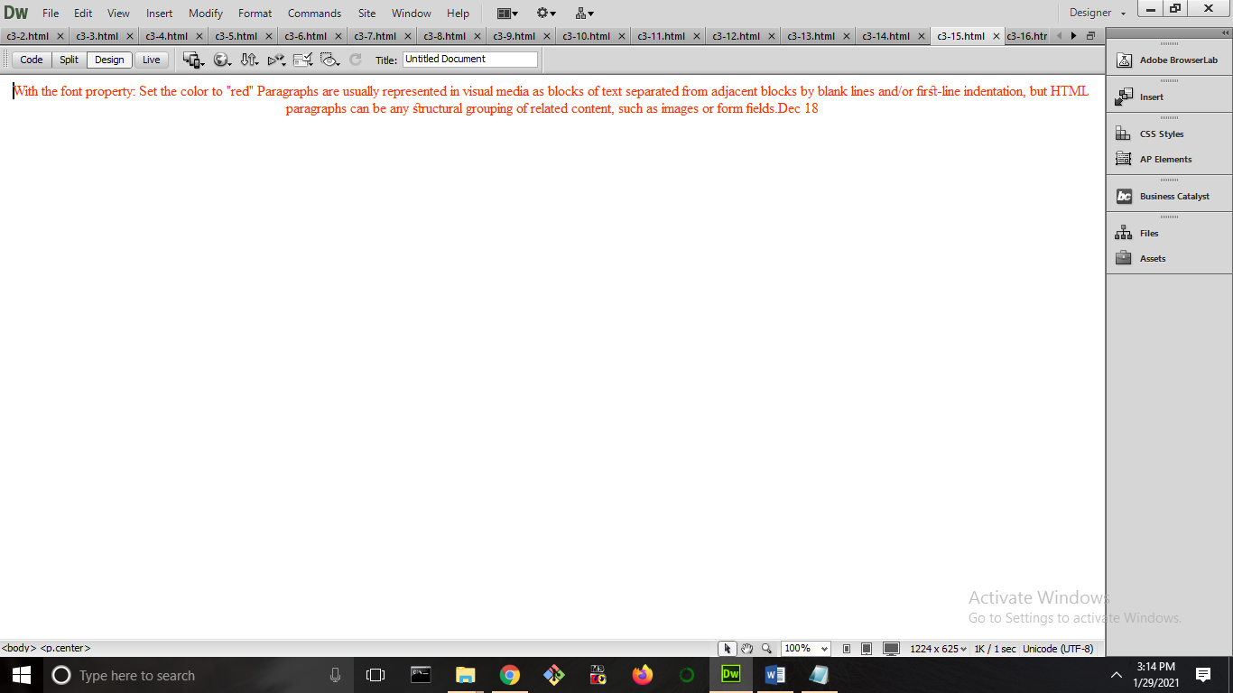

1. **Show <p> elements as "bold" text.**

<html xmlns="http://www.w3.org/1999/xhtml">

<head>

<meta http-equiv="Content-Type" content="text/html; charset=utf-8" />

<title>Untitled Document</title>

<style>

p{font-weight:bold;}

</style>

</head>

<body><center>

<h1>CSS</h1></center>

<p> css stands for cascading style sheet .</p>

<p> selector{ declaration block }</p>

<p>With the font property: Set the to "italic"</p>

<p>Paragraphs are usually represented in visual media as blocks of text separated from adjacent blocks by blank lines and/or first-line indentation, but HTML paragraphs can be any structural grouping of related content, such as images or form fields.Dec 18</p>

</body>

</html>

**OUTPUT**

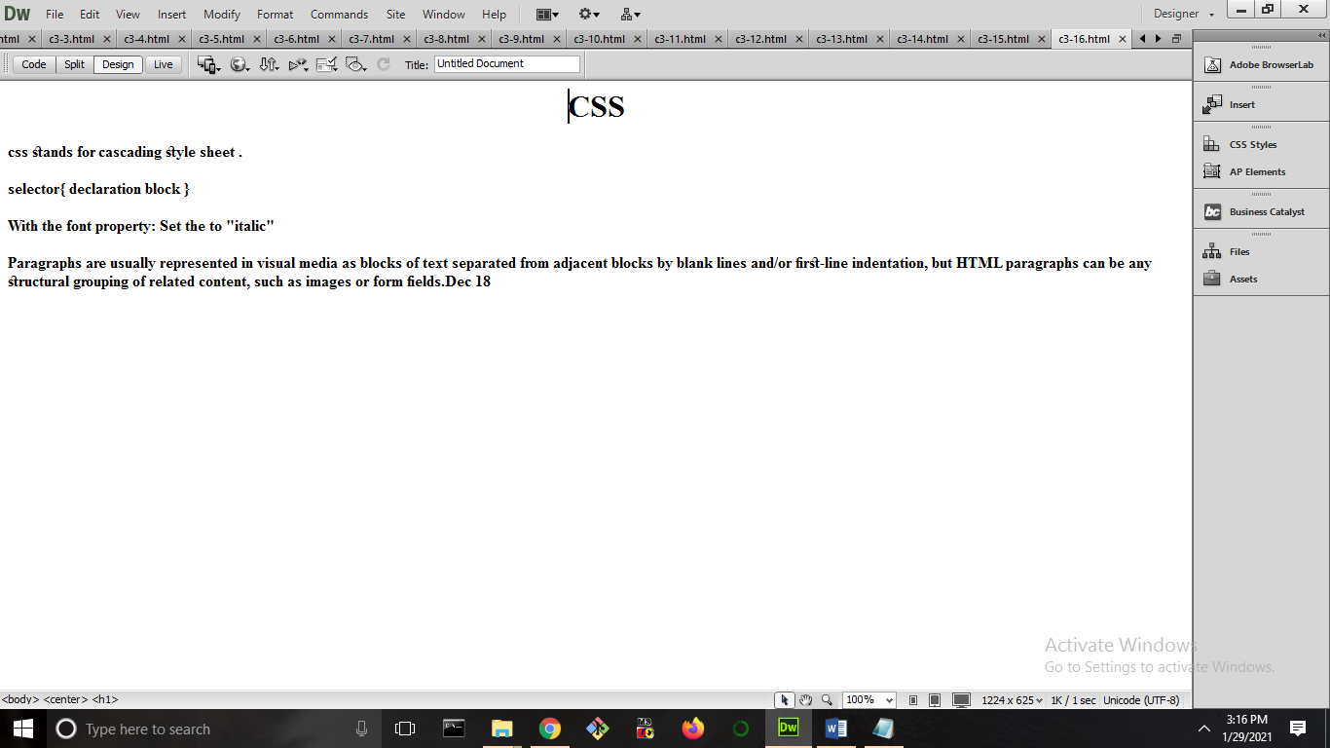

1. **Add an external style sheet with the URL: "mystyle.css".**

<html xmlns="http://www.w3.org/1999/xhtml">

<head>

<meta http-equiv="Content-Type" content="text/html; charset=utf-8" />

<title>Untitled Document</title>

<link rel="stylesheet" type="text/css" href="mystylesheet.css" />

</head>

<body>

<h1>CSS</h1>

<p> css stands for cascading style sheet .</p>

<p> selector{ declaration block }</p>

<p>With the font property: Set the to "italic"</p>

<p>Paragraphs are usually represented in visual media as blocks of text separated from adjacent blocks by blank lines and/or first-line indentation, but HTML paragraphs can be any structural grouping of related content, such as images or form fields.Dec 18</p>

</body>

</html>

**OUTPUT**

CSS

body

{background-color:green;

}

p{color:red;text-align:center;}

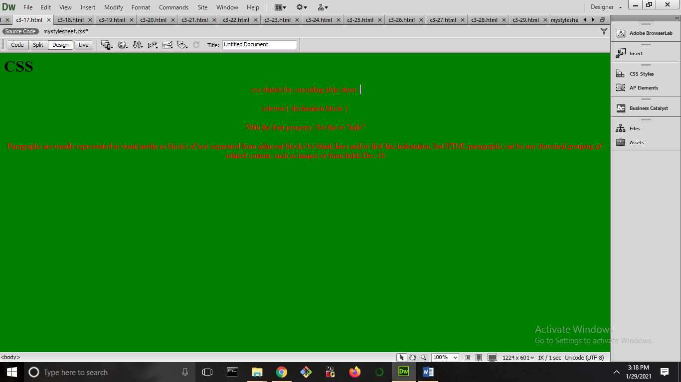

1. **Set the font size for the page to "20px", and the font size for <h1> to "3em".**

<html xmlns="http://www.w3.org/1999/xhtml">

<head>

<meta http-equiv="Content-Type" content="text/html; charset=utf-8" />

<title>Untitled Document</title>

<style>

h1{font-size:16px;}

</style>

</head>

<body>

<font size="20">

<h1>css</h1>

<p>the id selector</p><p>a id is always unique within the page so it is chosen to select a single</p>

<h1>Paragraphs are usually represented in visual media as blocks of text separated from adjacent blocks by blank lines and/or first-line indentation</h1>

</body></font>

</html>

**OUTPUT**

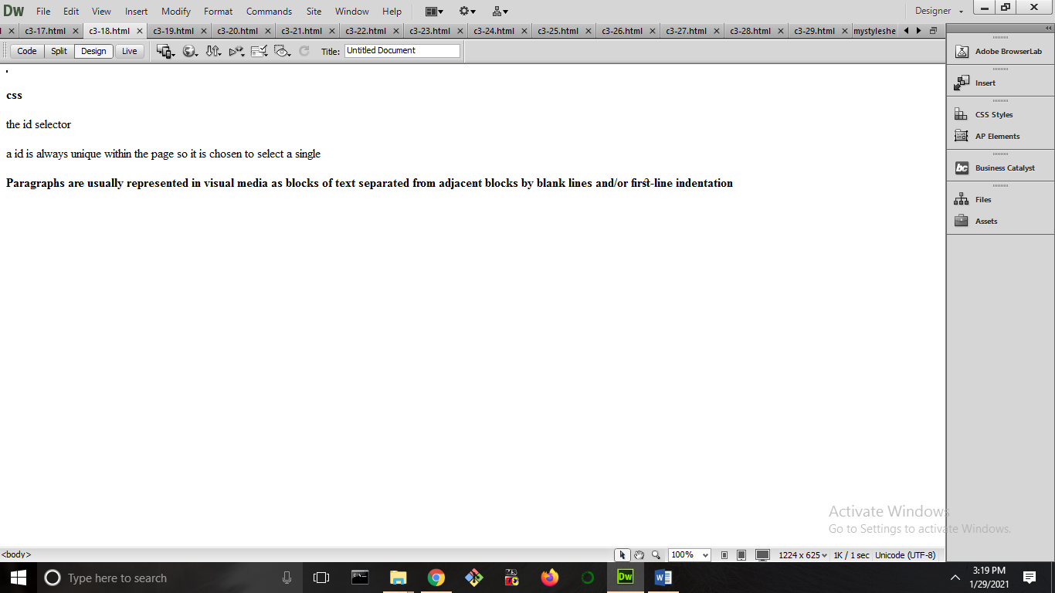

1. **Set "background-color: linen" for the page, using an internal style sheet.**

<html xmlns="http://www.w3.org/1999/xhtml">

<head>

<meta http-equiv="Content-Type" content="text/html; charset=utf-8" />

<title>Untitled Document</title>

<style>

body{background-color:linen;}

</style>

</head>

<body>

<h1>css</h1>

<p>19. Set "background-color: linen" for the page, using an internal style sheet</p><p>a id is always unique within the page so it is chosen to select a single</p>

<h1>Paragraphs are usually represented in visual media as blocks of text separated from adjacent blocks by blank lines and/or first-line indentation</h1>

</body>

</html>

**OUTPUT**

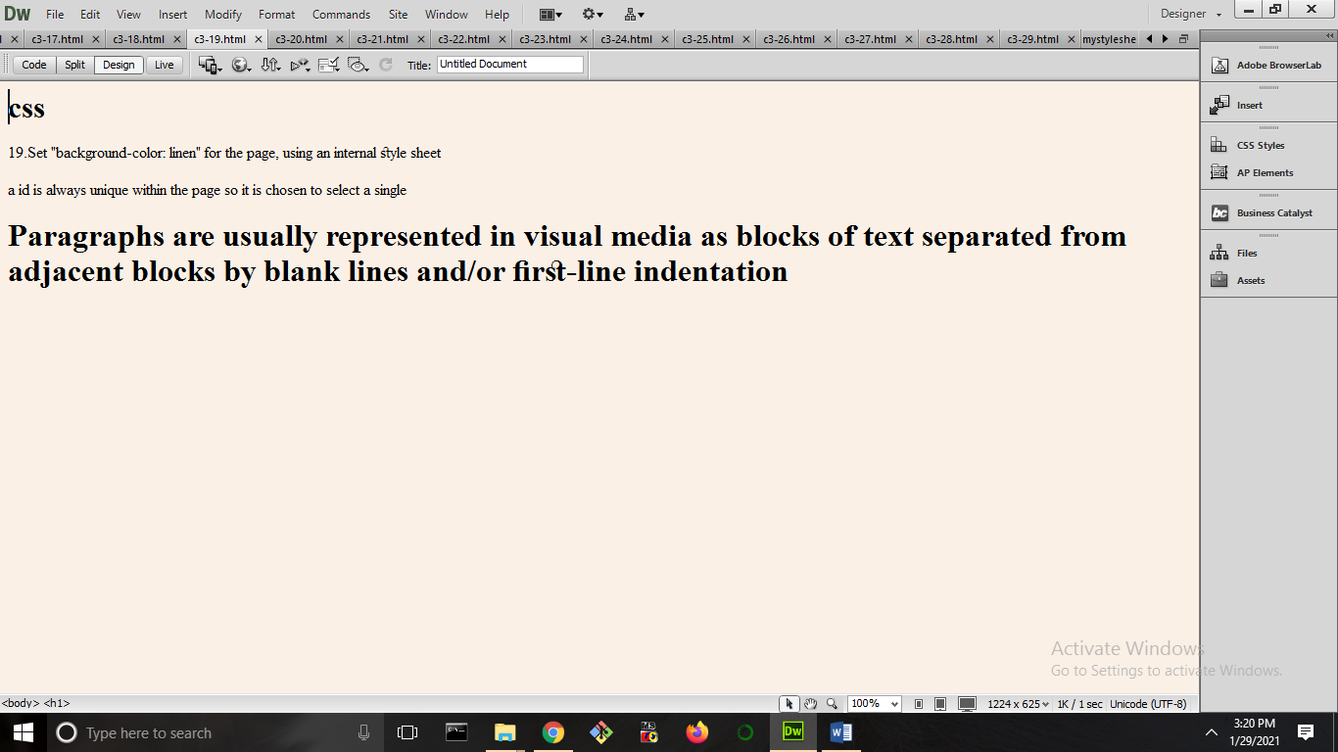

1. **Set "background-color: linen" for the page, using an inline style.**

<html xmlns="http://www.w3.org/1999/xhtml">

<head>

<meta http-equiv="Content-Type" content="text/html; charset=utf-8" />

<title>Untitled Document</title>

</head>

<body style="background-color:linen;">

<p>19. Set "background-color: linen" for the page, using an internal style sheet</p><p>a id is always unique within the page so it is chosen to select a single</p>

<p>Paragraphs are usually represented in visual media as blocks of text separated from adjacent blocks by blank lines and/or first-line indentation</p>

</body>

</html>

**OUTPUT**

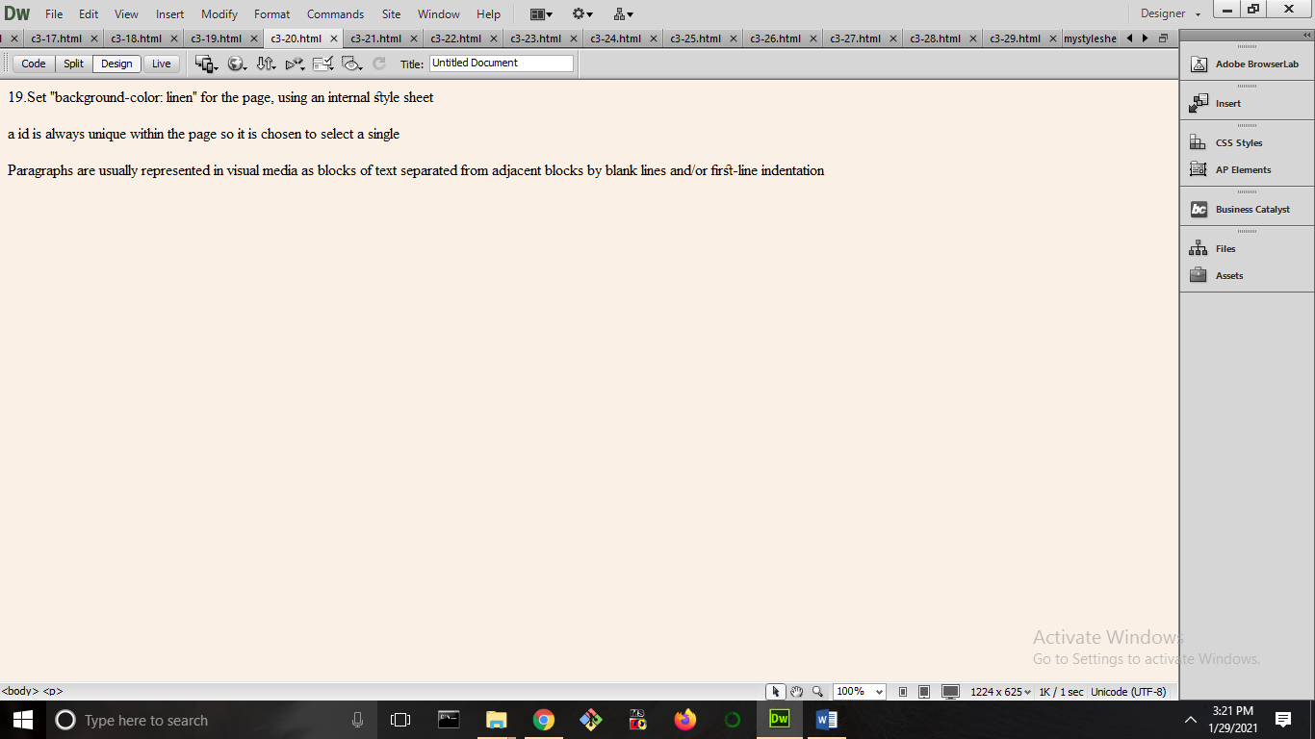

1. **Set the text color for the page to "red", and the text color for <h1> to "blue".**

<html xmlns="http://www.w3.org/1999/xhtml">

<head>

<meta http-equiv="Content-Type" content="text/html; charset=utf-8" />

<title>Untitled Document</title>

<style>

h1{color:blue;}

</style>

</head>

<body style="color:red;">

<p>19. Set "background-color: linen" for the page, using an internal style sheet</p><p>a id is always unique within the page so it is chosen to select a single</p>

<h1>Paragraphs are usually represented in visual media as blocks of text separated from adjacent blocks by blank lines and/or first-line indentation</h1>

</body>

</html>

**OUTPUT**

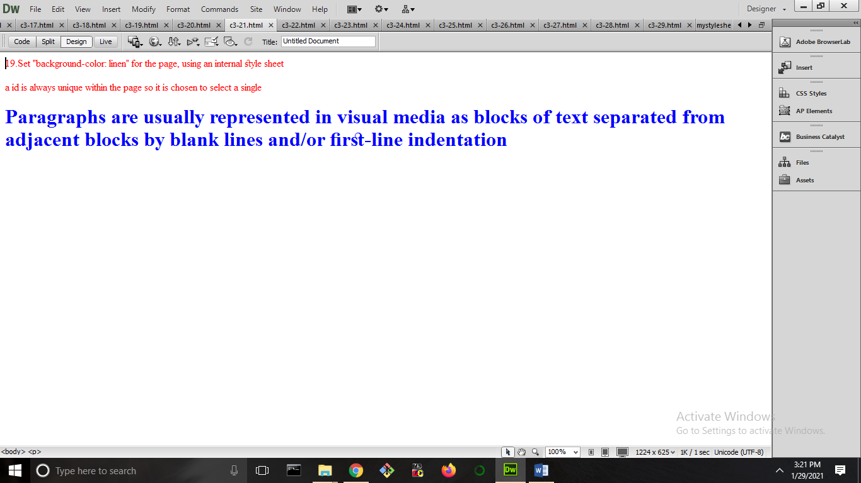

1. **Center align the <h1> element.**

<html xmlns="http://www.w3.org/1999/xhtml">

<head>

<meta http-equiv="Content-Type" content="text/html; charset=utf-8" />

<title>Untitled Document</title>

<style>

h1{text-align:center;}

</style>

</head>

<body>

<p>19. Set "background-color: linen" for the page, using an internal style sheet</p>

<h1>Paragraphs are usually represented in visual media as blocks of text separated from adjacent blocks by blank lines and/or first-line indentation</h1>

<p>a id is always unique within the page so it is chosen to select a single</p>

</body>

</html>

**OUTPUT**

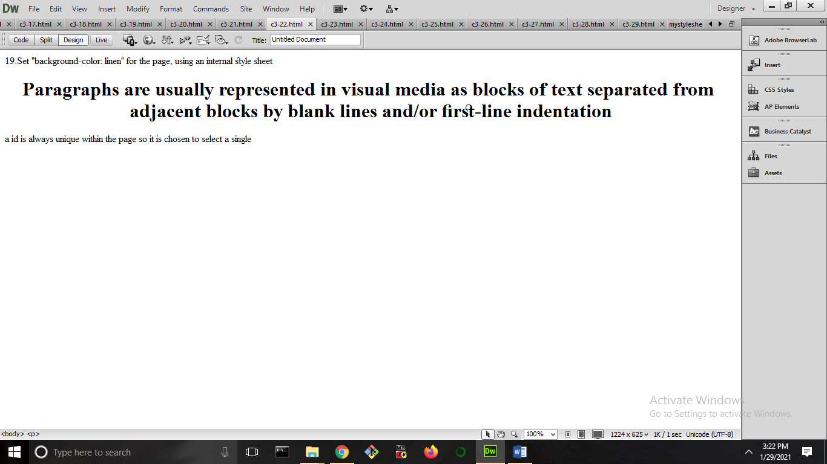

1. **Remove the underline from the link.**

<html xmlns="http://www.w3.org/1999/xhtml">

<head>

<meta http-equiv="Content-Type" content="text/html; charset=utf-8" />

<title>Untitled Document</title>

<style>

a{text-decoration:none;}

</style>

</head>

<body>

<p>19. Set "background-color: linen" for the page, using an internal style sheet</p><a href="#9099"> CSS</a><p>Paragraphs are usually represented in visual media as blocks of text separated from adjacent blocks by blank lines and/or first-line indentation</p>

<p>a id is always unique within the page so it is chosen to select a single</p><a href="#777">move</a>

</body>

</html>

**OUTPUT**

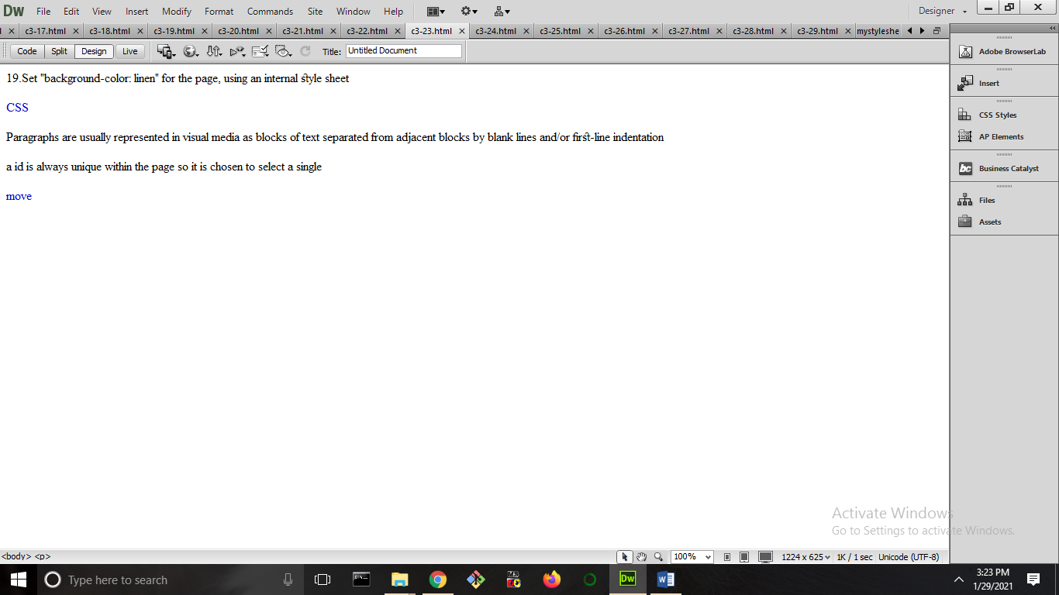

1. **Use the padding property to set the top and bottom paddings for <p> to "25px", and left and right paddings to "50px".**

<html xmlns="http://www.w3.org/1999/xhtml">

<head>

<meta http-equiv="Content-Type" content="text/html; charset=utf-8" />

<title>Untitled Document</title>

</head>

<body>

<table cellpadding="25px" cellspacing="50px">

<tr>

<th>roll number</th>

<th>name</th>

</tr>

<tr>

<td>1</td>

<td>2</td>

</tr>

<tr>

<td>anu</td>

<td>aneesha</td>

</tr>

</table>

</body>

</html>

**OUTPUT**

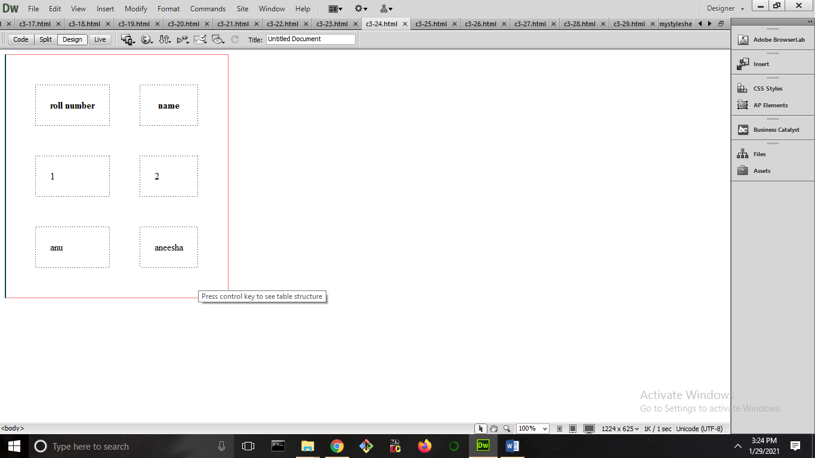

1. **Style text in <h1> to uppercase letters, and text in <p> to capitalized letters.**

<html xmlns="http://www.w3.org/1999/xhtml">

<head>

<meta http-equiv="Content-Type" content="text/html; charset=utf-8" />

<title>Untitled Document</title>

<style>

h1{

text-transform: uppercase;

}

p{

text-transform: capitalize;

}

</style>

</head>

<body>

<p>25. Style text in h1 to uppercase letters, and text in p to capitalized letters.</p>

<h1>a id is always unique within the page so it is chosen to select a single</h1>

</body>

</html>

**OUTPUT**

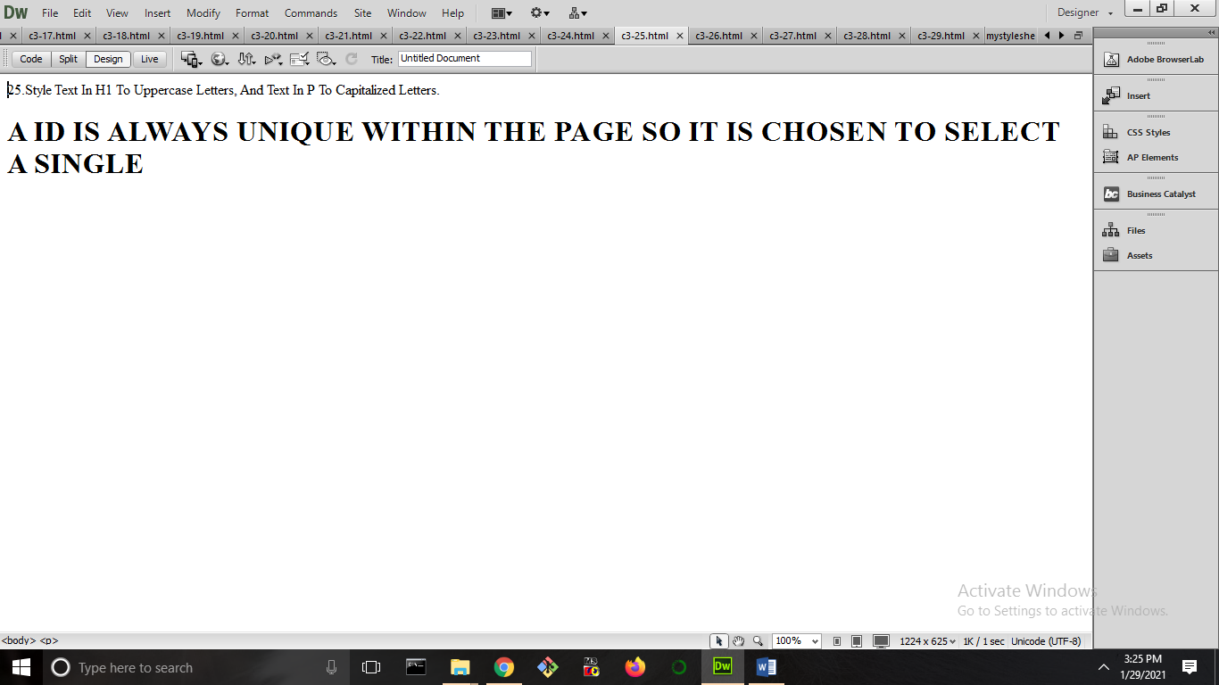

1. **Set the width of <h1> to "50%".**

<html xmlns="http://www.w3.org/1999/xhtml">

<head>

<meta http-equiv="Content-Type" content="text/html; charset=utf-8" />

<title>Untitled Document</title>

<style>

h1{width:"50%";}

</style>

</head>

<body>

<h1>a id is always unique within the page so it is chosen to select a single</h1>

</body>

</html>

**OUTPUT**

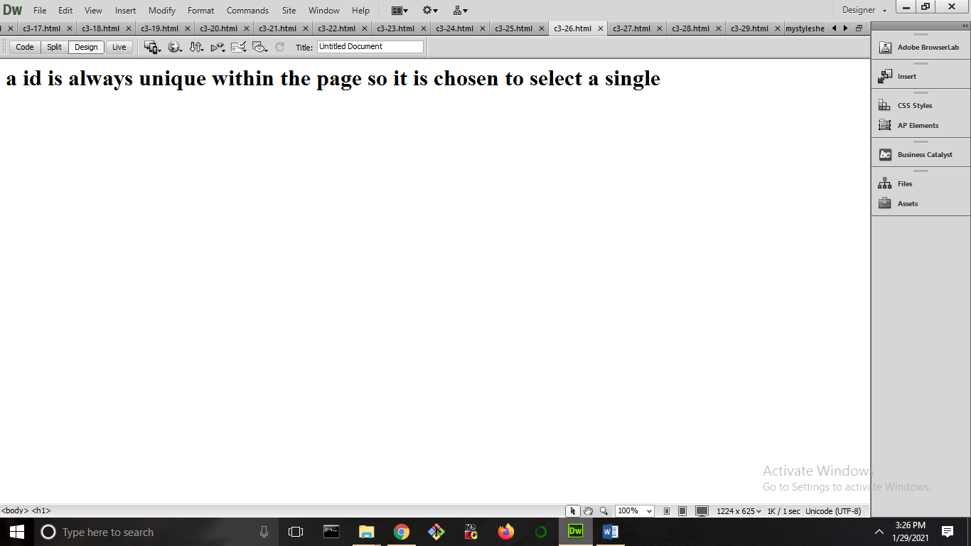

1. **With the border property: Set the border for p to "10px", "solid" and "green".**

<html xmlns="http://www.w3.org/1999/xhtml">

<head>

<meta http-equiv="Content-Type" content="text/html; charset=utf-8" />

<title>Untitled Document</title>

<style>

p{background-color:green;

border-style:solid;

font-size:10px;}

</style>

</head>

<body>

<p>27. With the border property: Set the border for p to "10px", "solid" and "green".</p>

<p>a id is always unique within the page so it is chosen to select a single</p>

</body>

</html>

**OUTPUT**

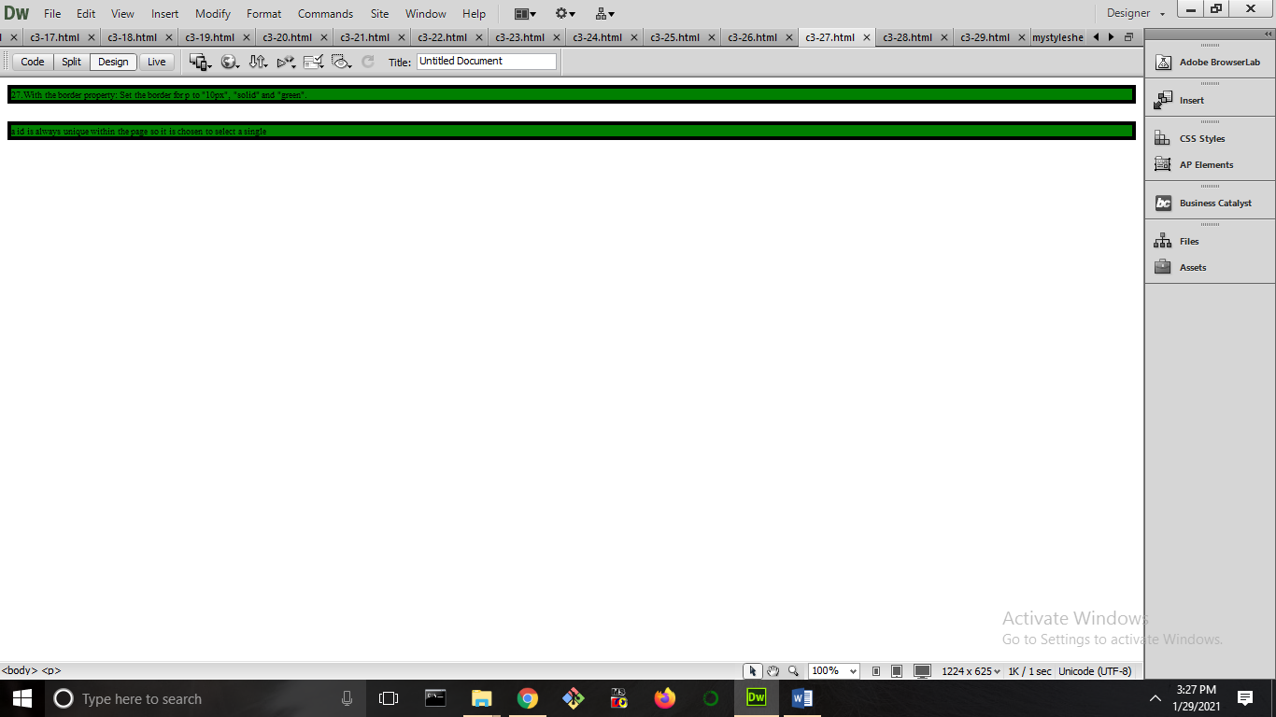

1. **Use the margin property to center align the <h1> element.**

<html xmlns="http://www.w3.org/1999/xhtml">

<head>

<meta http-equiv="Content-Type" content="text/html; charset=utf-8" />

<title>Untitled Document</title>

<style>

h1 {

background-color: pink;

width: 300px;

margin:auto;

}

</style>

</head>

<body>

<h1>This is a Heading</h1>

<p>This is a paragraph.</p>

</body>

</html>

**OUTPUT**

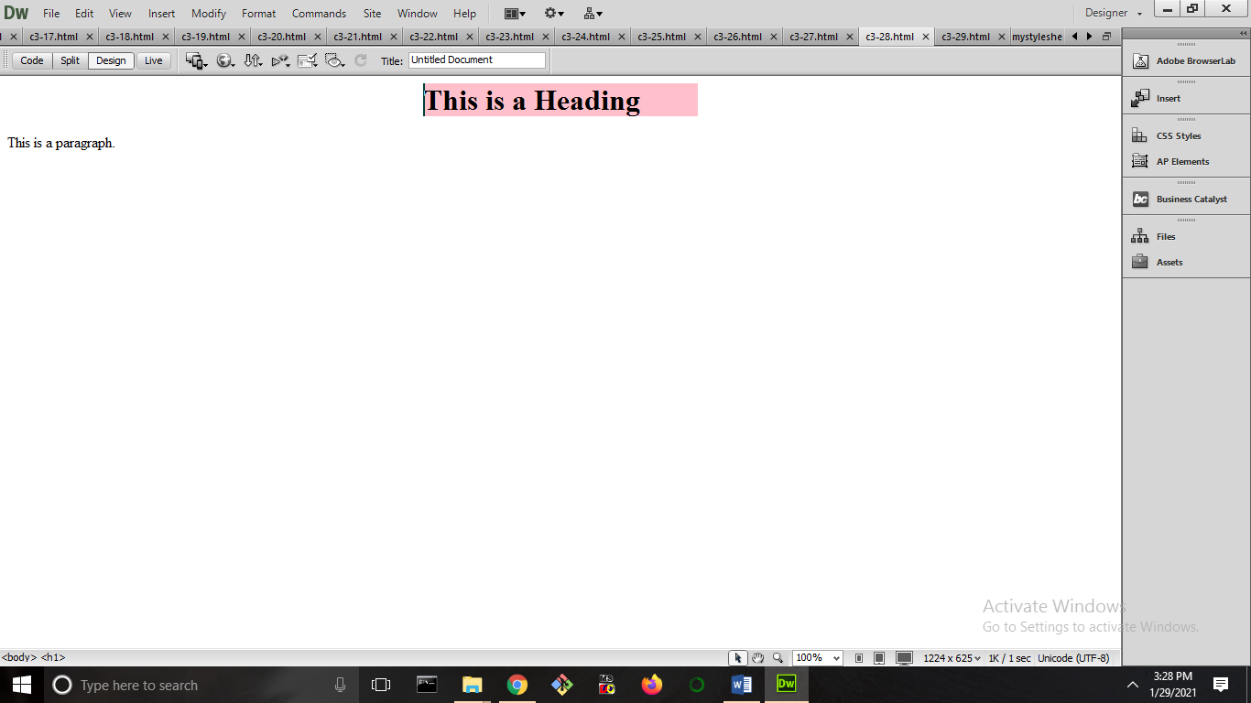

1. **Set the color for unvisited links to "red", and the color for visited links "blue”.**

<html xmlns="http://www.w3.org/1999/xhtml">

<head>

<meta http-equiv="Content-Type" content="text/html; charset=utf-8" />

<title>Untitled Document</title>

</head>

<body alink="#3300FF" vlink="#FF0000">

<p>19. Set "background-color: linen" for the page, using an internal style sheet</p><a href="#9099"> CSS</a><p>Paragraphs are usually represented in visual media as blocks of text </p><a href="#777">Home</a>

<p>separated from adjacent blocks by blank lines and/or first-line indentation</p>

<p>a id is always unique within the page so it is chosen to select a single</p><a href="#777">move</a>

</body>

</html>

**OUTPUT**

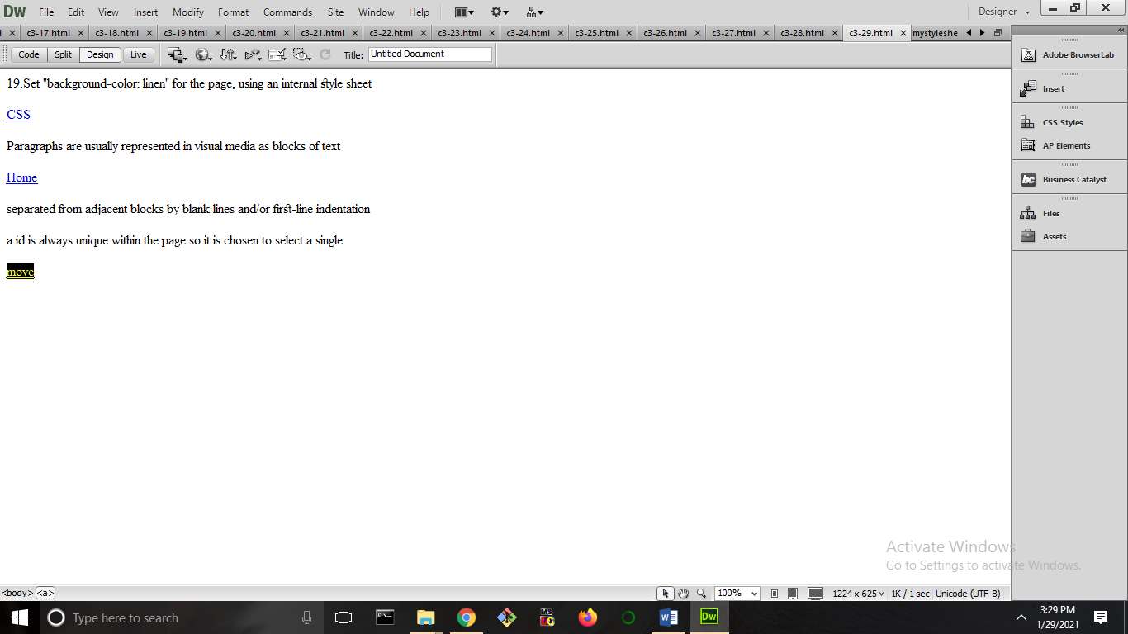

1. **Remove the bullets/markers from the list items.**

<html xmlns="http://www.w3.org/1999/xhtml">

<head>

<meta http-equiv="Content-Type" content="text/html; charset=utf-8" />

<title>Untitled Document</title>

<style>

ul {

list-style-type: none;

margin: 0;

padding: 0;

}

</style>

</head>

<body>

<ul>

<li>anu</li>

<li>anisha</li>

<li>albins</li>

</ul>

</body>

</html>

**OUTPUT**

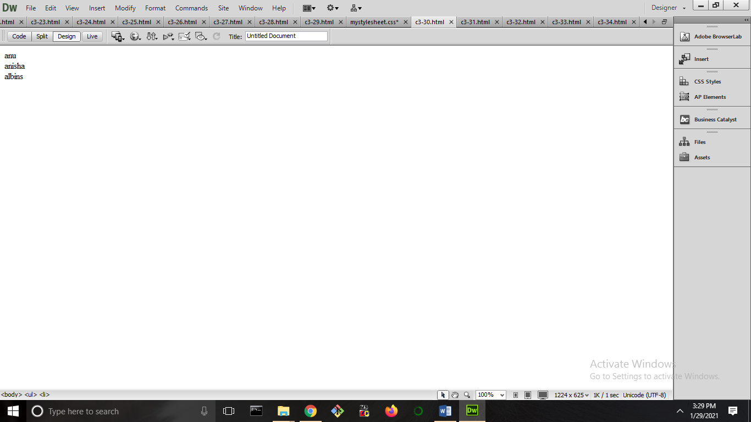

1. **Set the list style for unordered lists to "square", and the list style for ordered lists to "upper-roman".**

<html xmlns="http://www.w3.org/1999/xhtml">

<head>

<meta http-equiv="Content-Type" content="text/html; charset=utf-8" />

<title>Untitled Document</title>

<style>

ul {

list-style-type:square;

}

ol {

list-style-type:upper-roman;

}

</style>

</head>

<body>

<ul>

<li>anu</li>

<li>anisha</li>

<li>albins</li>

</ul>

<ol>

<li>baby</li>

<li>mercy</li>

<li>mary</li>

</ol>

</body>

</html>

**OUTPUT**

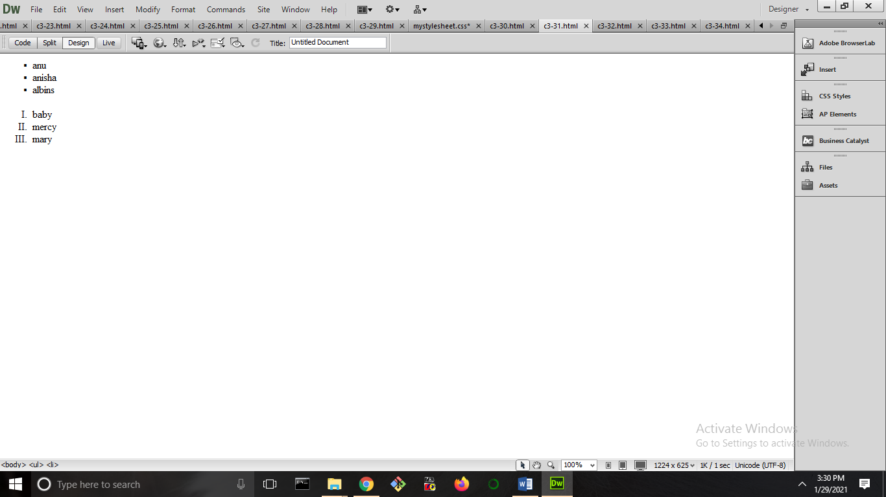

1. **Remove underlines for visited and unvisited links, and specify "underline" for the hover and active link states.**

<html>

<head>

<style>

a:hover {

text-decoration: underline;

}

a:link {

text-decoration: none;

}

a:visited {

text-decoration: none;

}

a:active {

text-decoration: underline;

}

</style>

</head>

<body>

<a href="https://www.w3schools.com">w3schools.com</a>

<a href="https://www.wikipedia.org">wikipedia.org</a>

<p>Set the background color for visited and unvisited links to "lightblue", and the background color for the hover and active link states to "yellow".</p>

</body>

</html>

**OUTPUT**

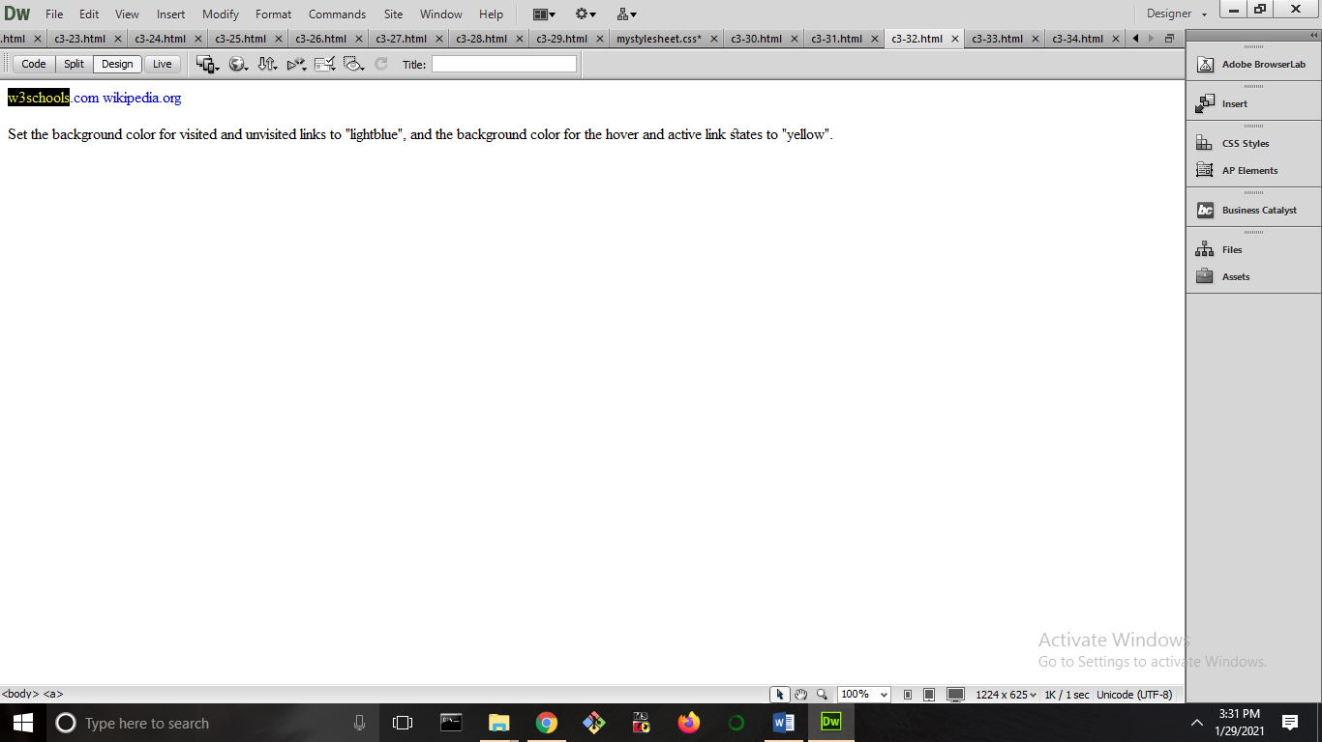

1. **Set the image "gif image" as the list item marker for the unordered list.**

<html xmlns="http://www.w3.org/1999/xhtml">

<head>

<meta http-equiv="Content-Type" content="text/html; charset=utf-8" />

<title>Untitled Document</title>

<style>

ul{list-style-image:url(demo.gif);

list-style-position:inside;

}

</style>

</head>

<body>

<ul>

<li>anu</li>

<li>anisha</li>

<li>albins</li>

</ul>

</body>

</html>

**OUTPUT**

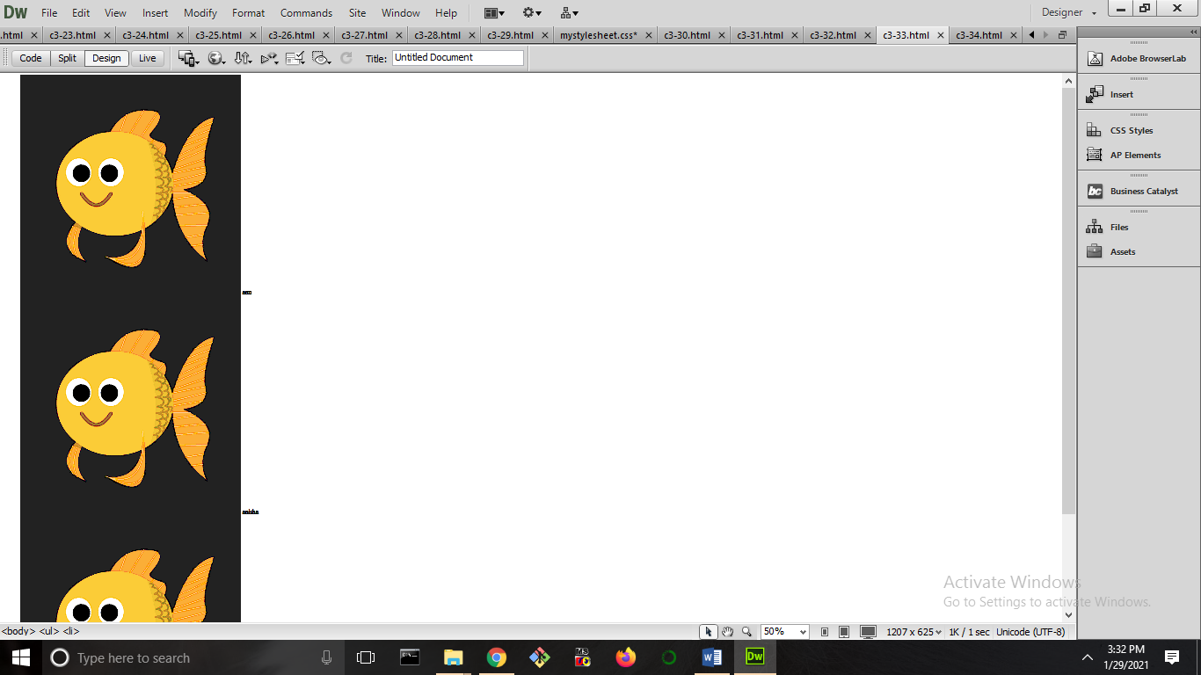

1. **Set the background color for visited and unvisited links to "lightblue", and the background color for the hover and active link states to "yellow".**

<html>

<head>

<style>

a:hover {

background-color: yellow;

}

a:link {

background-color:blue;

}

a:visited {

background-color:blue;

}

a:active {

background-color:yellow;

}

</style>

</head>

<body>

<a href="https://www.w3schools.com">w3schools.com</a>

<a href="https://www.wikipedia.org">wikipedia.org</a>

<p>Set the background color for visited and unvisited links to "lightblue", and the background color for the hover and active link states to "yellow".</p>

</body>

</html>

**OUTPUT**

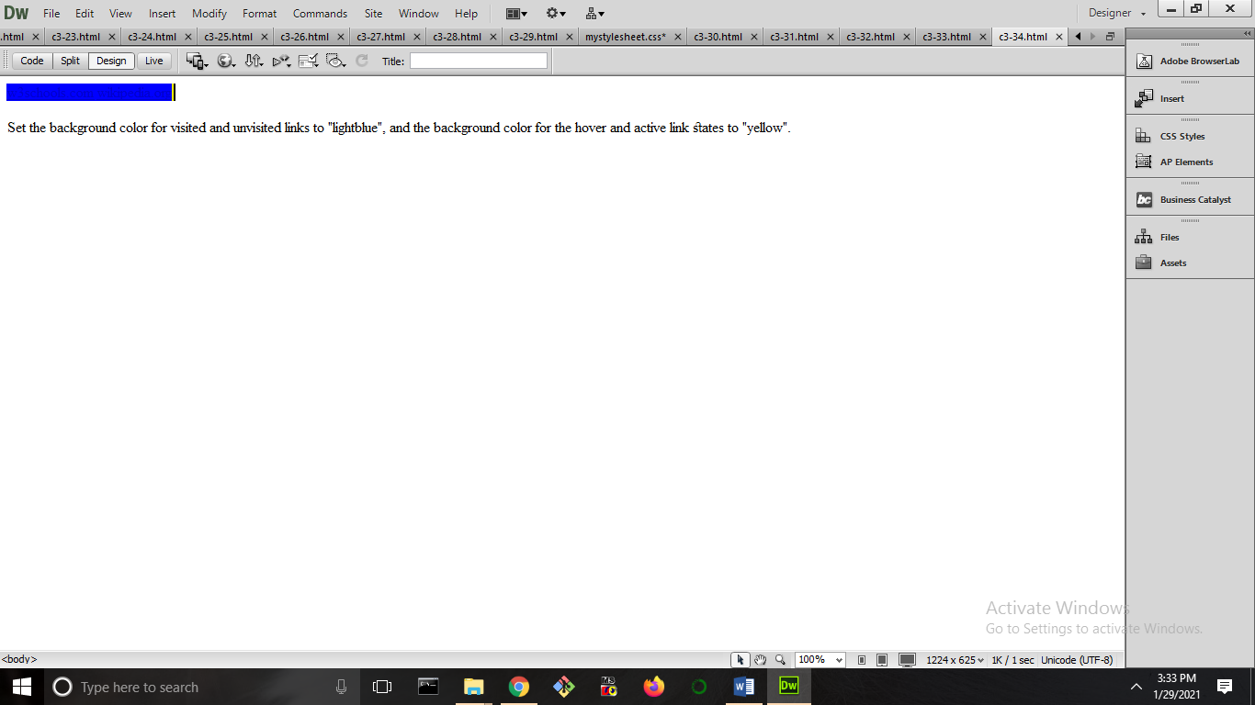

**CYCLE 4**

1.Program to perform addition of 2 numbers?

2.program to find reverse of a number?

3.program to check check whether a given number is armstrong or not?

4. Write a JavaScript program to get the current date.

5.write a javascript program to check whether a number is positive or negative?

6.Write a JavaScript program check if a given positive number is a multiple of 3 or a multiple of 7

7.Write a JavaScript program to find the largest of three given integers

8.Write a JavaScript program to calculate multiplication and division of two numbers (input from user)

9.Write a JavaScript program to create a new string adding "Py" in front of a given string. If the given string begins with "Py" then return the original string.

10.to change the background color after clicking the button in JavaScript

11.Write a web page that uses a prompt to ask the user what color they’d like the

background of their paragraphs to be. It should then write a paragraph with the background set

to the appropriate color.

12.Write a web page that uses the prompt to get the user to input their first name and then

their year of birth. Calculate how old they are and write it to the web page.

**1.Program to perform addition of 2 numbers?**

<html xmlns="http://www.w3.org/1999/xhtml">

<head>

<meta http-equiv="Content-Type" content="text/html; charset=utf-8" />

<title>Untitled Document</title>

</head>

<body>

<script>

a=15;

b=20;

c=a+b;

document.write("sum of numbers is: " +c);

</script>

</body>

</html>

**OUTPUT**

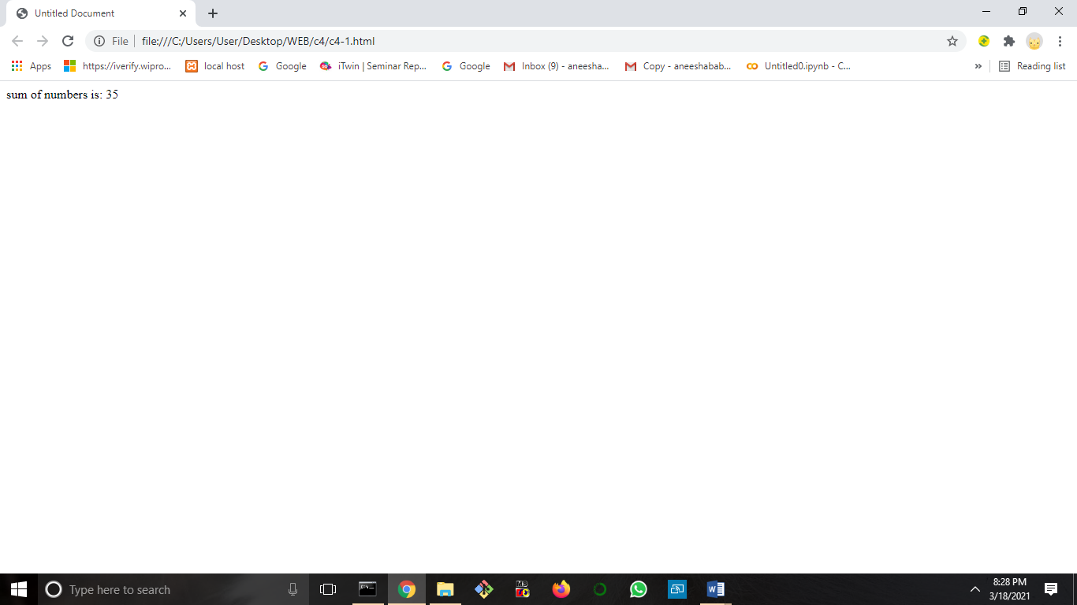

2**.program to find reverse of a number?**

<html xmlns="http://www.w3.org/1999/xhtml">

<head>

<script>

function palin()

{

var a,no,b,temp=0;

no=Number(document.getElementById("no_input").value);

b=no;

while(no>0)

{

a=no%10;

no=parseInt(no/10);

temp=temp*10+a;

}

alert(temp);

}

</script>

</head>

<body>

Enter any Number: <input id="no_input">

<button onclick="palin()">Check</button></br></br>

</body>

</html>

**OUTPUT**

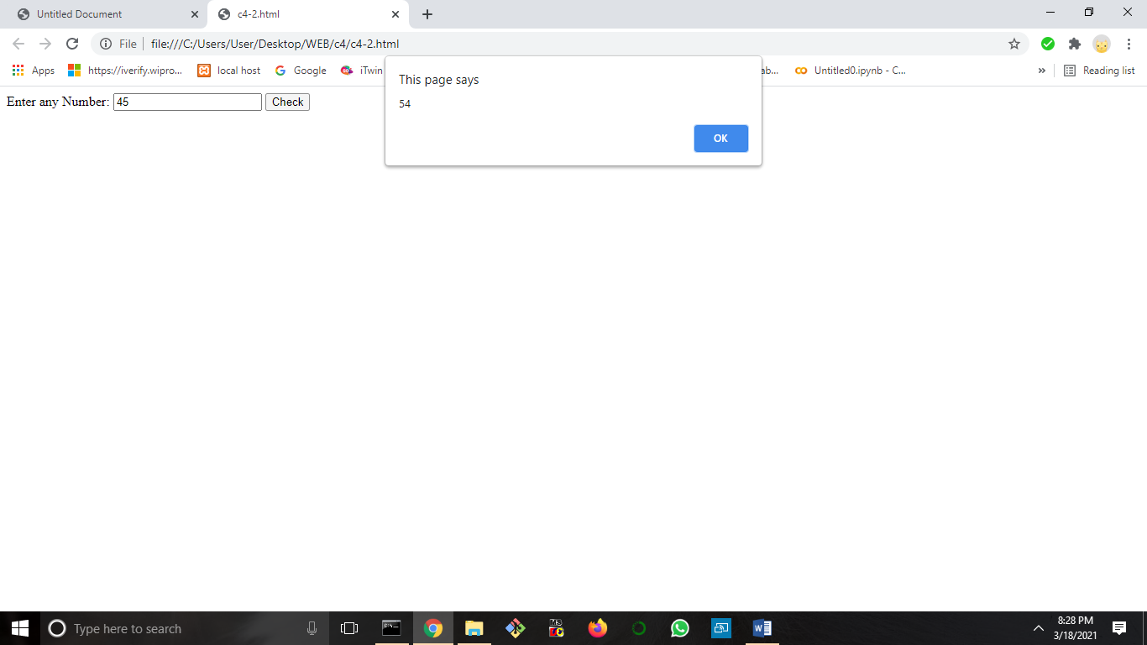

**3.program to check check whether a given number is armstrong or not?**

<html xmlns="http://www.w3.org/1999/xhtml">

<head>

<meta http-equiv="Content-Type" content="text/html; charset=utf-8" />

<title>Untitled Document</title>

</head>

<body>

<script>

var sum = 0;

const number = prompt('Enter a three-digit positive integer: ');

var temp = number;

while (temp > 0) {

// finding the one's digit

var remainder = temp % 10;

sum += remainder * remainder * remainder;

// removing last digit from the number

temp = parseInt(temp / 10); // convert float into integer

}

// check the condition

if (sum == number) {

alert(" an Armstrong number");

}

else {

alert(" is not an Armstrong number");

}

</script>

</body>

</html>

**OUTPUT**

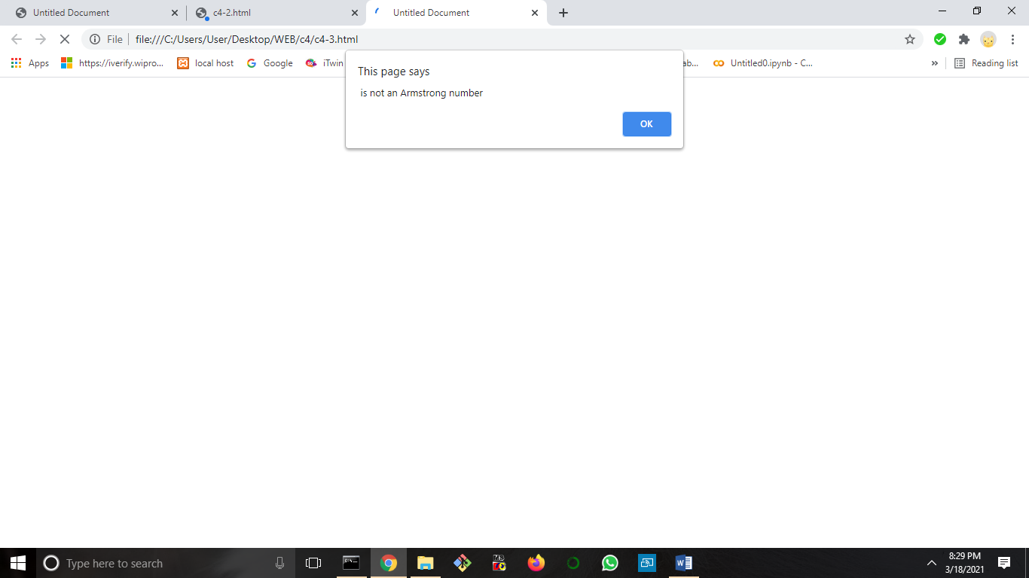

**4. Write a JavaScript program to get the current date.**

<html xmlns="http://www.w3.org/1999/xhtml">

<head>

<meta http-equiv="Content-Type" content="text/html; charset=utf-8" />

<title>Untitled Document</title>

</head>

<body>

<script>

var today = new Date();

var dd = today.getDate();

var mm = today.getMonth()+1;

var yyyy = today.getFullYear();

if(dd<10)

{

dd='0'+dd;

}

if(mm<10)

{

mm='0'+mm;

}

today = mm+'-'+dd+'-'+yyyy;

document.write(today);

</script>

</body>

</html>

**OUTPUT**

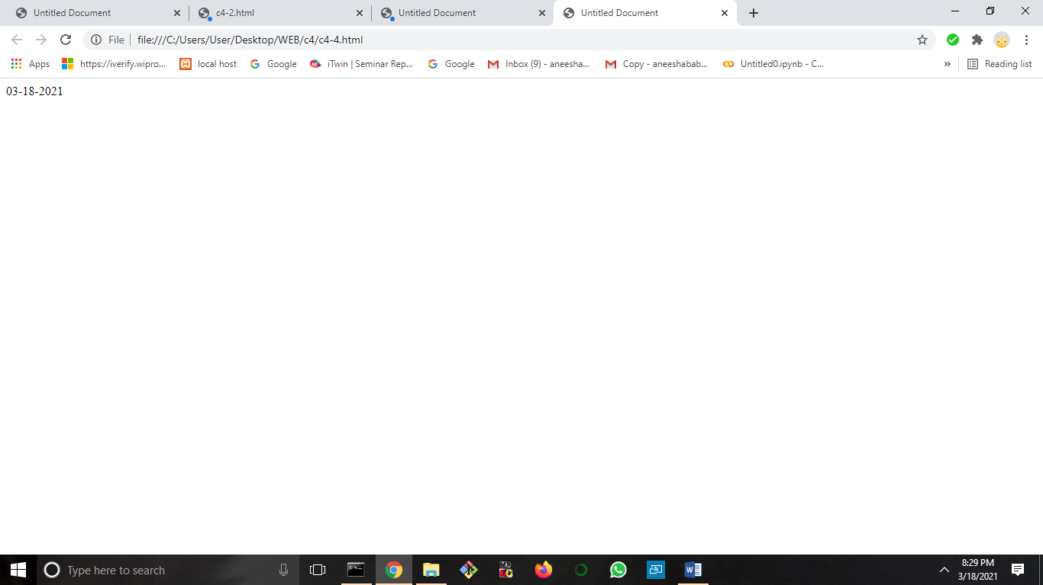

**5.write a javascript program to check whether a number is positive or negative?**

<html xmlns="http://www.w3.org/1999/xhtml">

<head>

<meta http-equiv="Content-Type" content="text/html; charset=utf-8" />

<title>Untitled Document</title>

</head>

<body>

<script>

const number = parseInt(prompt("Enter a number: "));

// check if number is greater than 0

if (number > 0) {

document.write("The number is positive");

}

// check if number is 0

else if (number == 0) {

document.write("The number is zero");

}

// if number is less than 0

else {

document.write("The number is negative");

}

</script>

</body>

</html>

**OUTPUT**

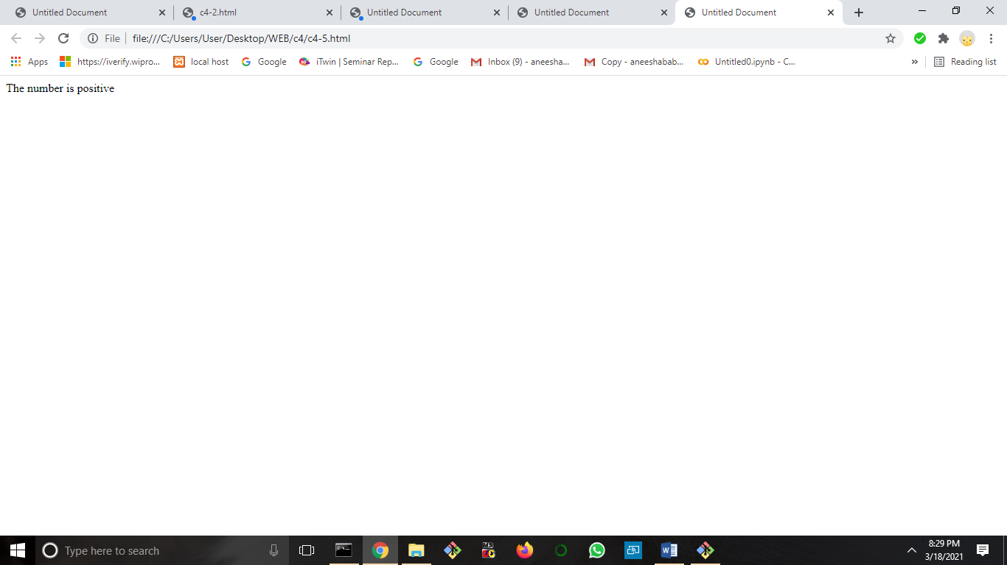

**6.Write a JavaScript program check if a given positive number is a multiple of 3 or a multiple of 7**

<!DOCTYPE html>

<html>

<head>

<title></title>

</head>

<body>

Enter first number: <input type="text" id="myText1" onchange="myFunction()">

<p id="b"></p>

<script>

function myFunction() {

var a = document.getElementById("myText1").value;

var t = parseInt(a)%3;

var s = parseInt(a)%7;

if (t == 0 || s==0) {

alert(" Entered number is a multiple of 3 or 7")

}

else

{

alert(" Entered number is not a multiple of 3 or 7")

}

}

</script>

</body>

</html>

**OUTPUT**

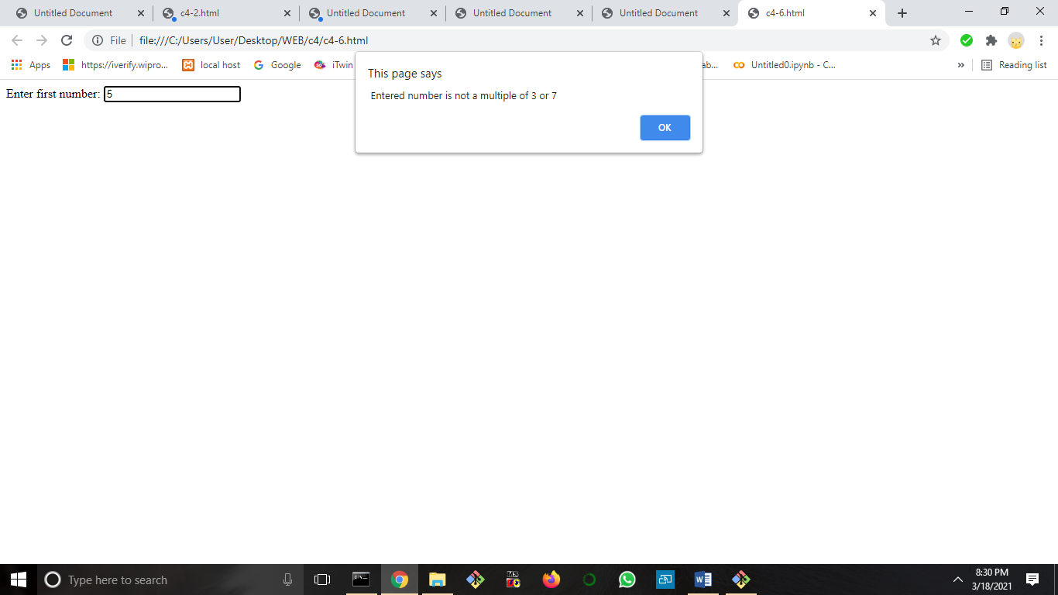**7.Write a JavaScript program to find the largest of three given integers**

<html xmlns="http://www.w3.org/1999/xhtml">

<head>

<meta http-equiv="Content-Type" content="text/html; charset=utf-8" />

<title>Untitled Document</title>

</head>

<body>

<script>

const num1 = parseFloat(prompt("Enter first number: "));

const num2 = parseFloat(prompt("Enter second number: "));

const num3 = parseFloat(prompt("Enter third number: "));

var largest;

// check the condition

if(num1 >= num2 && num1 >= num3) {

largest = num1;

}

else if (num2 >= num1 && num2 >= num3) {

largest = num2;

}

else {

largest = num3;

}

// display the result

alert("The largest number is " + largest);

</script>

</body>

</html>

**OUTPUT**

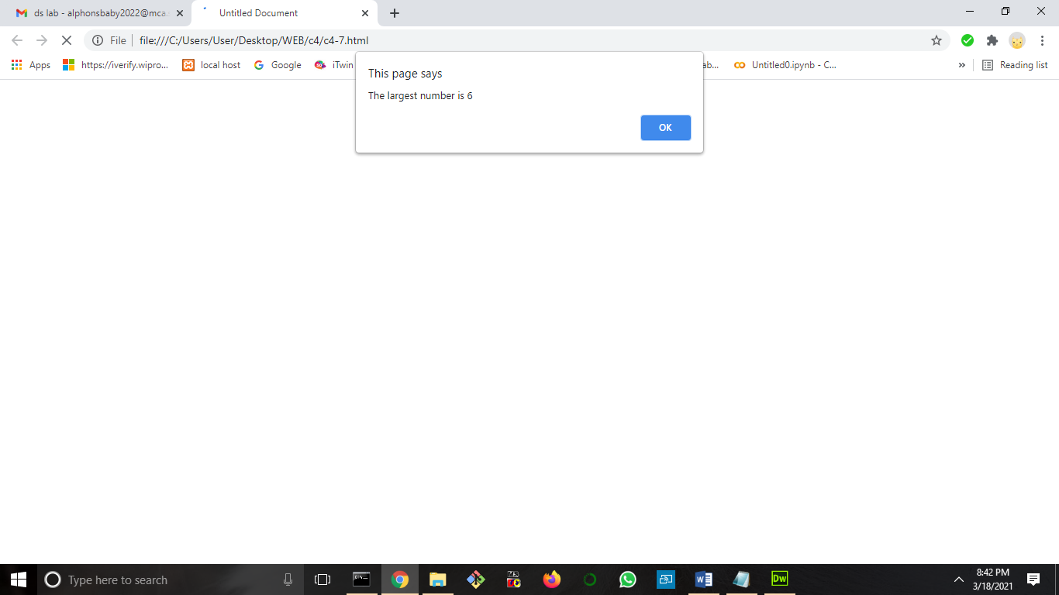

**8.Write a JavaScript program to calculate multiplication and division of two numbers (input from user)**

<html>

<head>

<meta charset=utf-8 />

<title>JavaScript program to calculate multiplication and division of two numbers </title>

<style type="text/css">

body {margin: 30px;}

</style>

</head>

<body>

<form>

1st Number : <input type="text" id="firstNumber" /><br>

2nd Number: <input type="text" id="secondNumber" /><br>

<input type="button" onClick="multiplyBy()" Value="Multiply" />

<input type="button" onClick="divideBy()" Value="Divide" />

</form>

<p>The Result is : <br>

<span id = "result"></span>

</p>

</body>

</html>

**OUTPUT**

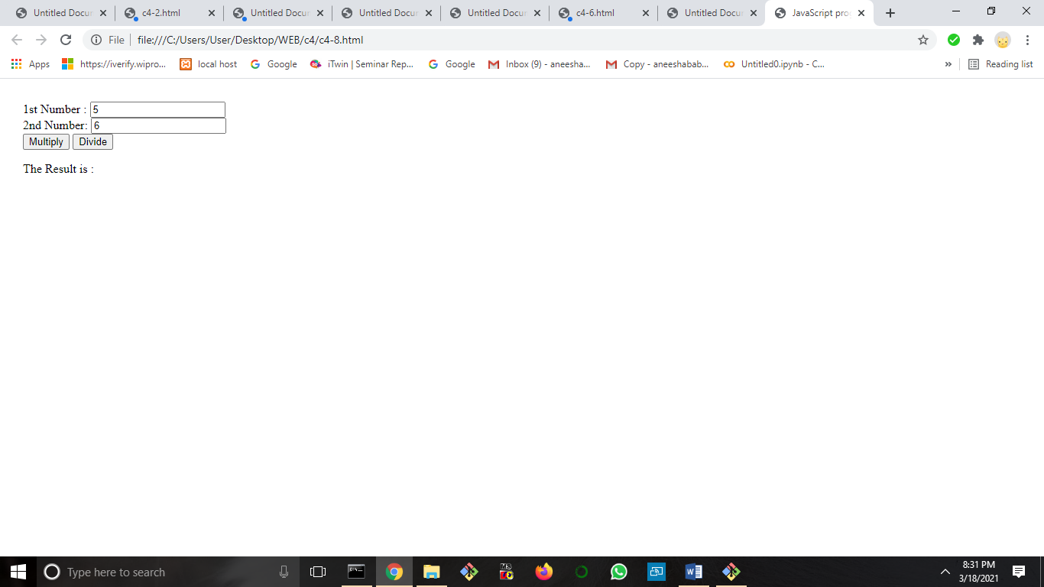

**9.Write a JavaScript program to create a new string adding "Py" in front of a given string. If the given string begins with "Py" then return the original string.**

<!DOCTYPE html>

<html>

<body>

Enter the character: <input type="text" id="myText" >

<p id="b"></p>

<button onclick="myFunction()">Try it</button>

<script>

function myFunction() {

var str1=document.getElementById("myText").value;

if (str1.substring(0, 2) === 'Py' || str1.substring(0, 2) === 'py')

{

document.getElementById("b").innerHTML = str1;

}

else{

document.getElementById("b").innerHTML = "Py"+str1;

}

}

</script>

</body>

</html>

**OUTPUT**

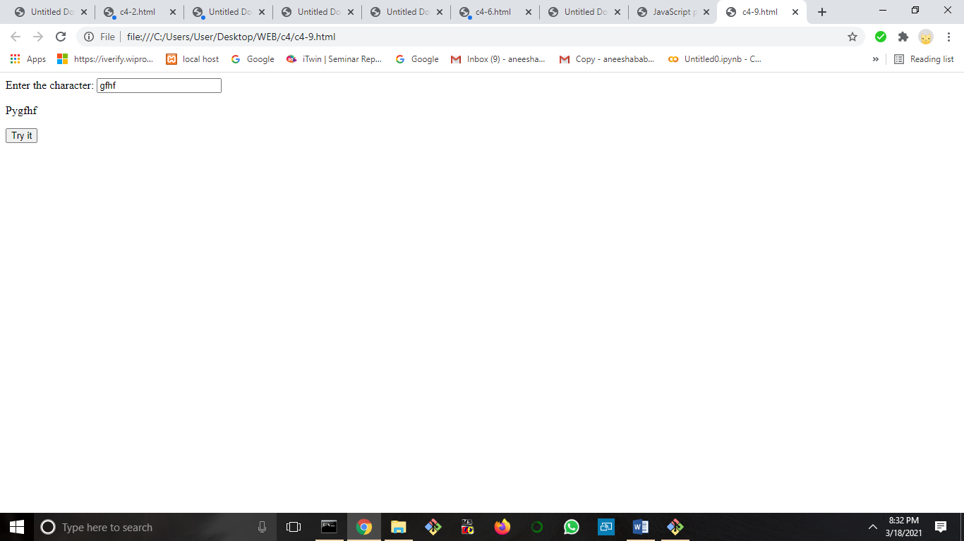

**10.to change the background color after clicking the button in JavaScript**

<!DOCTYPE HTML>

<html>

<head>

</head>

<body style = "text-align:center;">

<h1 style = "color:green;" >

GeeksForGeeks

</h1>

<p id = "GFG_UP" style =

"font-size: 16px; font-weight: bold;">

</p>

<button onclick = "gfg_Run()">

Click here

</button>

<p id = "GFG_DOWN" style =

"color:green; font-size: 20px; font-weight: bold;">

</p>

<script>

var el_up = document.getElementById("GFG_UP");

var el_down = document.getElementById("GFG_DOWN");

var str = "Click on button to change the background color";

el_up.innerHTML = str;

function changeColor(color) {

document.body.style.background = color;

}

function gfg_Run() {

changeColor('yellow');

el_down.innerHTML = "Background Color changed";

}

</script>

</body>

</html>

**OUTPUT**

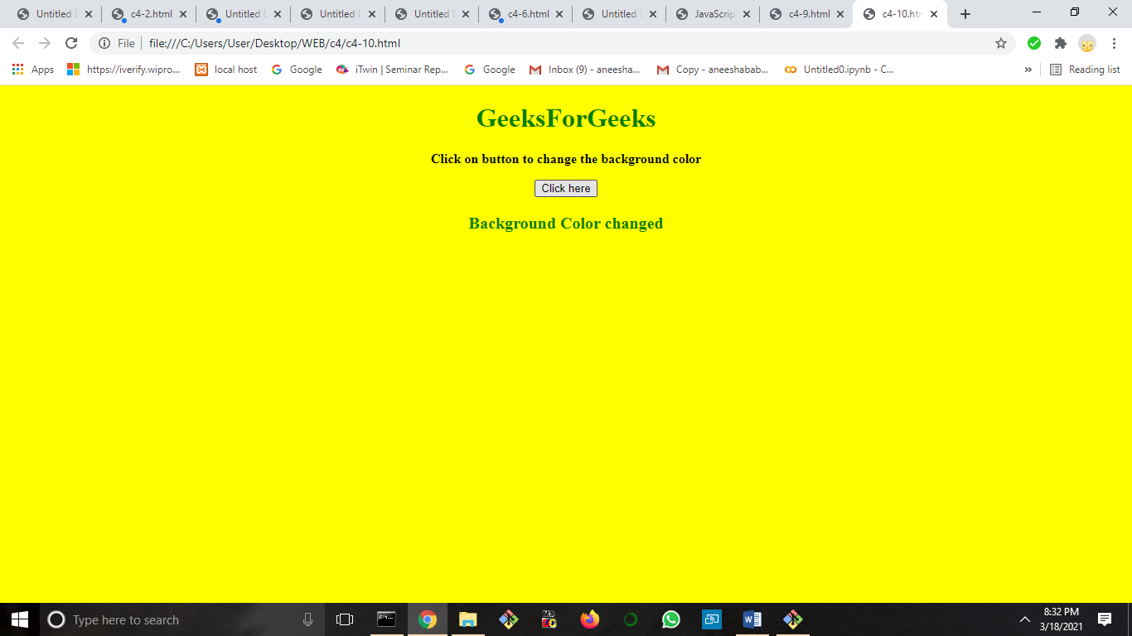

**11.Write a web page that uses a prompt to ask the user what color they’d like the background of their paragraphs to be. It should then write a paragraph with the background setto the appropriate color.**

<!DOCTYPE html>

<html>

<head>

<meta charset=utf-8 />

<title>Set the background color of a paragraph</title>

<script>

function set_background() {

docBody = document.getElementsByTagName("body")[0];

//Get all the p elements that are descendants of the body

myBodyElements = docBody.getElementsByTagName("p");

// get the first p elements

myp1 = myBodyElements[0];

myp1.style.background = "rgb(255,0,0)";

// get the second p elements

myp2 = myBodyElements[1];

myp2.style.background = "rgb(255,255,0)";

}

</script>

</head>

<body>

<input type="button" value="Click to set paragraph background color" onclick="set_background()">

<p>w3resource JavaScript Exercises</p>

<p>w3resource PHP Exercises</p>

</body>

</html>

**OUTPUT**

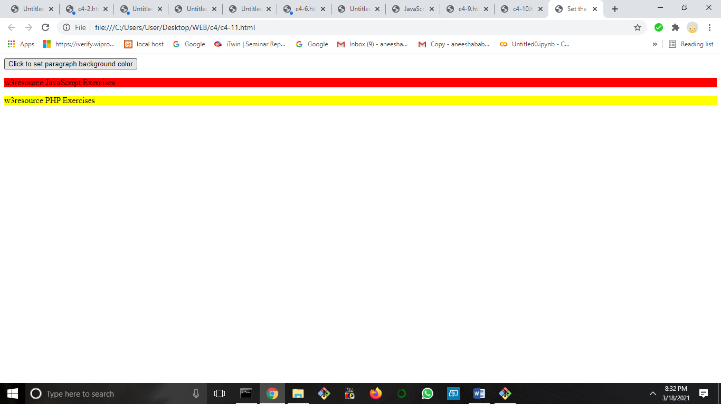**12.Write a web page that uses the prompt to get the user to input their first name and then their year of birth. Calculate how old they are and write it to the web page.**

<html>

<head>

</head>

<body>

<SCRIPT LANGUAGE="JavaScript1.2"> <!--

function myAgeValidation() {

var lre = /^\s*/;

var datemsg = "";

var inputDate = document.as400samplecode.myDate.value;

inputDate = inputDate.replace(lre, "");

document.as400samplecode.myDate.value = inputDate;

datemsg = isValidDate(inputDate);

if (datemsg != "") {

alert(datemsg);

return;

}

else {

//Now find the Age based on the Birth Date

getAge(new Date(inputDate));

}

}

function getAge(birth) {

var today = new Date();

var nowyear = today.getFullYear();

var nowmonth = today.getMonth();

var nowday = today.getDate();

var birthyear = birth.getFullYear();

var birthmonth = birth.getMonth();

var birthday = birth.getDate();

var age = nowyear - birthyear;

var age_month = nowmonth - birthmonth;

var age_day = nowday - birthday;

if(age_month < 0 || (age_month == 0 && age_day <0)) {

age = parseInt(age) -1;

}

alert(age);

if ((age == 18 && age_month <= 0 && age_day <=0) || age < 18) {

}

else {

alert("You have crossed your 18th birthday !");

}

}

function isValidDate(dateStr) {

var msg = "";

var datePat = /^(\d{1,2})(\/|-)(\d{1,2})\2(\d{4})$/;

var matchArray = dateStr.match(datePat); // is the format ok?

if (matchArray == null) {

msg = "Date is not in a valid format.";

return msg;

}

month = matchArray[1]; // parse date into variables

day = matchArray[3];

year = matchArray[4];

if (month < 1 || month > 12) { // check month range

msg = "Month must be between 1 and 12.";

return msg;

}

if (day < 1 || day > 31) {

msg = "Day must be between 1 and 31.";

return msg;

}

if ((month==4 || month==6 || month==9 || month==11) && day==31) {

msg = "Month "+month+" doesn't have 31 days!";

return msg;

}

if (month == 2) { // check for february 29th

var isleap = (year % 4 == 0 && (year % 100 != 0 || year % 400 == 0));

if (day>29 || (day==29 && !isleap)) {

msg = "February " + year + " doesn't have " + day + " days!";

return msg;

}

}

if (day.charAt(0) == '0') day= day.charAt(1);

return msg; // date is valid

}

// --> </SCRIPT>

<form name="as400samplecode">

Enter Birth Date: <input type="text" name="myDate" size=10 maxlength=10> (in MM/DD/YYYY format)

<input type="button" value="Find Age" onClick="Javascript:myAgeValidation()">

</form>

</body>

</html>

**OUTPUT**

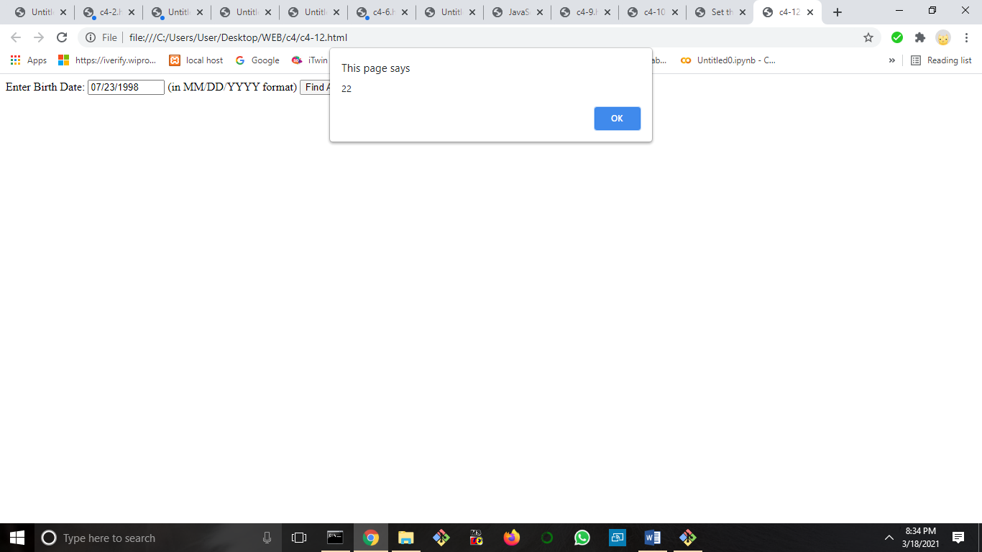

**CYCLE 5**

1. Create a php webpage and print “hello world”.
2. Write a php program to find maximum of three numbers.
3. Give the example of variable function: print_r()
4. Write a program to Develop student registration form and display all the submitted data on another page.
5. The first thing we need is a form where people can enter their username and password. It could look like this
6. Then we create the file: login.php. In this file, we check whether it is the correct username and password that has been entered. If that is the case, we set a session that says that this user is logged in with the correct username and password.
7. Write a program that keeps track of how many times a visitor has loaded the page.
8. Write a PHP program to insert record into a table STUDENT(id,Name,branch,mark) using MySQL.
9. Write a program to update table
10. Create a student Registration in PHP and Save and Display the

student Records.

11.Write a program to read customer information like c_no, c_name,

item_purchased and mob_no from customer table and display all this

information in table format on output screen.

12 Outline a registration form using PHP and do necessary validations. (K4)

13. Compose Electricity bill from user input based on a given tariff using PHP. (K6)

14. Build a PHP code to store name of students in an array and display it using print_r

function. Sort and Display the same using asort & arsort functions. (K6)

14. Build a PHP code to store name of Indian Cricket players in an array and display the same in HTML table. (K6)

**Create a php webpage and print “hello world”**

<Html>

<Head>

<Title> My Simple Program </Title>

</head>

<Body>

<?php

echo "Hello World"

?>

</Body>

</Html>

**OUTPUT**

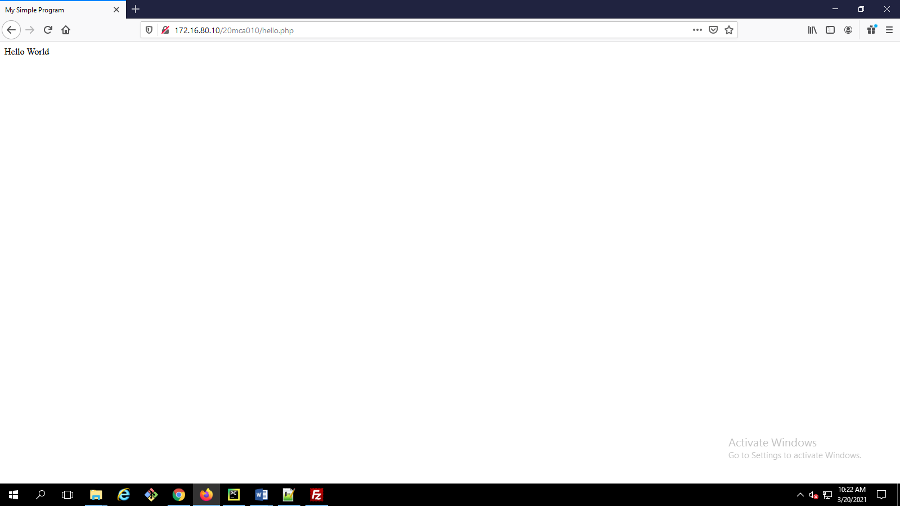

**Write a php program to find maximum of three numbers.**

<html>

<head>

<title> Max out of three </title>

</head>

<body>

<?php

$a = 1;

$b = 4;

$c = 3;

if($a > $b)

{

if($a > $c)

echo "Maximum num a = $a";

else

echo "Maximum num c = $c";

}

else

{

if($c > $b)

echo "Maximum num c = $c";

else

echo "Maximum num b = $b";

}

?>

</body>

</html>

**OUTPUT**

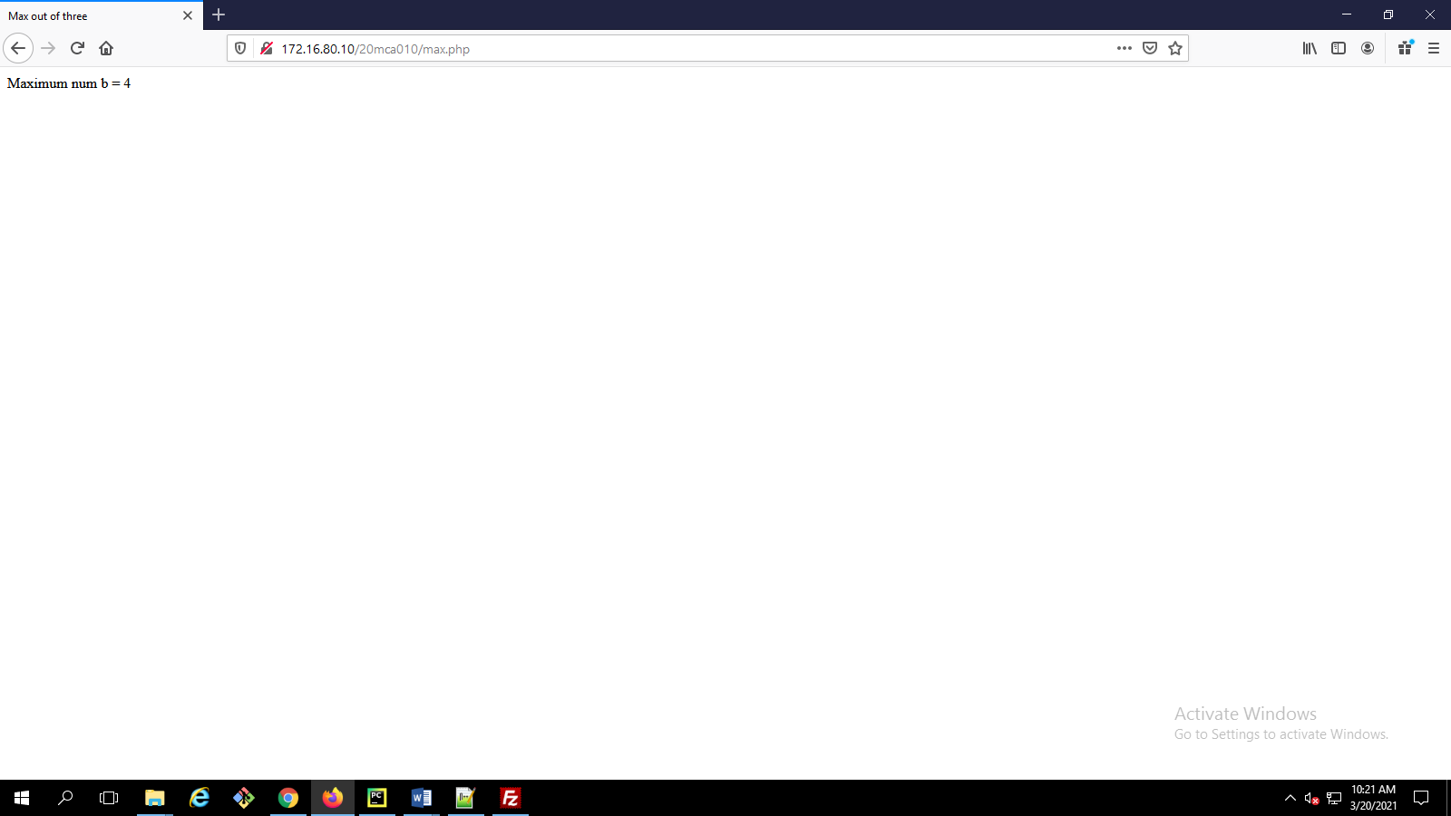

**Give the example of variable function: print_r()**

<!DOCTYPE html>

<html>

<body>

<?php

$a = array("anu", "alphonsa", "aneesha");

sort($a);

print_r($a);

echo "<br>";

?>

</body>

</html>

**OUTPUT**

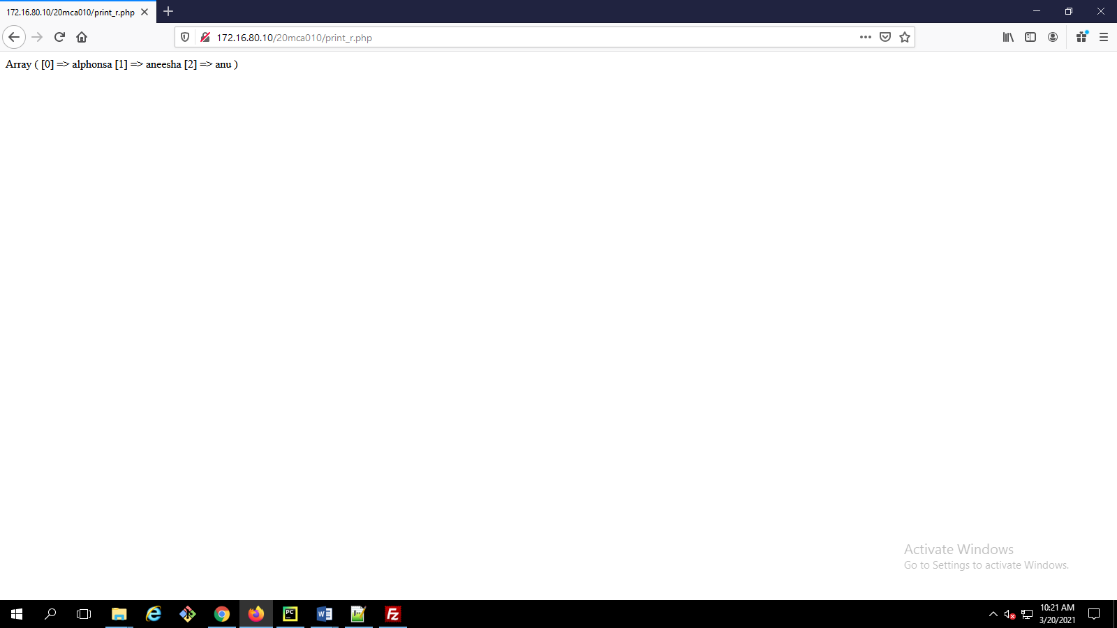

**Write a program to Develop student registration form and display all the submitted data on another page.**

<html>

<head>

<title>insert data in form</title>

</head>

<body>

<form action = "data.php" method = "POST">

Name:

<input type = "text" name = "txtname">

<br><br>

Roll no.:

<input type = "text" name = "txtr_no">

<br><br>

Address:

<textarea name = "add" type = "textarea"></textarea>

<br><br>

Contyact No:

<input type = "text" name = "txtc_no">

<br><br>

Email ID:

<input type = "text" name = "txteid">

<br><br>

<input type = "Submit" name = "insert" value = "Save">

<input type = "Reset" value = "Cancle">

</form>

</body>

</html>

Data.php

<html>

<head>

<title>get data from another page</title>

</head>

<body>

<?php

echo "Name:" .$_POST["txtname"]."</br>";

echo "Roll no.:".$_POST["txtr_no"]."</br>";

echo "Address:".$_POST["add"]."</br>";

echo "Contact No.:".$_POST["txtc_no"]."</br>";

echo "Email ID:".$_POST["txteid"]."</br>";

?>

</body>

**OUTPUT**

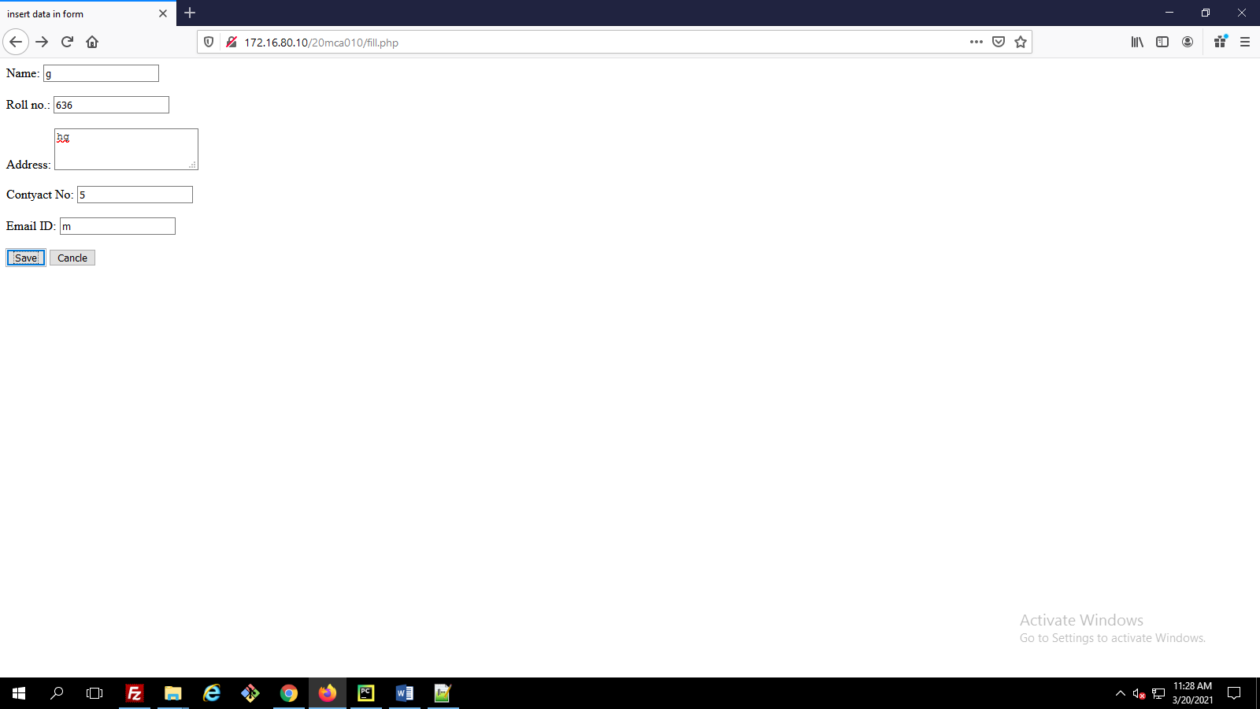

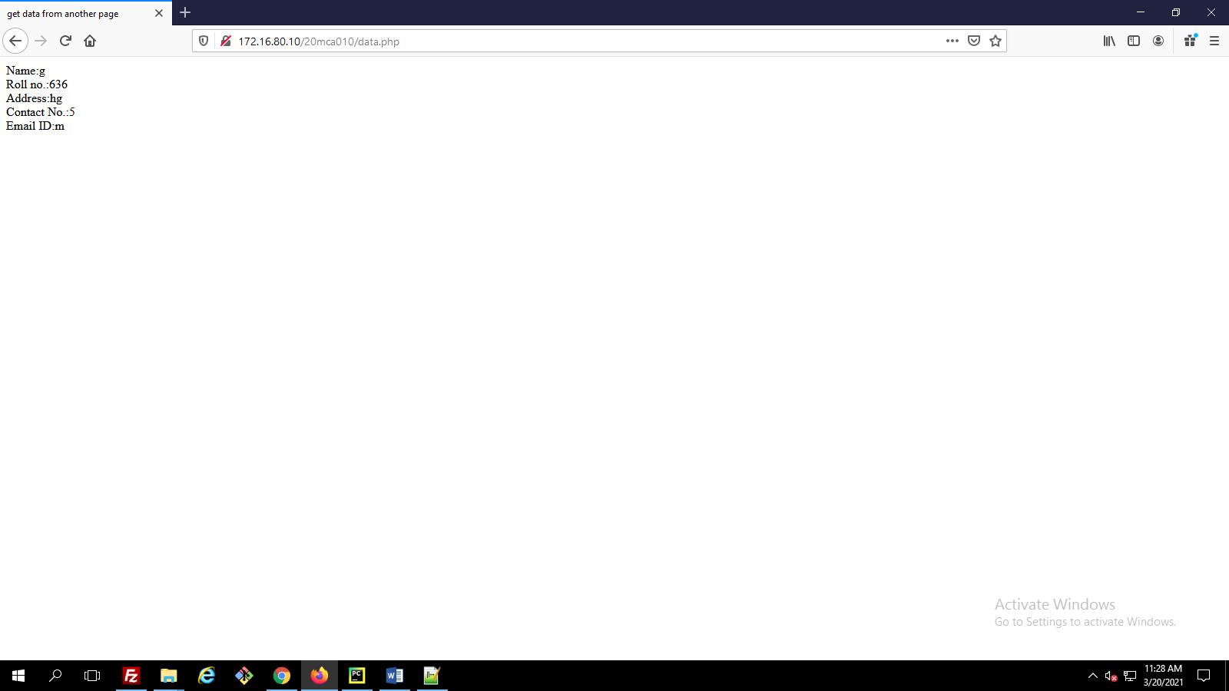

**The first thing we need is a form where people can enter their username and password. It could look like thisThen we create the file: login.php. In this file, we check whether it is the correct username and password that has been entered. If that is the case, we set a session that says that this user is logged in with the correct username and password.**

<html>

<head>

<title>Login</title>

</head>

<body>

<form method="post" action="login.php">

<p>Username: <input type="text" name="username" /></p>

<p>Password: <input type="text" name="password" /></p>

<p><input type="submit" value="Let me in" /></p>

</form>

</body>

</html>

Login.php

<html>

<head>

<title>Login</title>

</head>

<body>

<?php

// Check if username and password are correct

if ($_POST["username"] == "php" && $_POST["password"] == "php") {

// If correct, we set the session to YES

session_start();

$_SESSION["Login"] = "YES";

echo "<h1>You are now logged correctly in</h1>";

echo "<p><a href='fill.php'>Link to protected file</a><p/>";

}

else {

// If not correct, we set the session to NO

session_start();

$_SESSION["Login"] = "NO";

echo "<h1>You are NOT logged correctly in </h1>";

echo "<p><a href='#.php'>Link to protected file</a></p>";

}

?>

</body>

</html>

**OUTPUT**

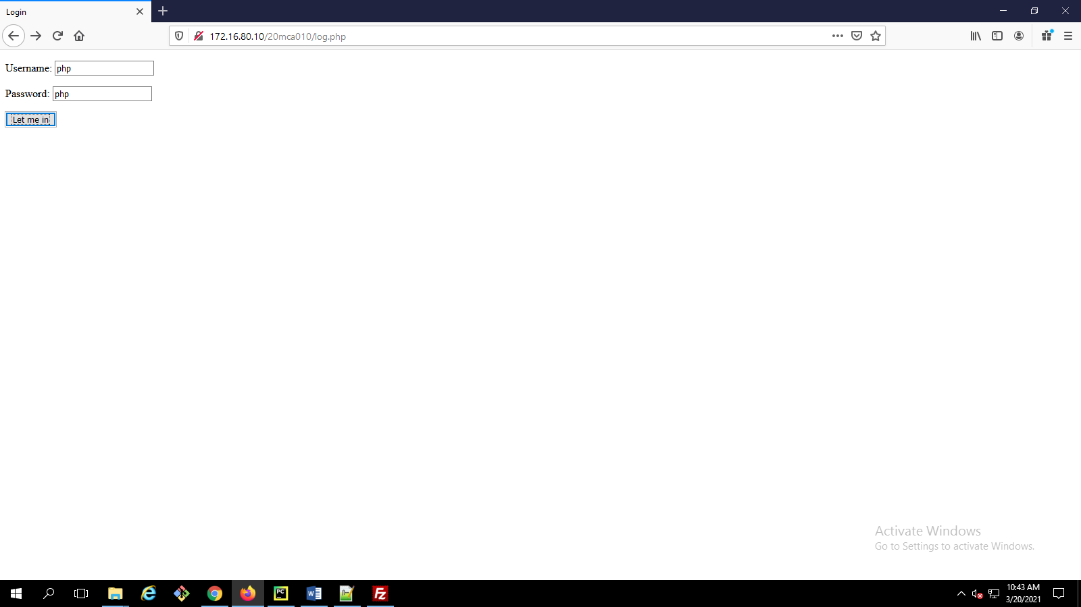

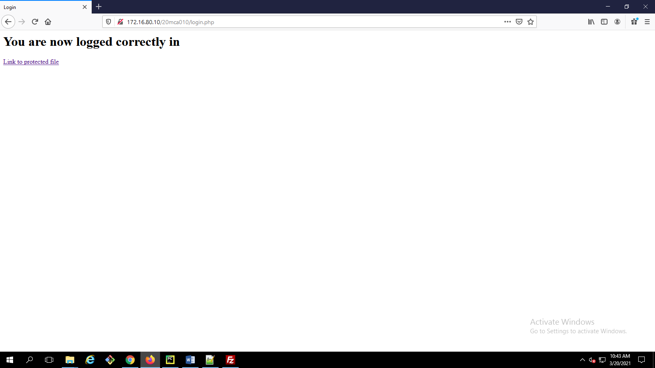

**Write a program that keeps track of how many times a visitor has loaded the page**.

**Write a PHP program to insert record into a tableSTUDENT(id,Name,branch,mark) using MySQL**

<html>

<head>

<title>Outline a registration form using PHP and do necessary validations.</title>

</head>

<body>

<form action = "regform.php" method = "POST">

Name:

<input type = "text" name = "txtname">

<br><br>

hall ticket no.:

<input type = "text" name = "txtr_no">

<br><br>

Address:

<textarea name = "add" type = "textarea"></textarea>

<br><br>

Mark:

<input type = "text" name = "mark">

<br><br>

<input type = "Submit" name = "insert" value = "Save">

<input type = "Reset" value = "Cancle">

</form>

</body>

<?php

$servername = "localhost";

$username = "20mca010";

$password = "2348";

$dbname = "20mca010";

// Create connection

$con = new mysqli($servername, $username, $password, $dbname);

$name =$_POST['txtname'];

$rollno = $_POST['txtr_no'];

$address = $_POST['add'];

$mark = $_POST['mark'];

$sql = "INSERT INTO getdata (name,rollno,address,mark)

values('$name','$rollno','$address','$mark')";

if (mysqli_query($con, $sql)) {

echo "New record created successfully";

}

else

{

echo "Error: " . $sql . "<br>" . mysqli_error($con);

}

mysqli_close($conn);

?>

</body>.

**OUTPUT**

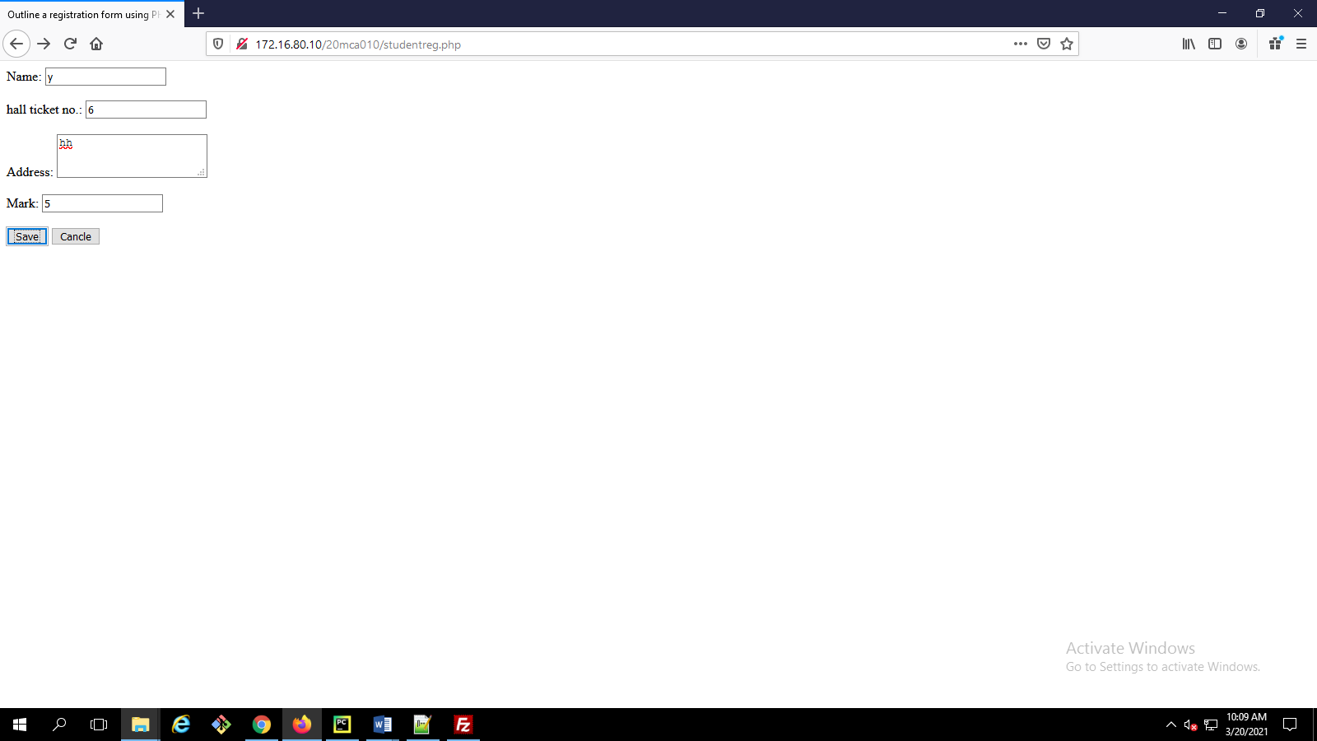

**Write a program to update table**

Db.php

<?php

$servername = "localhost";

$username = "20mca010";

$password = "2348";

$dbname = "20mca010";

$conn = mysqli_connect($servername, $username, $password, $dbname);

if(!$conn)

{

die('Could not Connect MySql Server:' .mysql_error());

}

?>

User.php

<html>

<head>

<title>PHP code to retrieve and update data from MySQL database</title>

<style type="text/css">

.bs-example{

margin: 20px;

}

</style>

<h2 class="pull-left">Users List</h2>

</div>

<?php

include_once 'db.php';

$result = mysqli_query($conn,"SELECT * FROM users");

if (mysqli_num_rows($result) > 0) {

?>

<table class='table table-bordered table-striped'>

<tr>

<td>Name</td>

<td>Email id</td>

<td>Mobile</td>

<td>Action</td>

</tr>

<?php

$i=0;

while($row = mysqli_fetch_array($result)) {

?>

<tr>

<td><?php echo $row["name"]; ?></td>

<td><?php echo $row["email"]; ?></td>

<td><?php echo $row["mobile"]; ?></td>

<td><a href="update-action.php?userid=<?php echo $row["id"]; ?>">Update</a></td>

</tr>

<?php

$i++;

}

?>

</table>

<?php

}

else{

echo "No result found";

}

?>

</body>

</html>

User-action.php

<?php

include 'db.php';

echo $_GET['userid'];

if(count($_POST)>0)

{

mysqli_query($conn,"UPDATE users set name='" . $_POST['name'] . "', mobile='" . $_POST['mobile'] . "' ,email='" . $_POST['email'] . "' WHERE id='" . $_POST['id'] . "'");

$message = "Record Modified Successfully";

}

?>

<html>

<head>

</head>

<body>

<h2>Update Record</h2>

<p>Please edit the input values and submit to update the record.</p>

<form action="" method="post">

<label>Name</label>

<input type="text" name="name" class="form-control" value="<?php echo $row["name"]; ?>">

<label>Email</label>

<input type="email" name="email" class="form-control" value="<?php echo $row["email"]; ?>">

<label>Mobile</label>

<input type="mobile" name="mobile" class="form-control" value="<?php echo $row["mobile"]; ?>">

<input type="hidden" name="id" value="<?php echo $row["id"]; ?>"/>

<input type="submit" class="btn btn-primary" value="Submit">

<a href="users.php" class="btn btn-default">Cancel</a>

</form>

</body>

</html>

**OUTPUT**

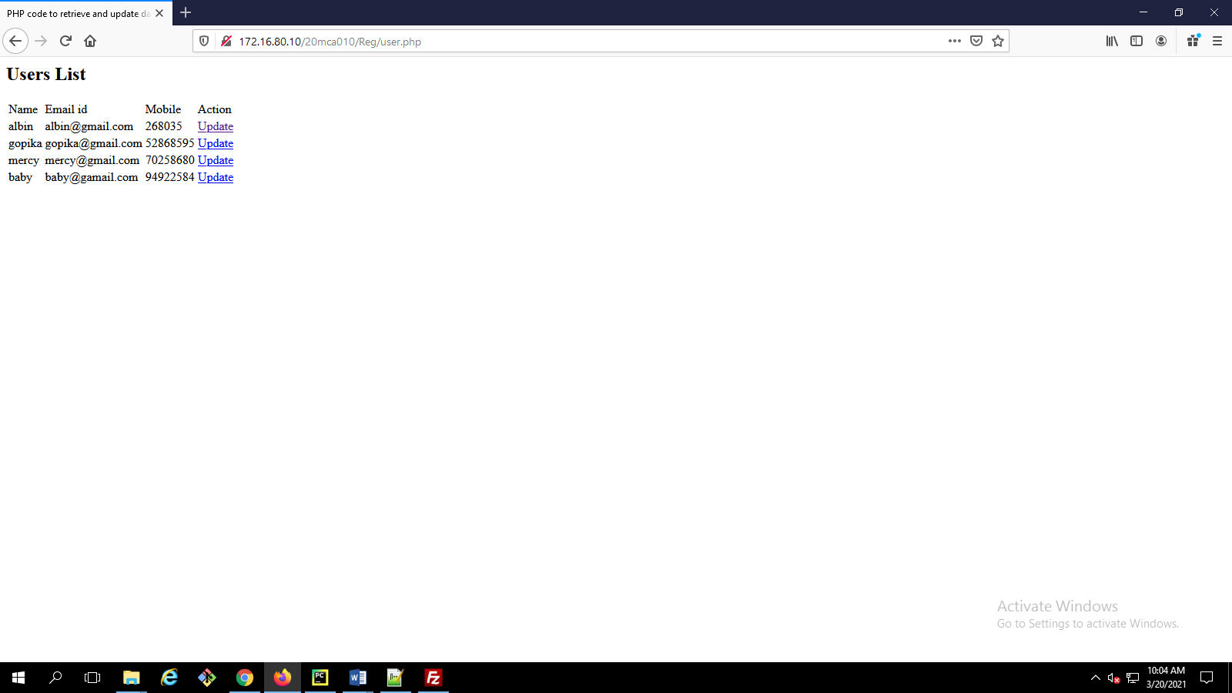

**Create a student Registration in PHP and Save and Display the student Records.**

<html>

<head>

<title>general form</title>

</head>

<body >

<form action = "" method = "POST">

Name:

<input type = "text" name = "txtname">

<br><br>

Roll no.:

<input type = "text" name = "txtr_no">

<br><br>

Gender:

<input type = "text" name = "txtgen">

<br><br>

Address:

<textarea name = "add" type = "textarea"></textarea>

<br><br>

<b><input type = "submit" name = "btnInsert" value = "Save">

<input name="btnselect" type="submit" id="select" value="View">

</form>

</body>

</html>

<?php

$servername = "localhost";

$username = "20mca010";

$password = "2348";

$dbname = "20mca010";

$con = mysqli_connect($servername, $username, $password, $dbname);

if(isset($_POST["btnInsert"]))

{

$name =$_POST["txtname"];

$rollno = $_POST["txtr_no"];

$gender =$_POST["txtgen"];

$address = $_POST["add"];

$insert = "INSERT INTO studinfo (name,rollno,gender,address) values('$name','$rollno','$gender','$address');";

if (mysqli_query($con, $insert))

{

echo "New record created successfully";

}

else

{

echo "Error: " . $insert . "<br>" . mysqli_error($con);

}

}

if(isset($_POST["btnselect"]))

{

$sql = "SELECT * from studinfo";

$result = mysqli_query($con, $sql);

if (mysqli_num_rows($result) > 0)

{

echo "<table>

<tr>

<th>Name</th>

<th>Roll No</th>

<th>Gender</th>

<th>Address</th>

</tr>";

while($row = mysqli_fetch_assoc($result))

{

echo "<tr>";

echo "<td><input type=text name=txtName".$row["rollno"] ." value=".$row['name']."</td>";

echo "<td><input type=text name=txt1Name value=".$row['rollno']."</td>";

echo "<td><input type=text name=txt2Name value=".$row['gender']."</td>";

echo "<td><input type=text name=txt3Name value=".$row['address']."</td>";

echo "<td><input type=hidden name=hdnRollNo[] value=".$row["rollno"]."</td>";

echo "</tr>";

}

echo "</table>";

} else

{

echo "0 results";

}

}

?>

**OUTPUT**

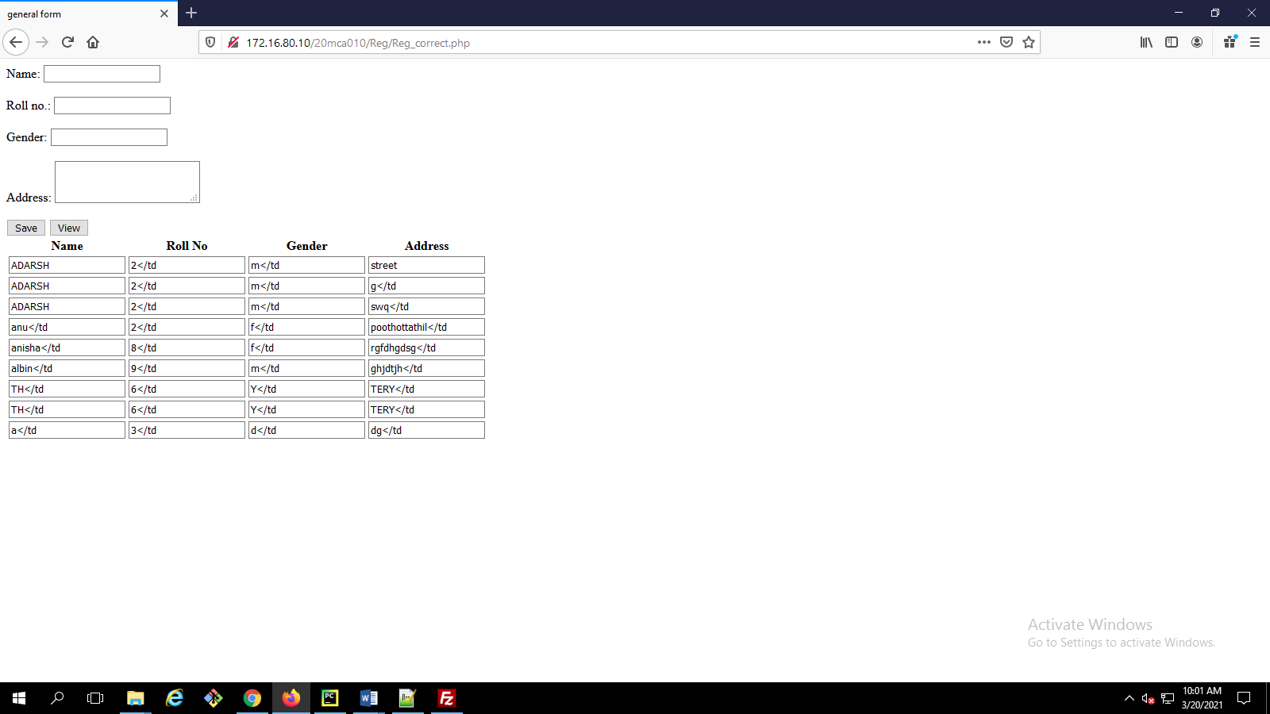

**Write a program to read customer information like c_no, c_name,**

**item_purchased and mob_no from customer table and display all this**

**information in table format on output screen.**

<html>

<head>

<title>display data in table format</title>

</head>

<body>

<?php

$servername = "localhost";

$username = "20mca010";

$password = "2348";

$dbname = "20mca010";

$conn = mysqli_connect($servername, $username, $password, $dbname);

// Check connection

if (!$conn) {

die("Connection failed: " . mysqli_connect_error());

}

$sql = "SELECT * from customer";

$result = mysqli_query($conn, $sql);

if (mysqli_num_rows($result) > 0) {

// output data of each row

echo "<table border = '1'>

<tr>

<th>C_No</th>

<th>C_Name</th>

<th>Item_Purchased</th>

<th>Mob_no</th>

</tr>";

while($row = mysqli_fetch_assoc($result))

{

echo "<tr>";

echo "<td>".$row["id"]."</td>";

echo "<td>".$row["name"]."</td>";

echo "<td>".$row["item"]."</td>";

echo "<td>".$row["mobile"]."</td>";

echo "</tr>";

}

echo "</table>";

} else {

echo "0 results";

}

mysqli_close($conn);

?>

</body>

</html>

**OUTPUT**

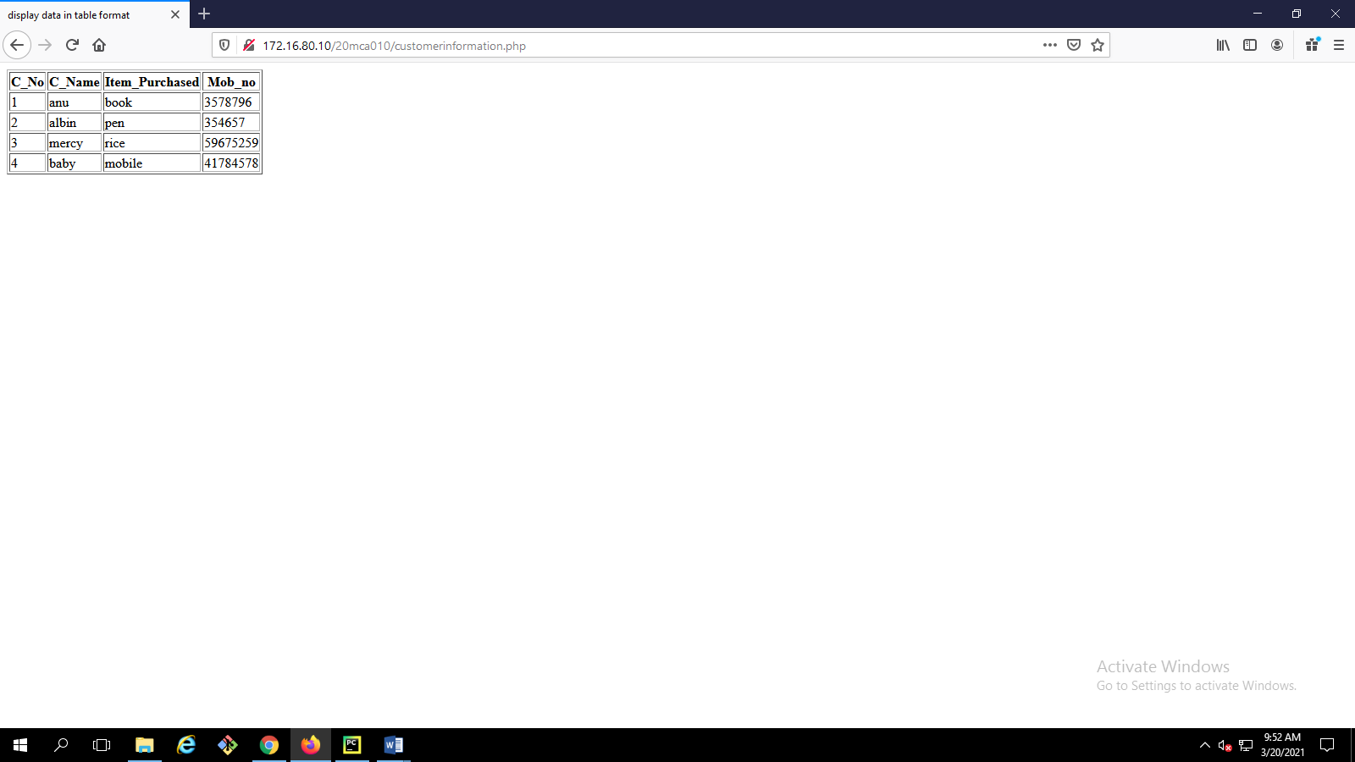

**Outline a registration form using PHP and do necessary validations. (K4)**

<!DOCTYPE HTML>

<html>

<head>

<style>

.error {color: #FF0000;}

</style>

</head>

<body>

<?php

// define variables and set to empty values

$nameErr = $emailErr = $genderErr = $websiteErr = "";

$name = $email = $gender = $comment = $website = "";

if ($_SERVER["REQUEST_METHOD"] == "POST") {

if (empty($_POST["name"])) {

$nameErr = "Name is required";

} else {

$name = test_input($_POST["name"]);

}

if (empty($_POST["email"])) {

$emailErr = "Email is required";

} else {

$email = test_input($_POST["email"]);

}

if (empty($_POST["website"])) {

$website = "";

} else {

$website = test_input($_POST["website"]);

}

if (empty($_POST["comment"])) {

$comment = "";

} else {

$comment = test_input($_POST["comment"]);

}

if (empty($_POST["gender"])) {

$genderErr = "Gender is required";

} else {

$gender = test_input($_POST["gender"]);

}

}

function test_input($data) {

$data = trim($data);

$data = stripslashes($data);

$data = htmlspecialchars($data);

return $data;

}

?>

<h2>PHP Form Validation Example</h2>

<p><span class="error">* required field</span></p>

<form method="post" action="<?php echo htmlspecialchars($_SERVER["PHP_SELF"]);?>">

Name: <input type="text" name="name">

<span class="error">* <?php echo $nameErr;?></span>

<br><br>

E-mail: <input type="text" name="email">

<span class="error">* <?php echo $emailErr;?></span>

<br><br>

Website: <input type="text" name="website">

<span class="error"><?php echo $websiteErr;?></span>

<br><br>

Comment: <textarea name="comment" rows="5" cols="40"></textarea>

<br><br>

Gender:

<input type="radio" name="gender" value="female">Female

<input type="radio" name="gender" value="male">Male

<input type="radio" name="gender" value="other">Other

<span class="error">* <?php echo $genderErr;?></span>

<br><br>

<input type="submit" name="submit" value="Submit">

</form>

<?php

echo "<h2>Your Input:</h2>";

echo $name;

echo "<br>";

echo $email;

echo "<br>";

echo $website;

echo "<br>";

echo $comment;

echo "<br>";

echo $gender;

?>

</body>

</html>

**OUTPUT**

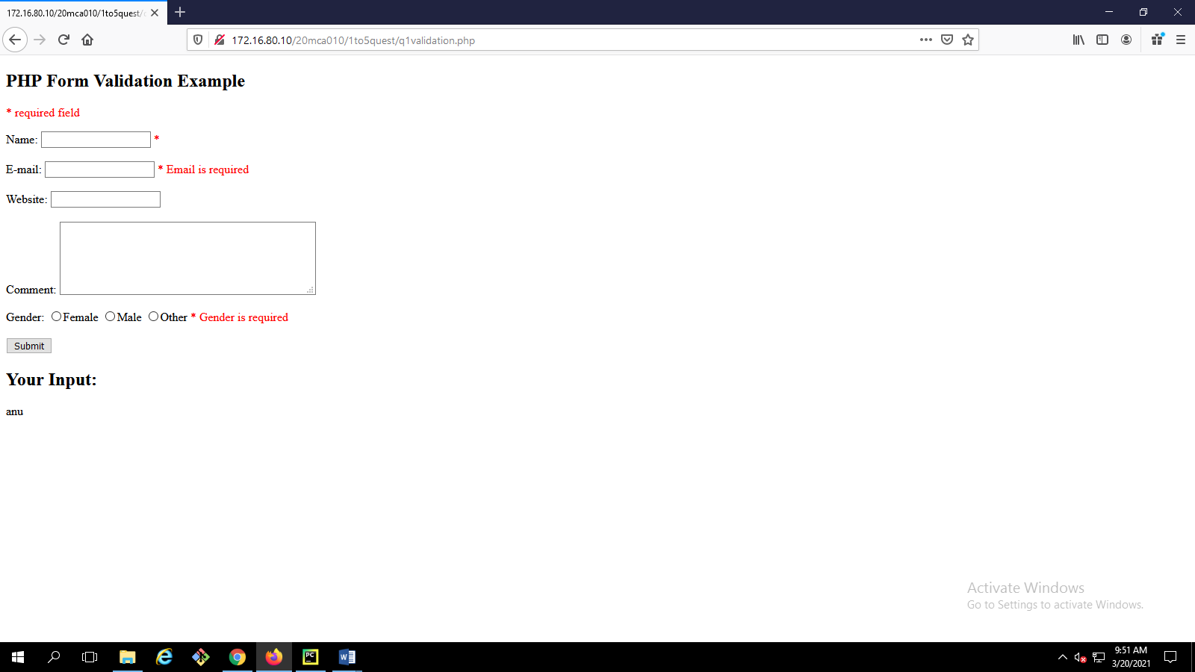

**Compose Electricity bill from user input based on a given tariff using PHP. (K6)**

<html>

<head></head>

<title>Electricity Bill Calculator</title>

<body>

<h1 style="text-align:center;color:green"><u>ELECTRICITY BILL CALCULATOR</u></h1>

<br><br>

<form method="post" >

<div align="center">

<label>Total Unit Consumption:</label>

<input type="text" name="unit"><br><br><br>

<input type="submit" value="calculate" name="calculate" style="background-color:green;color:white;">

</div>

</form>

<?php

if(isset($_POST["calculate"]))

{

$unit=$_POST["unit"];

if($unit<=300)

{

$price=$unit*5.80;

}

elseif($unit>=301 && $unit<=350)

{

$price=$unit*6.60;

}

elseif($unit>=351 && $unit<=400)

{

$price=$unit*6.90;

}

elseif($unit>=401 && $unit<=500)

{

$price=$unit*7.10;

}

else

{

$price=$unit*7.90;

}

?>

<h1 style="text-align:center;color:green"><u>ELECTRICITY BILL</u></h1>

<table align="center" border="0">

<tr>

<th>Total unit Consuption</th>

<td>:</td>

<td><?php echo $unit; ?></td></tr>

<tr>

<th>Amount to be paid</th>

<td>:</td>

<td><?php echo $price; ?></td>

</tr>

</table>

<?php

}

?>

</body>

</html>

**OUTPUT**

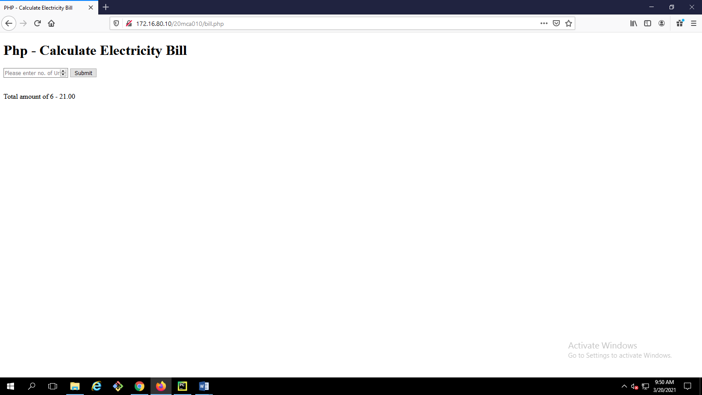

14**. Build a PHP code to store name of students in an array and display it using print_r function. Sort and Display the same using asort & arsort functions. (K6)**

<!DOCTYPE html>

<html>

<title>student array</title>

<body>

<?php

$name=array("Anjitha","k","kamal");

$name1=array("Anithra","k","kamal");

$name2=array("AA","AB","BB","BA","CC","CA");

echo "<h1>ARRAY IS</h1>";

print_r($name);

print_r($name1);

asort($name);

arsort($name1);

asort($name2);

arsort($name2);

echo "<h1>Ascending Order</h1>";

foreach($name as $name_array)

{

echo $name_array;

echo "<br>";

}

echo "<h1>Descending Order</h1>";

foreach($name1 as $name1_array)

{

echo $name1_array;

echo "<br>";

}

echo " new line<br><br><br>";

foreach($name2 as $name2_array)

{

echo $name2_array;

echo "<br>";

}

?>

</body>

</html>

**OUTPUT**

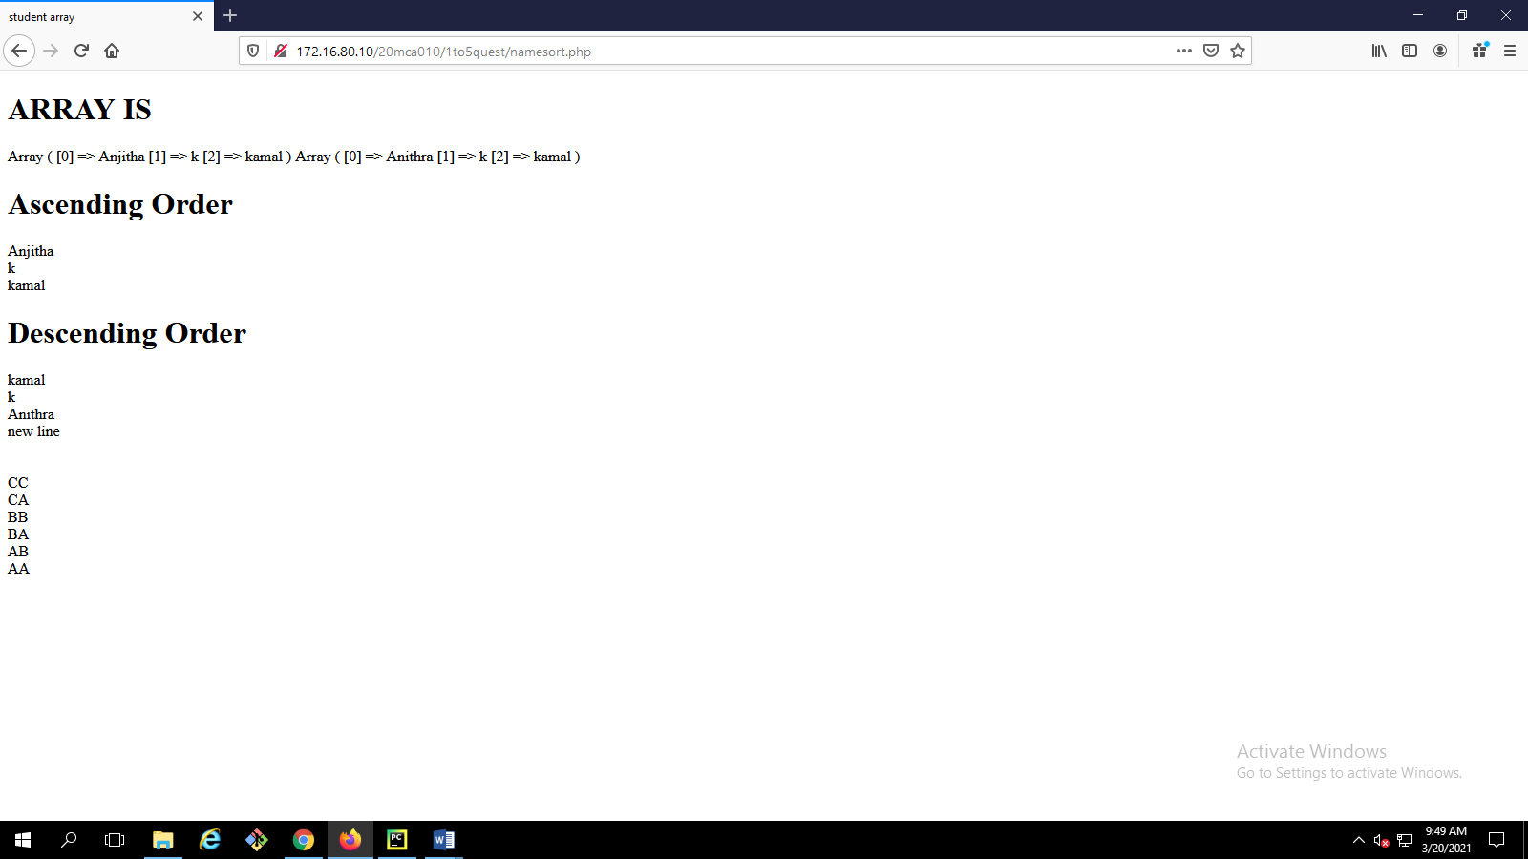

**14. Build a PHP code to store name of Indian Cricket players in an array and display the same in HTML table. (K6)**

<html>

<head></head>

<body>

<style>

body{

background-color:#f2e6ff;

}

table {

border-collapse: collapse;

width: 50%;

text-align: center

}

th,td{

padding: 10px;

}

th{

background-color:#b366ff;

}

tr:nth-child(even){background-color: #d9b3ff}

</style>

<?php

$my_array = array( "Virat Kohli", "Shikhar Dhawan", "M.S Dhoni","Suresh Raina","Rohit Sharma","Mohit Sharma","Vijay Shankar","Ravindra Jadeja","Irfan Pathan","Gautam Gambhir","Parthiv Pate","Virender Sehwag","Harbhajan Singh","Anil Kumble","Sachin Tendulkar","Rohit Sharma"," Gautam Gambhir");

?>

<h1 style="text-align:center"><u>Indian Cricket Players</u></h1>

<table border=”1” align="center">

<tr>

<th>Sl.No</th>

<th>Name of Players</th>

</tr>

<?php

$arraysize=sizeof($my_array);

for($i=0;$i<$arraysize;$i++)

{

?>

<tr>

<td><?php echo $i+1; ?></td>

<td><?php echo $my_array[$i];?></td>

</tr>

<?php

}

?>

</table>

</body>

</html>

**OUTPUT**

